Decision No. C23-0434
BEFORE THE PUBLIC UTILITIES COMMISSION OF THE STATE OF COLORADO
PROCEEDING NO. 23M-0005E
IN THE MATTER OF THE YEAR 2023 FILINGS BY COLORADO ELECTRIC UTILITIES IN ACCORDANCE WITH 4 CCR 723-3-3206 FOR THE DESIGNATION OF ELECTRIC UTILITY TRANSMISSION FACILITIES WHETHER THE FACILITIES ARE IN THE NORMAL COURSE OF BUSINESS OR AN APPLICATION TO OBTAIN A CERTIFICATE OF PUBLIC CONVENIENCE AND NECESSITY IS REQUIRED.
COMMISSION decision PROVIDING notice of
AMENDING, WAIVING COMMISSION RULES, AND ESTABLISHING dateS for filing COMMENTS AND STAFF RECOMMENDATIONS
Mailed Date: July 6, 2023
Adopted Date: June 28, 2023

BY THE COMMISSION

Statement
- Rule 3206(c) of the Commission’s Rules Regulating Electric Utilities, 4 Code of Colorado Regulations 723-3, requires each Colorado electric utility to file with the Colorado Public Utilities Commission (“Commission”), no later than April 30 of each year, information on its proposed new construction or extensions of transmission facilities for the next three calendar years.
- The following utilities timely filed information on proposed construction projects:
- Black Hills Colorado Electric, LLC
- CORE Electric Cooperative
- Public Service Company of Colorado
- Tri-State Generation and Transmission Association, Inc.
- On May 8, 2023, Grand Valley Power filed information indicating that the company had “…no plans for any new generation or transmission facilities within the next three years.”
- Specific information may be found in each utility’s report filing in this Proceeding on file with the Commission.
- Rule 3206(d)(II)(A) provides that the Commission will give notice of the filing of data to all those who, in the opinion of the Commission, may be interested in the reports, and provides for comments to be filed by June 15. Rule 3206(d)(II)(B) directs Commission Staff (“Staff”) to review the filings and comments, and to make recommendations to the Commission by July 1.
- Staff will be unable to make recommendations to the Commission by July 1, 2023.
- As permitted by Commission Rule 1003 et al. of the Rules of Practice and Procedure, the Commission will waive Rules 3206(d)(II) (B) so as to provide additional time until August 3, 2023, for Staff to make recommendations to the Commission.

ORDER

It Is Ordered That:
- Rules 3206(d)(II)(B) of the Commission’s Rules Regulating Electric Utilities, 4 Code of Colorado Regulations 723-3 is waived.
- Staff shall make recommendations to the Commission by August 9, 2023.
- This Decision is effective upon its Mailed Date.

ADOPTED IN COMMISSIONERS’ WEEKLY MEETING
June 28, 2023.
(S E A L)    ATTEST: A TRUE COPY  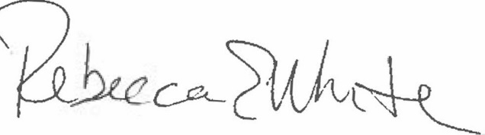  Rebecca E. White,  Director | THE PUBLIC UTILITIES COMMISSION  OF THE STATE OF COLORADO  ERIC BLANK  ________________________________  MEGAN M. GILMAN  ________________________________  TOM PLANT  ________________________________  Commissioners

