Decision No. C23-0297
BEFORE THE PUBLIC UTILITIES COMMISSION OF THE STATE OF COLORADO
PROCEEDING NO. 23A-0114R
IN THE MATTER OF THE APPLICATION OF THE CITY OF FORT COLLINS FOR AUTHORITY TO INSTALL TRAFFIC SIGNALS AT THE INTERSECTION OF EAST VINE DRIVE AND NORTH TIMBERLINE ROAD, AND TO PROVIDE INTERCONNECTION BETWEEN THE TRAFFIC SIGNAL SYSTEM AND THE BNSF RAILWAY CROSSING 244647X IN FORT COLLINS, LARIMER COUNTY, STATE OF COLORADO.
commission decision
granting application
Mailed Date: May 9, 2023
Adopted Date: May 3, 2023

BY THE COMMISSION

Statement
- This matter comes before the Public Utilities Commission (Commission) for consideration of an application (Application) filed by the City of Fort Collins (Fort Collins) on March 8, 2023, requesting authority to interconnect and preempt a new traffic signal at the existing intersection of Timberline Road and East Vine Drive, widen the existing crossing to add an additional left-turn lane, and install cantilever flashing lights, a new railroad signal bungalow, and upgrade the constant warning time circuitry at the crossing of the tracks of the BNSF Railway Company (BNSF) Front Range Subdivision at railroad mile post 77.16, National Inventory No.244647X, in Fort Collins, County of Larimer, State of Colorado.
- The Commission gave notice of this Application (Notice) to all interested parties, including adjacent property owners pursuant to § 40-6-108(2), C.R.S. The Notice was mailed on March 13, 2023.
- On April 12, 2023, BNSF filed an Entry of Appearance and Notice of Intervention. BNSF does not contest or oppose this matter.
- The Commission has reviewed the record in this matter and the Application was automatically deemed complete within the meaning of § 40-6-109.5, C.R.S. by operation of law on April 27, 2023.
- The Commission has jurisdiction in this matter under §§ 40-4-106(2)(a) and (3)(a), C.R.S.
- Now being fully advised in the matter, we grant the Application.

Findings of Fact
- The Commission gave notice to all interested parties, including the adjacent property owners. No intervention was received opposing the Application.
- Fort Collins is widening the intersection of Timberline and Vine to add left-turn lanes to all four legs of the intersection, which will slightly widen the Timberline crossing with BNSF. With the additional lane being added at the Timberline crossing, Fort Collins proposes to add a cantilever flashing light for the northbound traffic on Timberline across the crossing, add a new grade crossing signal bungalow, and upgrade the constant warning time circuitry.
- As part of this project, Fort Collins is installing a new traffic signal at the intersection of Timberline and Vine. Fort Collins proposes operating the traffic signal with advanced preemption and providing 22 seconds of advance preemption time to the traffic signal.
- Fort Collins states that the existing traffic volume on Timberline using the crossing is 7,000 vehicles per day (VPD) using the crossing with approximately 5% heavy vehicles and two-3 school buses crossing the track per day at a posted speed limit of 25 miles per hour (MPH). Fort Collins estimates that 2027 traffic volumes at 9,025 VPD and the 2042 traffic volume at 18,600 VPD. There are currently six trains per day using the crossing at a maximum timetable speed of 25 MPH with no projections for any increases or decreases in the future.
- There have been six accidents at the crossing including one injury accident in 2022 and five property damage only accidents with two in 1988, one in 1990, one in 1991, and one in 2008.
- Fort Collins estimates the const of construction for the crossing upgrades to the intersection are $442,449 with Fort Collins paying for the entire project.
- Fort Collins proposes starting construction in August 2023 and completing the project by November 2023. Fort Collins will be required to inform the Commission in writing that the crossing work is complete and operational within ten days of completion. The Commission will expect this letter by November 30, 2023. However, the Commission does understand this letter may be provided earlier or later than this date depending on changes or delays to the construction schedule.
- Fort Collins will also be required to file a copy of the signed Construction and Maintenance Agreement for this project prior to the start of construction. We will require Fort Collins to file the signed Construction and Maintenance Agreement by July 31, 2023, prior to the start of construction at the crossing.
- BNSF will be required to update the crossing inventory form for this crossing showing the new configuration and information for the crossing. The Commission will expect this information to be filed with the completion of the crossing work by November 30, 2023.

Conclusions
- The Commission has jurisdiction in this matter under §§ 40-4-106(2)(a) and (3)(a), C.R.S.
- No intervenor that filed a petition to intervene or other pleading contests or opposes the Application.
- Because the Application is unopposed, the Commission will determine this matter upon the record, without a formal hearing under § 40-6-109(5), C.R.S., and Rule 1403, Commission Rules of Practice and Procedure, 4 Code of Colorado Regulations 723-1.
- Based on the Findings of Fact, we find good cause exists and that the requirements of public safety and necessity are met by granting the Application consistent with the above discussion.

ORDER

The Commission Orders That:
- The application (Application) filed by the City of Fort Collins (Fort Collins) on March 8, 2023, requesting authority to interconnect and preempt a new traffic signal at the existing intersection of Timberline Road and East Vine Drive, widen the existing crossing to add an additional left-turn lane, and install cantilever flashing lights, a new railroad signal bungalow, and upgrade the constant warning time circuitry a at the crossing of the tracks of the BNSF Railway Company (BNSF) Front Range Subdivision at railroad mile post 77.16, National Inventory No.244647X, in Fort Collins, County of Larimer, State of Colorado was automatically deemed complete within the meaning of § 40-6-109.5, C.R.S. by operation of rule on April 27, 2023.
- The intervention of BNSF is granted.
- The Application is granted.
- Fort Collins is authorized and ordered to proceed with construction, interconnection and preemption of a new traffic signal and railroad signal additions and changed at the intersection Timberline Road and East Vine Drive and crossing of the BNSF tracks.
- BNSF shall provide a total of 22 seconds of advance preemption time to the traffic signal.
- Fort Collins shall inform the Commission in writing that the crossing changes are complete and operational within ten days of completion. We shall expect this letter by November 30, 2023. However, we understand this letter may be provided earlier or later than this date depending on changes or delays to the construction schedule.
- Fort Collins shall file a copy of the signed Construction and Maintenance Agreement for this project prior to starting construction at the crossing. We shall expect this agreement to be filed by July 31, 2023.
- BNSF shall be required to update their fields in National Inventory Form for this crossing and file a copy of the updated crossing inventory form in this proceeding by November 30, 2023.
- The 20-day period provided for in § 40-6-114, C.R.S., within which to file applications for rehearing, reargument, or reconsideration, begins on the first day following the effective date of this Decision.
- The Commission retains jurisdiction to enter further decisions, as necessary.
- This Decision is effective on its Mailed Date.

ADOPTED IN COMMISSIONERS’ WEEKLY MEETING
May 3, 2023.
(S E A L)    ATTEST: A TRUE COPY  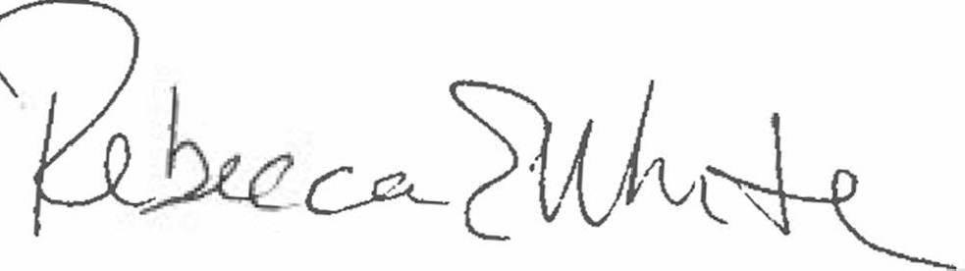  Rebecca E. White,  Director | THE PUBLIC UTILITIES COMMISSION  OF THE STATE OF COLORADO  ERIC BLANK  ________________________________  MEGAN M. GILMAN  ________________________________  TOM PLANT  ________________________________  Commissioners

