Decision No. C23-0040
BEFORE THE PUBLIC UTILITIES COMMISSION OF THE STATE OF COLORADO
PROCEEDING NO. 20M-0109R
REPOSITORY DOCKET FOR THREE-YEAR STATE SAFETY OVERSIGHT AUDIT AND INVESTIGATIONS OF THE REGIONAL TRANSPORTATION DISTRICT.
Commission DECISION adopting
accident investigation reports
Mailed Date: January 26, 2023
Adopted Date: January 25, 2023

BY THE COMMISSION

Statement
- This matter comes before the Commission for consideration of formal adoption of nine accident investigation reports submitted by the metro Denver area Regional Transportation District light rail operation. The investigation reports are for nine accidents between the dates of July 1, 2022, and September 30, 2022. A report summarizing these accidents was filed by Staff of the Public Utilities Commission (Staff) on January 11, 2023.
- The accident numbers for the ten accidents reviewed by the Commission are:
A1-07062022, A1-07252022, A1-08042022, A1-08052022, A1-08122022, A1-09172022, A1-09212022, A1-09262022, A1-09292022.
- The Commission has reviewed the summary report filed by Staff and concurs with Staff’s review of the investigation reports and recommendations.
- The Commission has jurisdiction in this matter under § 40-18-103, C.R.S., and Rule 7349 of the Rules Regulating Railroads, Rail Fixed Guideways, Transportation by Rail, and Rail Crossings, 4 Code of Colorado Regulations 723-7.

ORDER

The Commission Orders That:
- The Commission formally adopts investigation reports A1-07062022, A1-07252022, A1-08042022, A1-08052022, A1-08122022, A1-09172022, A1-09212022, A1-09262022, and A1-09292022, submitted by the metro Denver area Regional Transportation District light rail operations.
- This Decision is effective on its Mailed Date.

ADOPTED IN COMMISSIONERS’ WEEKLY MEETING
January 25, 2023.

(S E A L)    ATTEST: A TRUE COPY  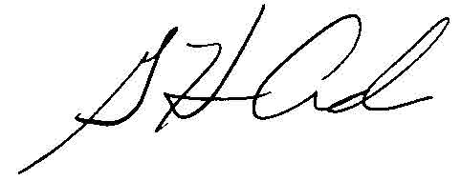  G. Harris Adams.,  Interim Director | THE PUBLIC UTILITIES COMMISSION  OF THE STATE OF COLORADO  ERIC BLANK  ________________________________  JOHN GAVAN  ________________________________  MEGAN M. GILMAN  ________________________________  Commissioners

