Decision No. C23-0037-E
BEFORE THE PUBLIC UTILITIES COMMISSION OF THE STATE OF COLORADO
PROCEEDING NO. 22A-0545E
IN THE MATTER OF THE APPLICATION OF BLACK HILLS COLORADO ELECTRIC, LLC FOR COMMISSION APPROVAL OF A REFUND PLAN FOR UNDERPAYMENT FOR EXCESS ENERGY PRODUCTION BY NET METERED CUSTOMERS.
ERRATA NOTICE FOR
commission decision granting
the waiver of Rules 3402(a)(V) and Rule 3402(C) AND approving the application
Errata Mailed Date: January 30, 2023
Original Decision No. C23-0037 mailed: January 26, 2023

The Ordering Paragraph 1 reads incorrectly:
The Motion filed on July 25, 2022 for a waiver of the number of meters required to be tested in calendar year 2022 pursuant to the Commission’s Rules Regulating Gas Utilities, 4 Code of Colorado Regulations (CCR) 723-4-4304(b) and 4 CCR 723-4-4304(d), and the meter testing plan approved by the Commission in Decision No. R19-0219 is granted.
The Ordering Paragraph 1 is amended to read as follows:
The application filed by Black Hills Colorado Electric, LLC on December 9, 2022, for approval of a refund plan for underpayment of excess energy production to net metered customers, is granted.
(S E A L)    ATTEST: A TRUE COPY  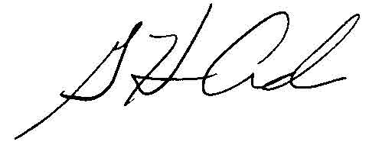  G. Harris Adams,  Interim Director | THE PUBLIC UTILITIES COMMISSION  OF THE STATE OF COLORADO  G. HARRIS ADAMS  ________________________________  Interim Director

