Decision No. R22-0788-I
BEFORE THE PUBLIC UTILITIES COMMISSION OF THE STATE OF COLORADO
PROCEEDING NO. 22G-0333TO
COLORADO PUBLIC UTILITIES COMMISSION,

COMPLAINANT,

V.

Eric Houston doing business as CODE 3 Towing,

RESPONDENT.
INTERIM DECISION OF
ADMINISTRATIVE LAW JUDGE
Aviv segev
Vacating and Resetting hearing
Mailed Date: December 6, 2022

STATEMENT
- This proceeding concerns Civil Penalty Assessment Notice (CPAN)
No. 131017 filed by Commission Staff on July 22, 2022 against Eric Houston doing business as Code 3 Towing (Code 3 Towing).
- On November 9, 2022, the Commission referred this proceeding to an Administrative Law Judge (ALJ) by minute entry.
- On December 1, 2022, the ALJ issued Interim Decision No. R22-0774-I that, among other things, set an evidentiary hearing for January 16, 2023.
- The setting of the hearing was made by the ALJ in error, as January 16, 2023 is a Colorado State holiday.
- The evidentiary hearing in this matter will be vacated and rescheduled as ordered below.

ORDER

It Is Ordered That:
- The remote prehearing conference that is scheduled for January 19, 2023 at
9:00 a.m. is vacated and rescheduled as follows:
DATE: February 1, 2023
TIME: 10:00 a.m.
PLACE: Commission Hearing Room
1560 Broadway, Suite 250
Denver, Colorado
Optionally, any party may participate remotely by joining a video conference using Zoom at the link provided as to the established parties in an e-mail prior to the scheduled hearing, as addressed in Interim Decision No. R22-0774-I.
- The remaining requirements ordered in Interim Decision No. R22-0774-I shall remain in effect.
- This Decision shall be effective immediately.
(S E A L)    ATTEST: A TRUE COPY  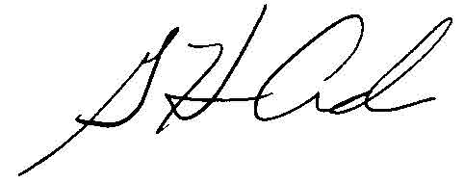  G. Harris Adams,  Interim Director | THE PUBLIC UTILITIES COMMISSION  OF THE STATE OF COLORADO  AVIV SEGEV  ________________________________  Administrative Law Judge

