______________________________________________________________________________
ATTACHMENT A
REQUIREMENTS AND INFORMATION
ON USING ZOOM TO ATTEND HEARING
______________________________________________________________________________
- This Attachment directs the parties on certain aspects of their participation in the remote hearing in this matter using Zoom (https://zoom.us/), and provides information which will aid parties in doing so. Additional information about the Zoom platform and various tips on how to use the Zoom platform are available at: https://zoom.us. This is not intended to provide full and complete instructions on how to use Zoom to participate in a hearing.
- Parties are responsible for ensuring they have familiarized themselves with Zoom and are able to use it for the hearing. All are strongly encouraged to participate in a test meeting prior to the scheduled hearing. See https://zoom.us/test.
- Participants in a Zoom hearing by video-conference must use a computer, smart phone, or tablet with internet access, an operational microphone, camera, and a speaker. A few minutes prior to the start of the hearing, parties and counsel must enter the link provided to them for the Zoom hearing in their internet browser. Each party is responsible for ensuring that their respective witnesses are provided the same link.
- Participants will then be taken to the screen where they may join the hearing. The participant’s browser should prompt the participant to “Open Zoom Meetings” which the participant should click. If the browser prompt does not appear, participants may click “Launch Meeting” as shown in the image below.
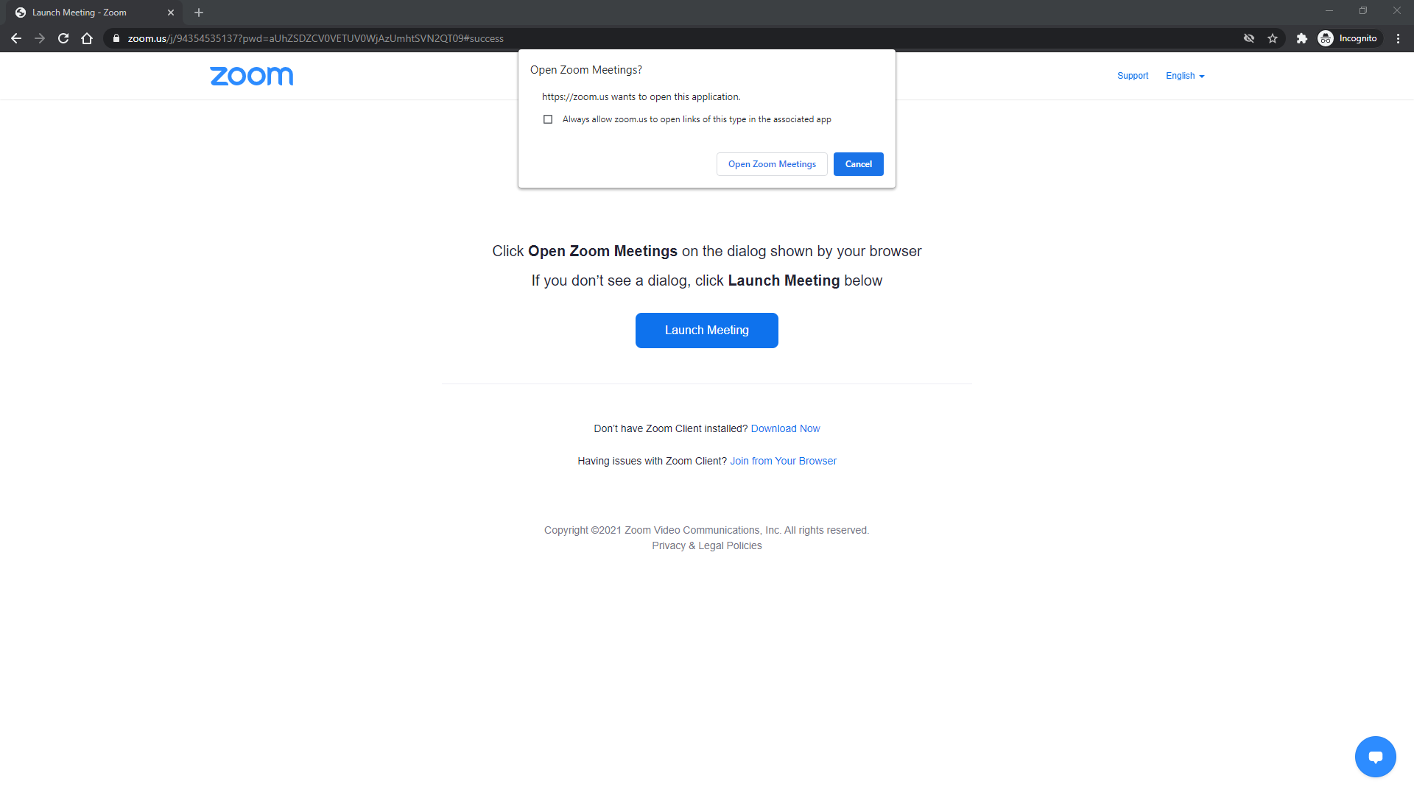
- The Zoom program will then open on the participant’s computer. A video preview window will open automatically. Participants should click “Join with Video.” If participants are prompted to allow the session to access their computers’ microphone and camera, they should allow access and should click “Join With Computer Audio”. Participants will be able to modify their settings during the session should they need to mute their microphone or turn off their cameras. These steps are shown in the images below.
Step 1:
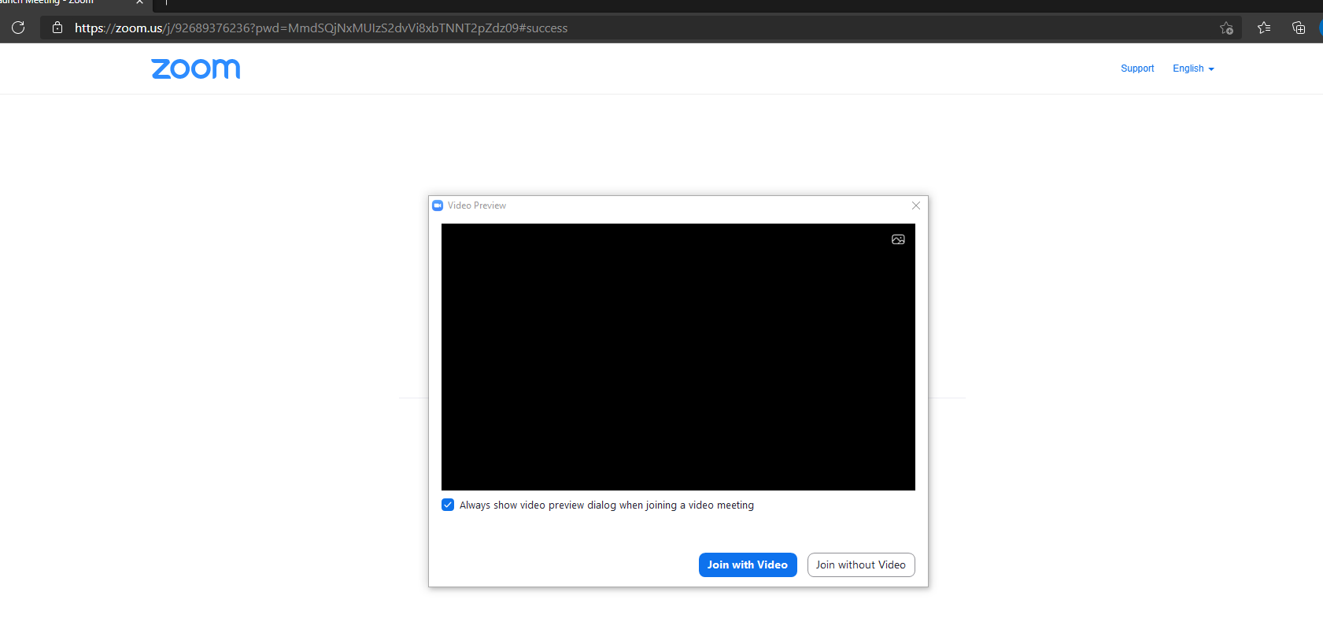
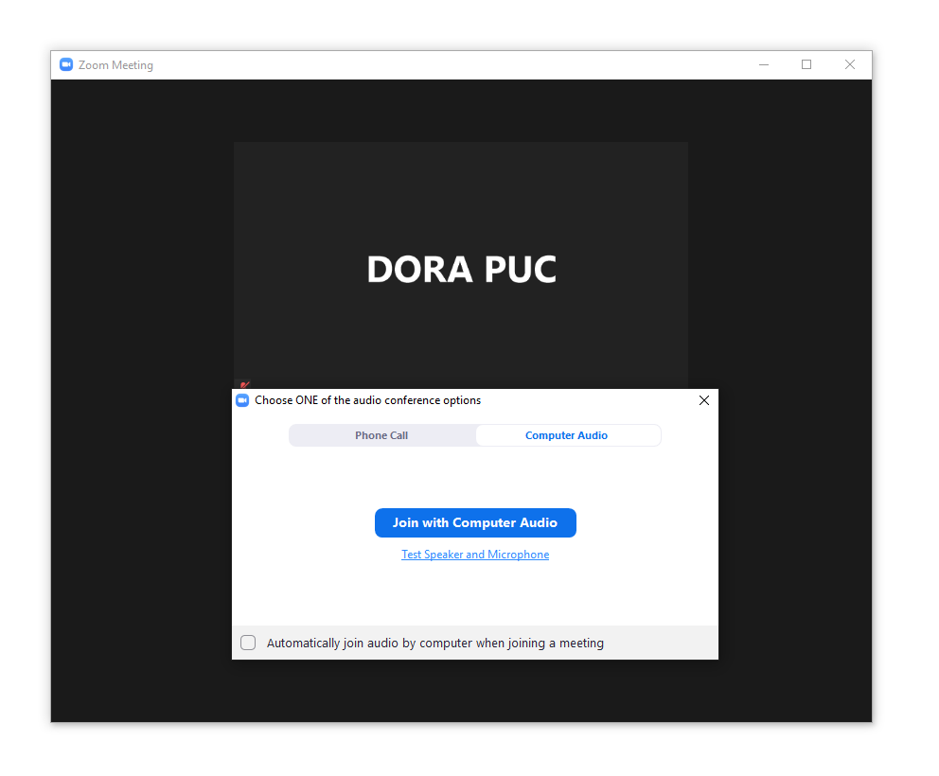
Step 2:

- When prompted by Zoom, participants must enter their name for identification during the session. Among other reasons, this is required for identification and because the presiding official may close the meeting to unauthorized or new participants once all parties have joined.
- Participants may control the audio volume using their computer’s audio controls. Those who do not want their picture displayed for others in the meeting may select the camera icon labeled “Stop Video” at the bottom left of the Zoom window at any point. A slash will appear over the camera icon, indicating that the camera has been turned off. Likewise, to mute or turn off the microphone, select the microphone icon at the bottom left of the Zoom window and visually confirm that there is a slash over the microphone icon. Illustratively, the below image shows the microphone turned on and the camera turned off.
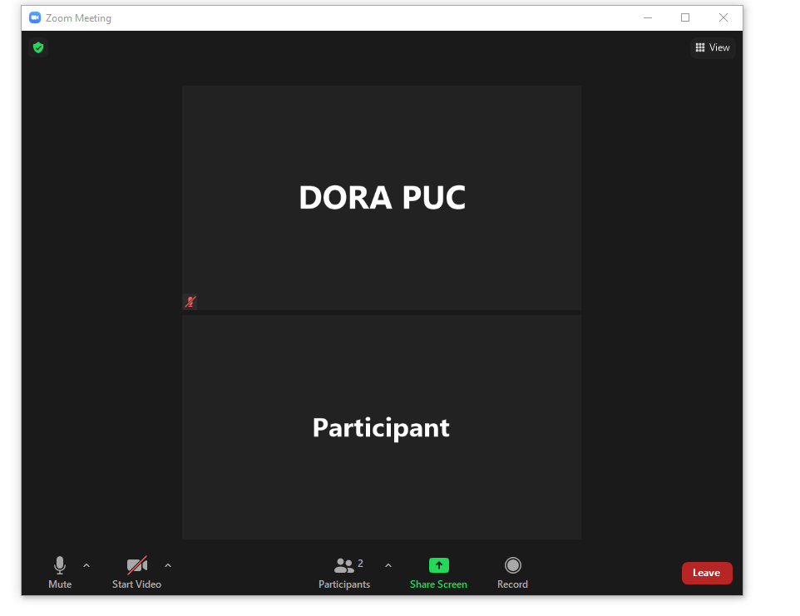
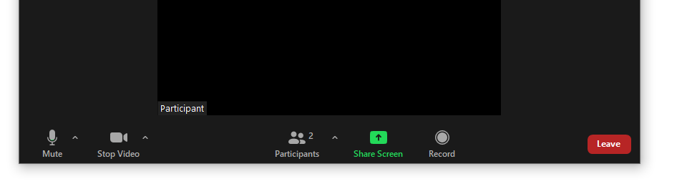
- Conversely, the below image shows the microphone and camera icons turned on and ready to transmit video and audio upon joining the hearing.

- A full and complete record and all testimony will be stenographically or electronically recorded. To facilitate this, participants must minimize feedback and background noise. First, all participants are required to mute their microphones and cameras during the hearing until called upon by the Administrative Law Judge (ALJ). Second, all participants must ensure that they are in a location with minimal or no background noise while participating in the hearing. Participants must avoid connecting to the hearing with multiple computers or devices located in the same room, as this will cause echos and audio feedback. Although not mandatory, participants are encouraged to participate using headphones connected to their computers to help reduce audio feedback.
- The Commission has enabled the Zoom “Live Transcript” feature, which allows participants to view subtitles using automatic speech recognition technology. To access this feature, participants can select the “Live Transcript” icon on the bottom of the screen and then choose “Show Subtitle.” To hide the subtitles, click on the “Live Transcript” icon again and choose “Hide Subtitle.”
- A Zoom hearing may or may not have a functional chat feature active during a particular hearing. Any information provided in the chat will not be part of the record of the proceeding. In addition, the ALJ and Commission Staff who administer the hearings do not actively monitor Zoom’s chat function and thus may not be aware of, or respond to, any information provided in chat.
- To terminate participation in the hearing, select the “Leave” button then select “Leave Meeting” in the pop-up box, as shown below. A party who inadvertently selects the “Leave” button may instead click anywhere else on the screen to stay in the meeting.
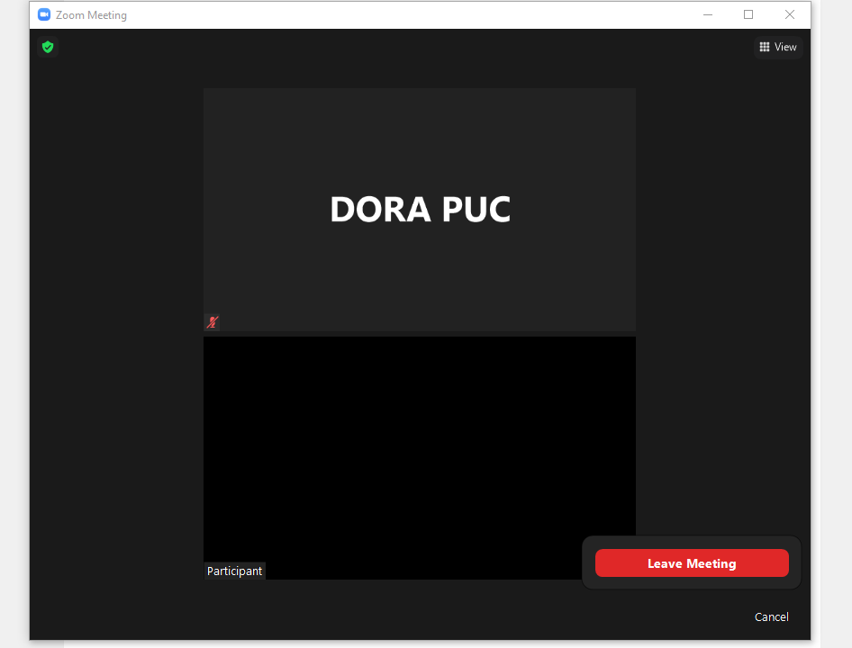

These instructions are not directed at using a tablet or smartphone to participate in a Zoom video conference. Using a smartphone or tablet may limit a participant’s ability to view hearing exhibits during the hearing due to screen size. As such, participation by computer is encouraged. Participants who chose to use a smartphone or tablet are responsible for ensuring they are able to fully participate in the hearing.
These links are provided for the parties’ convenience; the ALJ does not warrant that the information contained in these links is accurate or that it provides all the information participants may need to use Zoom.
If a participant is unable to participate by computer or mobile device, participation by telephone only will be accommodated. The phone number and access code needed to participate by telephone will be included in the email sent to all parties prior to the hearing.
If the participant has never used Zoom before, a download in the browser may start and participant will need to click the Zoom icon in the bottom of the browser to open the program.
Participants can also click the link for “Test Speaker and Microphone” to ensure their audio is properly connected.
Note, closing the meeting does not affect the availability of the webcast of the proceeding.

