Decision No. C22-0785
BEFORE THE PUBLIC UTILITIES COMMISSION OF THE STATE OF COLORADO
PROCEEDING NO. 22A-0253R
IN THE MATTER OF THE APPLICATION OF AEROTROPOLIS REGIONAL TRANSPORTATION AUTHORITY FOR AUTHORITY TO CONSTRUCT THE AEROTROPOLIS PARKWAY GRADE SEPARATED CROSSING OVER THE UNION PACIFIC RAILROAD (UPRR) AND SMITH ROAD IN THE CITY OF AURORA, ADAMS COUNTY, STATE OF COLORADO.
commission decision granting motion
for extension of time to provide final plans
Mailed Date: December 9, 2022
Adopted Date: December 7, 2022

by the commission

Statement
- This matter comes before the Commission for consideration of an Unopposed Motion for Extension of Time To File Final Plans (Motion) filed by the Aerotropolis Regional Transportation Authority (Aerotropolis) on November 30, 2022 requesting an extension of time to December 31, 2023 to file the final plans for Commission review and action.
- As grounds for the Motion, Aerotropolis states they have been working diligently in good faith toward completion of the final plans for the proposed new grade separation. However, this grade separation is only a part of a much larger regional transportation system currently being planned, designed, financed, and constructed by Aerotropolis, which components much be planned and designed in a coordinated manner. The complexity of this regional transportation system design has hit unforeseen circumstances delaying the necessary planning and design work, which affects the subject crossing. Because of these unforeseen delays, Aerotropolis requests an extension until December 31, 2023, to submit final plans.
- Aerotropolis has conferred with counsel for the Union Pacific Railroad Company, which does not oppose the extension of time. Aerotropolis also reached out to the counsel for the Colorado Department of Transportation and did not receive a response. Aerotropolis presumes that Colorado Department of Transportation does not oppose the Motion.
- Now being fully advised in the matter, we grant the Motion.

ORDER

The Commission Orders That:
- The Unopposed Motion for Extension of Time To File Final Plans (Motion) filed by the Aerotropolis Regional Transportation Authority on November 30, 2022 requesting an extension of time to December 31, 2023 to file the final plans for Commission review and action is granted.
- Aerotropolis shall file the final plans for Commission review and action by December 31, 2023.
- The Commission retains jurisdiction to enter further decisions, as necessary.
- This Decision is effective on its Mailed Date.

ADOPTED IN COMMISSIONERS’ WEEKLY MEETING
December 7, 2022.
(S E A L)    ATTEST: A TRUE COPY  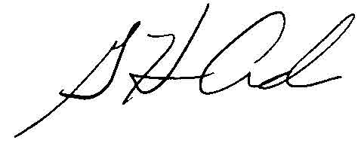  G. Harris Adams,  Interim Director | THE PUBLIC UTILITIES COMMISSION  OF THE STATE OF COLORADO  ERIC BLANK  ________________________________  JOHN GAVAN  ________________________________  MEGAN M. GILMAN  ________________________________  Commissioners

