Decision No. C22-0723
BEFORE THE PUBLIC UTILITIES COMMISSION OF THE STATE OF COLORADO
PROCEEDING NO. 22A-0377R
IN THE MATTER OF THE APPLICATION OF THE TOWN OF KERSEY FOR AUTHORITY TO REMOVE EXISTING ADVANCED WARNING DEVICES, CROSSING SURFACE, AND ROAD APPROACHES TO CLOSE THE EXISTING CROSSINGS ON 3RD STREET AND TRUMBILL STREET AT THE TRACKS OWNED BY UNION PACIFIC RAILROAD COMPANY IN THE TOWN OF KERSEY, WELD COUNTY, STATE OF COLORADO.
commission decision requesting additional information from the town of kersey
Mailed Date: November 18, 2022
Adopted Date: November 16, 2022

BY THE COMMISSION

Statement
- This matter comes before the Commission for consideration of a Motion for Continuance (Motion) filed by the Town of Kersey (Kersey) on October 21, 2022. Kersey is requesting a ten-week continuance of the final hearing for this proceeding to be held on a date after January 1, 2023.
- Kersey states in its Motion that the application for closure of the crossing was filed on September 1, 2022, that the PUC accepted Kersey’s application as complete, that Kersey has been working with Union Pacific Railroad (UPRR)
to complete an Agreement for the purchase of land and improvements directly affecting the subject crossing, that Kersey has been unable to complete the Agreement, and that Kersey will continue to work diligently to obtain a final executed Agreement. Kersey requests a ten-week continuance of the final hearing for this proceeding to be held on a date after
January 1, 2023.
- There is currently no hearing scheduled in this matter, and no party has requested a hearing. No continuance is therefore necessary at this time.
- To consider procedural next steps in this matter, we request Kersey to make a filing answering the following:
  - Please provide the Commission with a more detailed explanation of the agreement being sought between Kersey and UPRR.
  - Please explain how the purchase of land and improvements directly affect the crossing for which closure is being sought by Kersey.
  - Is Kersey expecting that the final executed agreement between Kersey and UPRR will occur before January 1, 2023?
  - By what date will Kersey make a filing letting the Commission know when the agreement in question is complete and executed?
- We request that Kersey provide responses to the above information requests and questions by November 30, 2022.

ORDER

The Commission Orders That:
- The Town of Kersey is to provide responses to the requests for information and questions included in paragraph no. 5 above by November 30, 2022.

- This Decision is effective on its Mailed Date.

ADOPTED IN COMMISSIONERS’ WEEKLY MEETING
November 16, 2022.
(S E A L)    ATTEST: A TRUE COPY  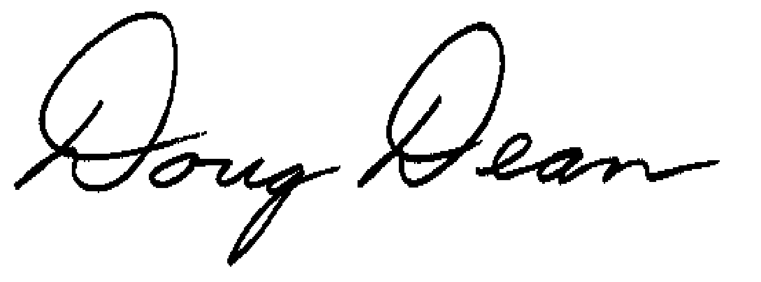  Doug Dean,  Director | - THE PUBLIC UTILITIES COMMISSION  OF THE STATE OF COLORADO  ERIC BLANK  ________________________________  JOHN GAVAN  ________________________________  MEGAN M. GILMAN  ________________________________  Commissioners

The application was deemed complete by minute entry October 26, 2022.
UPRR provided an intervention pleading in this matter on October 6, 2022. UPRR has filed no response to the Motion or further pleadings in this matter.

