______________________________________________________________________________
ATTACHMENT A
REQUIREMENTS AND INFORMATION
ON USING GOTOMEETING TO ATTEND HEARING
______________________________________________________________________________
- This Attachment directs the parties on certain aspects of their participation in the remote hearing in this matter using GoToMeeting (https://www.gotomeeting.com/), and provides information which will aid parties in doing so. This is not intended to provide full and complete instructions on how to use GoToMeeting to participate in a hearing. Parties are responsible for ensuring they have familiarized themselves with GoToMeeting and are able to use it for the hearing (see https://support.goto.com/meeting/system-check).
- Participants in a GoToMeeting hearing by video-conference must use a computer, smart phone, or tablet with internet access, an operational microphone, camera, and a speaker. A few minutes prior to the start of the hearing, parties and counsel must enter the link provided to them for the GoToMeeting hearing in their internet browser. Each party is responsible for ensuring that their respective witnesses are provided the same link.
- Participants will then be taken to the screen where they may join the hearing. Parties should select the computer option, as shown in the below image.
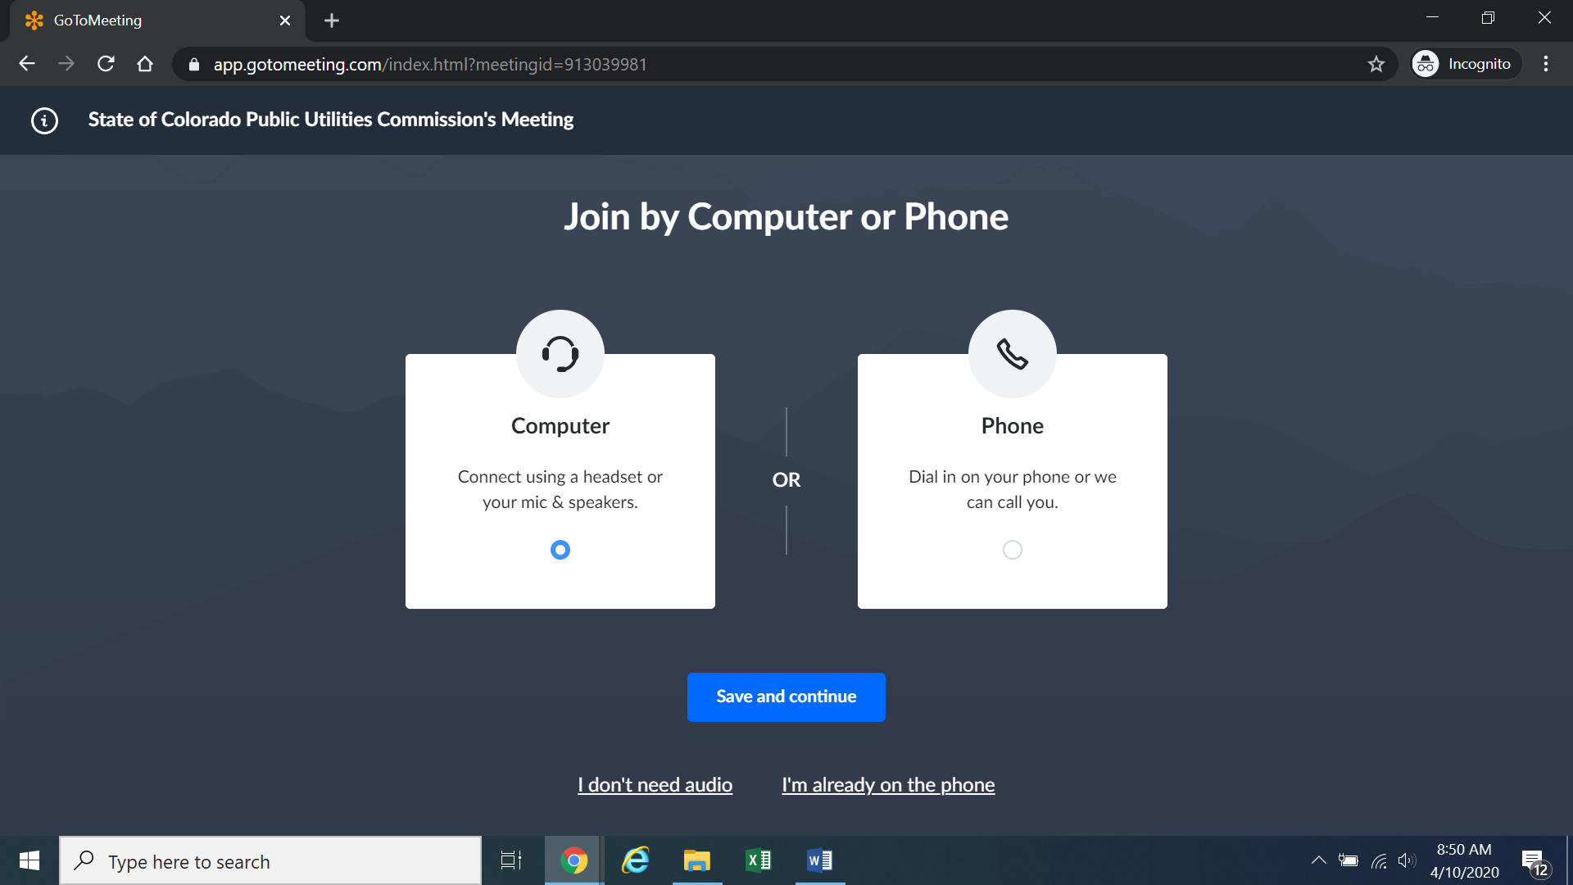
- Participants will then be required to confirm their audio settings; once complete, participants should select the “Save and continue” icon. If participants are prompted to allow the session to access their computers’ microphone and camera, they should allow access. As explained later, participants will be able to modify their settings during the session should they need to mute their microphone or turn off their cameras.

- Participants will be prompted to enter their name for identification during the session, as shown in the image below.
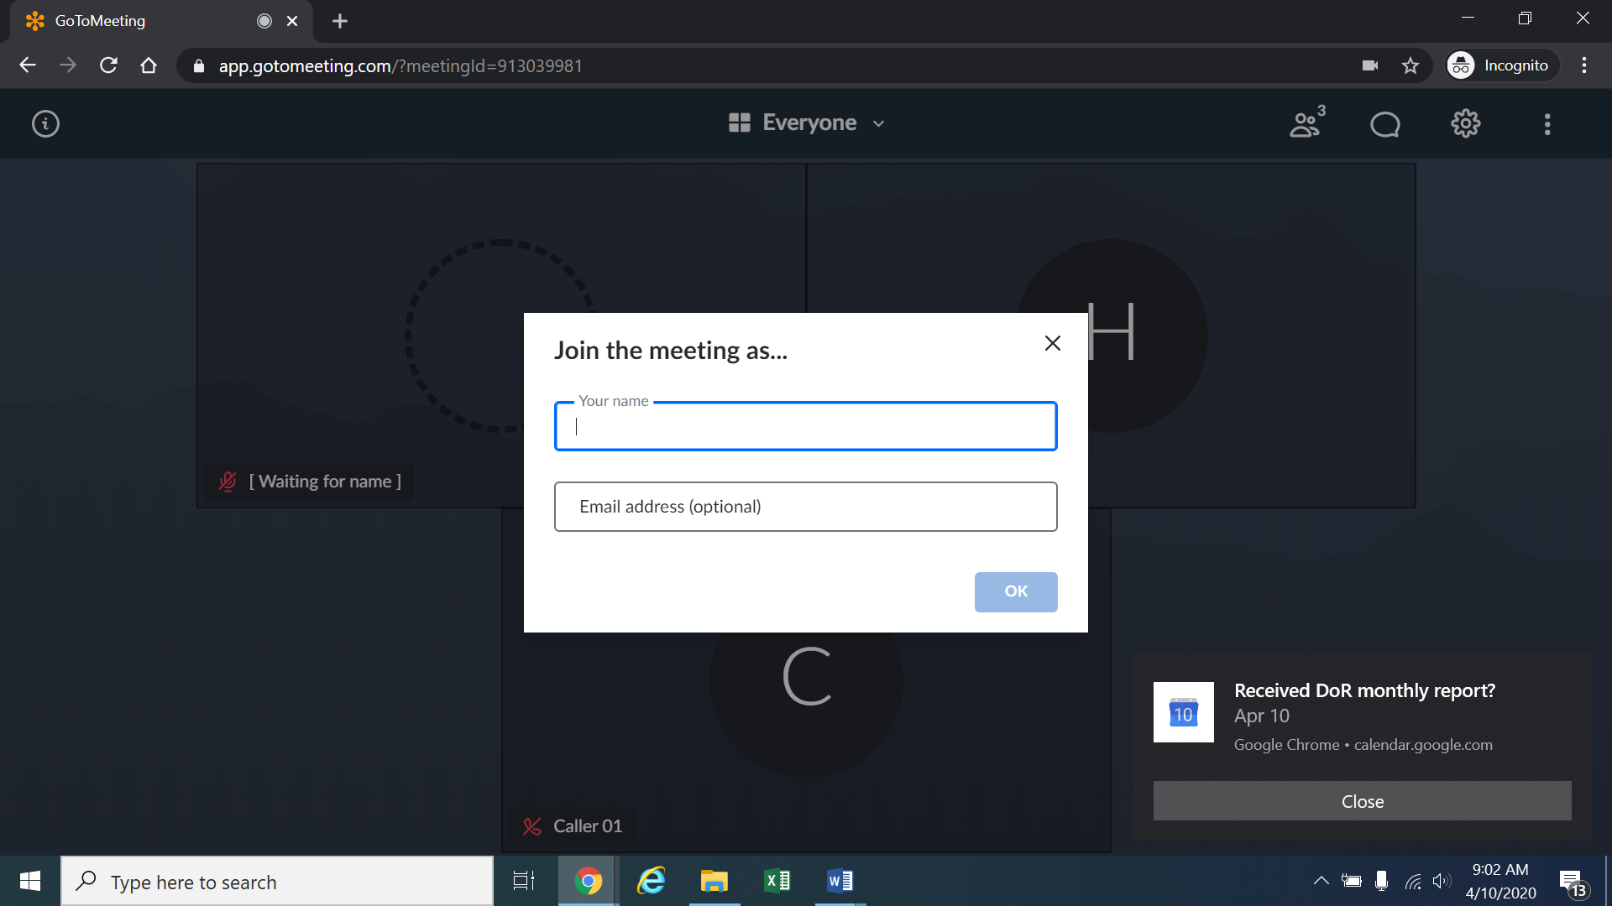
- All participants must enter their full name. Among other reasons, this is required for identification and because the presiding official may close the meeting to unauthorized or new participants once all parties have joined. If the meeting is closed, the ALJ will unlock the hearing when witnesses are called to testify so that they may join GoToMeeting only when needed to testify.
- Participants may control the audio volume using their computer’s audio controls. Those who do not want their picture displayed for others in the meeting may select the camera icon in the green circle at the bottom of the video screen at any point. A slash will appear over the camera icon, indicating that the camera has been turned off. Likewise, to mute or turn off the microphone, select the microphone icon and visually confirm that there is a slash over the microphone icon. Illustratively, the below image shows the microphone turned off and the camera turned on.
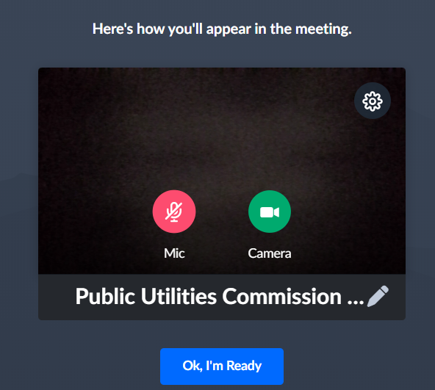
- Conversely, the below image shows the microphone and camera icons turned on and ready to transmit video and audio upon joining the hearing.
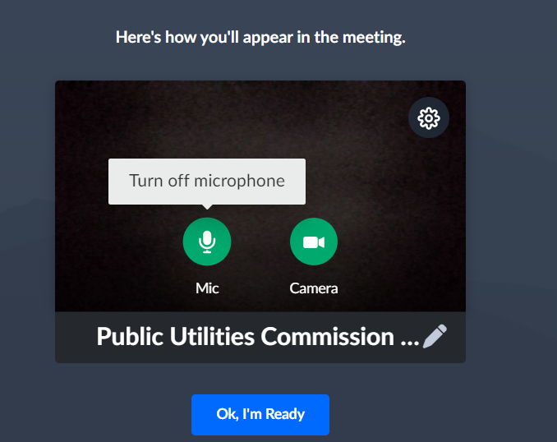
- A full and complete record and all testimony will be stenographically or electronically recorded. To facilitate this, participants must minimize feedback and background noise. First, all participants are required to mute their microphones during the hearing until called upon by the ALJ. Second, all participants must ensure that they are in a location with minimal or no background noise while participating in the hearing. Participants must avoid connecting to the hearing with multiple computers or devices located in the same room, as this will cause echos and audio feedback. Although not mandatory, participants are encouraged to participate using headphones connected to their computers, which may help reduce audio feedback.
- To terminate participation in the hearing, select the telephone handset icon with the word “Leave” underneath it and then select “Yes” in the pop-up box, as shown below. A party who inadvertently selects the handset icon may select “Not now” instead of “Yes” to stay in the meeting, as shown below.

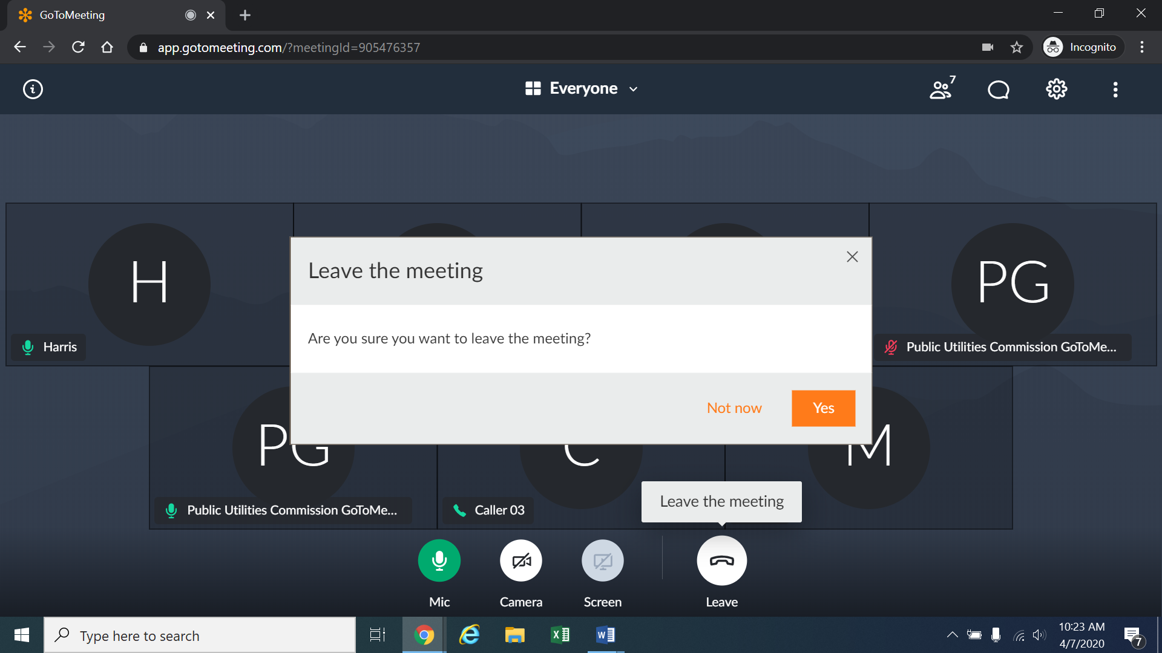
- Additional information and tutorials on using GoToMeeting are available at:
https://www.gotomeeting.com/meeting/resources/gotomeeting-quick-and-helpful-guide-for-attendees.

This link is provided for the parties’ convenience; the ALJ does not warrant that the information on the link is accurate or that it provides all the information participants may need to use GoToMeeting.
12. The ALJ or a legal specialist may informally email parties approximately one week before the hearing to participate in a test GoToMeeting session, to discuss how the hearing will work, including presenting exhibits. As such, the parties should be fully prepared to use GoToMeeting by that time.

These instructions are not directed at using a tablet or smartphone to participate in a GoToMeeting video-conference. Using a smartphone or tablet may limit a participant’s ability to view hearing exhibits during the hearing due to screen size. As such, participation by computer is encouraged. Participants who chose to use a smartphone or tablet are responsible for ensuring they are able to fully participate in the hearing.
Note, closing the meeting does not affect the availability of the webcast of the proceeding.

