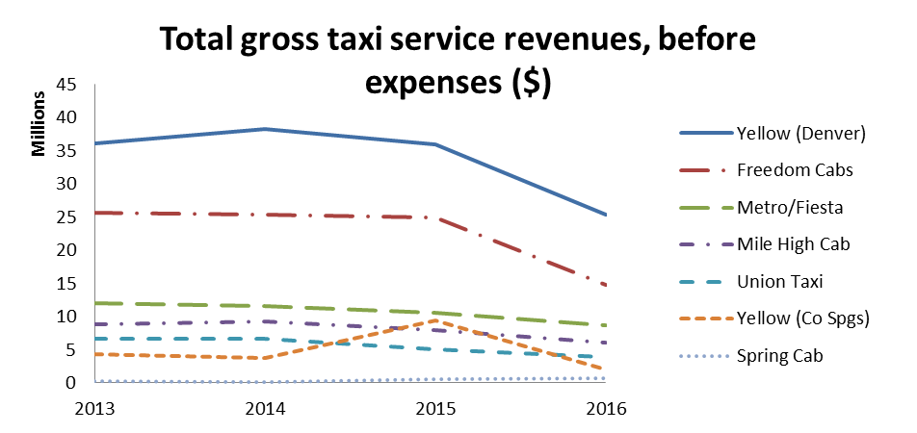

Figure 1. Taxi service revenues for companies operating in Denver metro area and El Paso County. Source: Source: annual reports filed with the Public Utilities Commission.

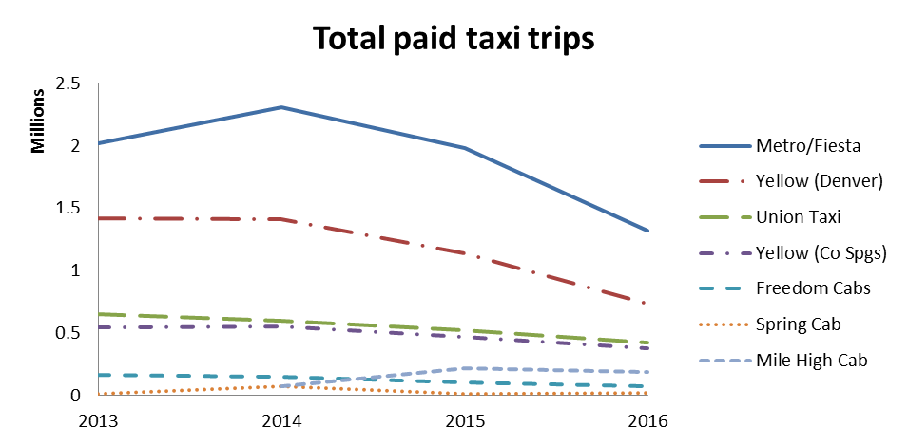
Figure 2. Taxi paid trips for companies operating in Denver metro area and El Paso County. Includes flat-rate trips to/from DIA. Source: annual reports filed with the Public Utilities Commission.

