Decision No. R03-1339-I
BEFORE THE PUBLIC UTILITIES COMMISSION OF THE STATE OF COLORADO
DOCKET NO. 03A-432CP
in the matter of the application of rocky mountain powder, inc., 4950 south yosemite, f-2, #118, greenwood village, colorado 80111 for a certificate of public convenience and necessity to operate as a common carrier by motor vehicle for hire.
interim order of
administrative law judge
dale e. isley
granting motion for expedited
re-notice of amended application
Mailed Date: November 28, 2003

statement
- On November 25, 2003, the Applicant, Rocky Mountain Powder, Inc. (RMPI), filed a Motion to Amend Application With Expedited Re-Notice (Motion) in the captioned proceeding.
- The Motion requests that the application be amended and that the notice period for the amended application be shortened to ten days. In support of the request to shorten the notice period, RMPI points out that subject amendment constitutes a very nominal change in the scope of the application as originally noticed.
- Good grounds having been shown, the Motion will be granted.

order

It Is Ordered That:
- The Motion to Amend Application With Expedited Re-Notice filed by Rocky Mountain Powder, Inc., is granted.
- The notice period for the amended application of Rocky Mountain Powder, Inc., shall be shortened to ten days.
- This Order shall be effective immediately.

THE PUBLIC UTILITIES COMMISSION
OF THE STATE OF COLORADO
DALE E. ISLEY
________________________________
Administrative Law Judge
(S E A L)

ATTEST: A TRUE COPY
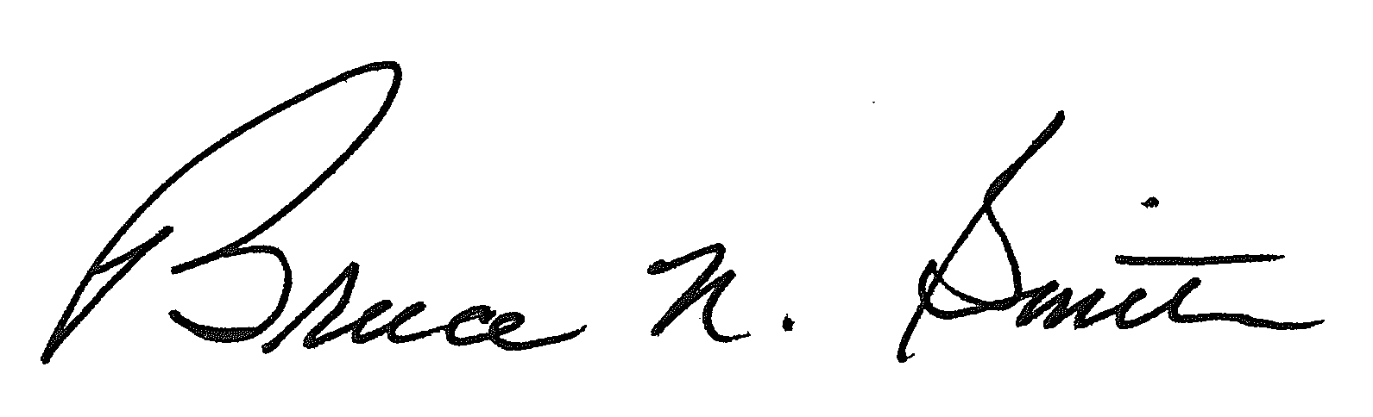
Bruce N. Smith
Director
/tmp/in/input.doc:srs

