Decision No. R03-1327-I
BEFORE THE PUBLIC UTILITIES COMMISSION OF THE STATE OF COLORADO
DOCKET NO. 03G-473CP
Colorado public utilities commission,
complainant,
v.
east west resort transportation, llc, doing business as
colorado mountain express and/or CME Premier and/or
premier vip transportation and/or resort express
a/k/a colorado mountain express, llc,
respondent.
INTERIM ORDER OF
ADMINISTRATIVE LAW JUDGE
MANA L. JENNINGS-FADER
vacating hearing
Mailed Date: November 26, 2003

statement
- On October 29, 2003, the Commission set the hearing in this matter for November 28, 2003, at 10:30 a.m. See Order Setting Hearing and Notice of Hearing.
- On November 26, 2003, Respondent East West Resort Transportation, LLC, doing business as Colorado Mountain Express and/or CME Premier and/or Premier VIP Transportation and/or Resort Express, also known as Colorado Mountain Express, LLC, and Staff of the Commission, the only parties in this docket, filed a Motion to Approve Stipulation of Settlement and Close Docket (Motion). A Stipulation of Settlement, which will resolve all issues if accepted by the Commission, is incorporated into the Motion.
- The hearing in this matter is scheduled for November 28, 2003. In view of the intervening Thanksgiving holiday, there is insufficient time to consider the Stipulation of Settlement before the scheduled hearing. A hearing in this matter will not be necessary if the Stipulation of Settlement is found to be acceptable. Accordingly, the undersigned Administrative Law Judge (ALJ) will vacate the scheduled hearing in this proceeding. If, upon review, the Stipulation of Settlement is found to be unacceptable, the ALJ will establish a new hearing date by subsequent order.

ORDER

It Is Ordered That:
- The hearing scheduled for November 28, 2003, is vacated.
- This Order is effective immediately.

THE PUBLIC UTILITIES COMMISSION
OF THE STATE OF COLORADO
MANA L. JENNINGS-FADER
________________________________
Administrative Law Judge
(S E A L)

ATTEST: A TRUE COPY
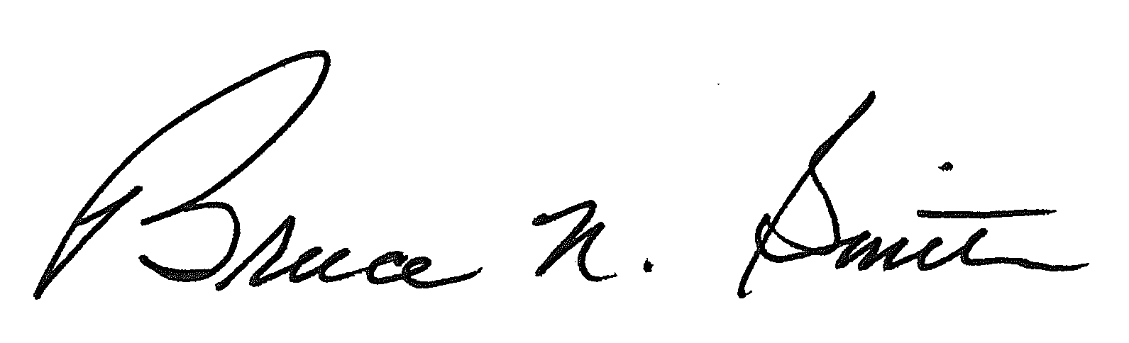
Bruce N. Smith
Director
/tmp/in/input.doc:srs

