Decision No. R03-1322-I
BEFORE THE PUBLIC UTILITIES COMMISSION OF THE STATE OF COLORADO
DOCKET NO. 03A-277T
in the matter of the application of south park telephone company for approval of its application for high cost support mechanism support.
interim order of
administrative law judge
MANA L. JENNINGS-FADER
granting motion, vacating
hearing date, rescheduling
hearing date, amending
procedural schedule, shortening
response time to prehearing
motions, and waiving response time
Mailed Date: November 25, 2003

statement
- On June 27, 2003, South Park Telephone Company (Applicant) filed its Application for Approval of its Application for HCSM Support and Motion for Waiver of Certain Commission Rules Pertaining to HCSM Support (4 CCR 723-41-18.6.1.3 and 723-27-Part 2) (Application). The Application commenced this proceeding.
- Staff of the Commission (Staff) and the Colorado Office of Consumer Counsel (OCC) filed timely interventions. There are no other intervenors.
- On September 22, 2003, by Decision No. R03-1078-I, the Administrative Law Judge (ALJ) established a procedural schedule and scheduled hearing dates of December 9 and 10, 2003, in this docket.
- In accordance with the established procedural schedule, Applicant has filed its direct testimony and exhibits; and Staff and OCC have filed their answer testimony and exhibits.
- On November 24, 2003, Applicant filed a Motion to Vacate Procedural Schedule and for Waiver of Response Time (Motion). In support of the Motion, Applicant states that it is a small rural telecommunications provider; that, due to press of business matters over the past month, its management personnel have not had the necessary time to devote to preparation of rebuttal testimony; and that, as a result, Applicant seeks additional time to prepare and to file its rebuttal testimony. Motion at ¶ 4. Importantly and in addition, Applicant states that it has been engaged in discussions with Staff in an effort to settle this matter. Id. Finally, Applicant states that no party objects to the granting of the Motion. Id. at ¶ 6.
- At present, the Commission should render a decision in this matter no later than March 12, 2004. See Decision No. R03-0971-I at ¶ 11. Recognizing that granting the Motion would affect adversely the Commission’s ability to render a decision by that date, Applicant states that it “will file its Waiver of Statutory Time Limit for Commission Decision under the provisions of Section 40-6-109.5, C.R.S.” Motion at ¶ 5.
- The Motion states good cause. No party will be prejudiced by the granting of this Motion. The Motion will be granted, subject to the following condition: Applicant must file, on or before December 5, 2003, its waiver of the provisions of § 40-6-109.5, C.R.S. If the waiver is not filed timely, the hearing dates of December 9 and 10, 2003, will be reinstated.
- It is necessary to establish new hearing dates and an amended procedural schedule. Applicant suggests that rebuttal testimony and exhibits be due on or before January 7, 2004, and that a hearing be scheduled during the last week of January or the first week of February, 2004. Id. Because Staff and OCC do not object to the granting of the Motion, the ALJ assumes that the proposed dates are available for, and are acceptable to, those parties.
- The hearing in this matter will be scheduled for January 27 and 28, 2004.
- The procedural schedule established in Decision No. R03-1078-I will be amended as follows: (a) Applicant shall file its rebuttal testimony and exhibits on or before January 7, 2004; (b) each Intervenor shall file its cross-answer testimony and exhibits on or before January 7, 2004; (c) each party shall file its corrected testimony and exhibits on or before January 12, 2004; (d) each party shall file its prehearing motions on or before January 14, 2004; (e) parties shall file any stipulation and settlement agreement on or before January 20, 2004; (f) responses to prehearing motions shall be filed on or before noon, January 26, 2004; (g) hearing in this matter shall be held on January 27 and 28, 2004; and (h) parties shall file their post-hearing statements of position on or before February 13, 2004. Absent further order, no response to statements of position will be permitted.
- After it is filed with the Commission, a response to a prehearing motion shall be hand-delivered by the filing party to the ALJ. This requirement does not reduce the number of copies which must be filed with the Commission.
- For discovery propounded with respect to rebuttal testimony and exhibits and propounded with respect to cross-answer testimony and exhibits, the provisions of Rule 4 Code of Colorado Regulations 723-1-77 shall govern, except that service shall be by electronic means (with paper copy to follow) or by in-hand delivery to counsel for the responding party. Should a party desire modification of this requirement, that party may file an appropriate motion.
- For discovery propounded with respect to corrected testimony and exhibits, the following requirements govern: (a) discovery shall be served electronically (with paper copy to follow) or in-hand delivery to counsel for the responding party; and (b) response shall be due and served electronically (with paper copy to follow) or in-hand delivery to counsel for requesting party not later than five calendar days after service of the request. This paragraph applies only to discovery addressed to corrected testimony and exhibits.
- The provisions of Decision No. R03-1078-I which are not modified by this Order remain in effect. Parties shall comply with those requirements and provisions.
- No party objects to the granting of the Motion. Thus, the Motion to Waive Response Time will be granted; and response time to the Motion will be waived.

ORDER

It Is Ordered That:
- Motion to Vacate Procedural Schedule is granted.
- South Park Telephone Company shall file, on or before December 5, 2003, a waiver of the provisions of § 40-6-109.5, C.R.S. If the waiver is not filed timely, the hearing dates of December 9 and 10, 2003, will be reinstated.
- The modified procedural schedule set out above in this Order is adopted.
- Hearing shall be conducted in this matter at the following dates, time, and place:
DATES: January 27 and 28, 2004
TIME: 9:00 a.m.
PLACE: Commission Hearing Room
1580 Logan Street, OL-2
Denver, Colorado
- The parties shall follow the procedures and shall make the filings set forth above.
- The Motion for Waiver of Response Time is granted.
- Response time to the Motion to Vacate Procedural Schedule and for Waiver of Response Time is waived.
- The provisions of Decision No. R03-1078-I not modified by this Order remain in effect. Parties shall abide by those provisions and requirements.
- This Order shall be effective immediately.

THE PUBLIC UTILITIES COMMISSION
OF THE STATE OF COLORADO
MANA L. JENNINGS-FADER
________________________________
Administrative Law Judge
(S E A L)

ATTEST: A TRUE COPY
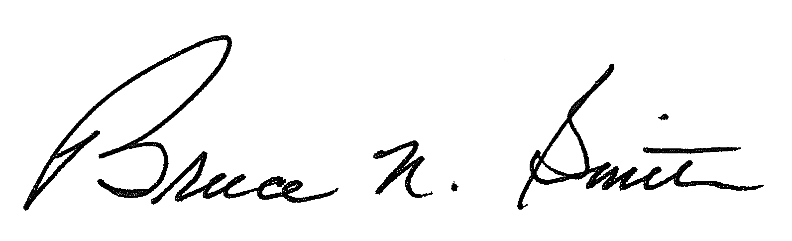
Bruce N. Smith
Director
/tmp/in/input.doc:srs

Cross-answer testimony and exhibits can address, and respond to, only answer testimony and exhibits.
This date does not apply to motions to compel response to discovery or to motions to compel response to audit. Parties should file those motions as the need arises. The ALJ will consider a motion to compel on an expedited basis.
This requirement applies both to all-party settlements and to partial settlements (i.e., those reached among some, but not all, of the parties and/or those addressing some, but not all, of the issues).
This is a shortened response time.

