Decision No. R03-1321-I
BEFORE THE PUBLIC UTILITIES COMMISSION OF THE STATE OF COLORADO
DOCKET NO. 03A-382CP
In the Matter of the Application for authority to transfer a portion of Certificate of Public Convenience and Necessity (CPCN) PUC No. 7010&I, from The Mountain Men, Inc., dba Best Mountain Tours, 3003 South Macon Circle, Aurora, Colorado 80014, to Argo Enterprises, L.L.C., 302 Soda Ash Road, Idaho Springs, Colorado 80452.
interim order of
administrative law judge
ken f. kirkpatrick
accepting verified statement in
lieu of terminating annual report
Mailed Date: November 25, 2003

statement
- On November 14, 2003, Applicant Transferor The Mountain Men, Inc., and Jon Nicholls Trustee, its Trustee in Bankruptcy filed their Transferor’s Motion to Provide Verified Statement in Lieu of Terminating Annual Report. By this motion the movants state that the above captioned transfer application has been granted under Decision No. C03-1177. One compliance requirement of the order is for the Applicant Transferor to file with the Commission a terminating annual report. The motion notes there is nothing to report for the year 2003, as the Applicant Transferor has been in continuous suspension approved by the Commission since September 30, 2002 and has already filed its annual report for 2002. Further, Applicant Transferor has been in Chapter 7 Bankruptcy since October 2002.
- Applicant Transferor seeks to have an attached verified statement of the bankruptcy trustee accepted in lieu of the normal required terminating annual report. Applicant Transferor suggests that the statement is more informative than literal compliance with the Order, which would be a report full of zeros.
- The undersigned Administrative Law Judge agrees with the Applicant Transferor that good cause exists for accepting the verified statement in lieu of the terminating annual report. Ordering paragraph no. 6 of Decision No. C03-1177 is hereby modified to that effect.

ORDER

It Is Ordered That:
- The Motion to Provide Verified Statement in Lieu of Terminating Annual Report filed November 14, 2003 by The Mountain Men, Inc., and Jon Nicholls, Trustee, its Trustee in Bankruptcy, is granted. The verified statement attached to the motion is accepted in lieu of the terminating annual report required by Ordering Paragraph No. 6 of Decision No. C03-1177. To the extent necessary, Ordering Paragraph No. 6 of Decision No. C03-1177 is modified to accept a verified statement.
- This Order shall be effective immediately.

THE PUBLIC UTILITIES COMMISSION
OF THE STATE OF COLORADO
KEN F. KIRKPATRICK
________________________________
Administrative Law Judge
(S E A L)

ATTEST: A TRUE COPY
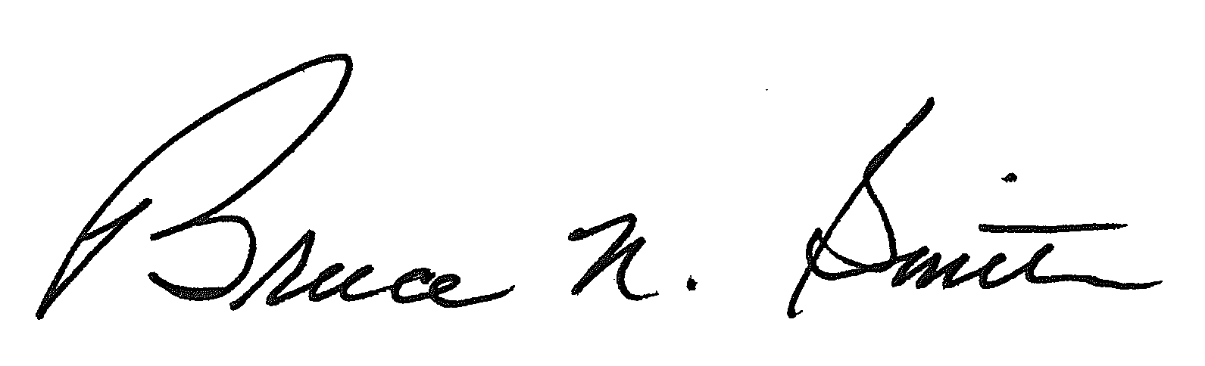
Bruce N. Smith
Director
/tmp/in/input.doc:srs

