Decision No. R03-1319
BEFORE THE PUBLIC UTILITIES COMMISSION OF THE STATE OF COLORADO
DOCKET NO. 03F-390CP
golden west commuter, llc,

complainant,

v.

benjamin r. sagenkahn, doing business as peak transit,

respondent.
recommended decision of
administrative law judge
dale e. isley
denying motion for summary
relief and dismissing
Complaint, as moot
Mailed Date: November 25, 2003

statement, findings, and conclusions
- The captioned proceeding was commenced on September 5, 2003, when the Complainant, Golden West Commuter, LLC (Golden West), filed a Complaint with the Colorado Public Utilities Commission (Commission) against the Respondent, Benjamin R. Sagenkahn, doing business as Peak Transit (Peak).
- On September 9, 2003, the Commission issued its Order to Satisfy or Answer. The Commission served Peak with the Order to Satisfy or Answer, along with a copy of the Golden West Complaint (Complaint), on the same day.
- The hearing of this matter was originally scheduled for October 28, 2003, but was subsequently re-scheduled to November 6, 2003. See, Decision No. R03-1102-I.
- On September 26, 2003, Peak filed a Motion to Dismiss the Complaint (Motion to Dismiss). The Motion to Dismiss was denied on October 7, 2003. See, Decision No. R03-1138-I.
- On October 17, 2003, Peak filed its Answer to the Complaint.
- On October 28, 2003, Golden West filed a Motion for Summary Relief and Motion for Shortened Response Time. The Motion for Shortened Response Time was denied and Peak was granted until November 12, 2003, to submit a response to the Motion for Summary Relief. See, Decision No. R03-1229-I. That Decision also vacated the November 7, 2003, hearing date. Peak did not file a response to the Motion for Summary Relief.
- The Complaint was filed for the purpose of making permanent the findings contained in Decision No. R03-0973 issued in Docket No. 03A-199CP-Transfer. That Decision approved the transfer of Certificate of Public Convenience and Necessity (CPCN) PUC No. 55275 from Peak to Denver Mountain Carrier, Inc., doing business as Denver Mountain Express (DME). The transfer was, however, conditioned on the cancellation of certain portions of CPCN PUC No. 55275 that were found to be dormant. The Complaint seeks, among other remedies, the cancellation or revocation of those dormant portions of CPCN PUC No. 55275 in the event Peak and/or DME do not accept this condition by failing to consummate the subject transfer. As indicated therein, the Complaint becomes moot if Peak and DME consummate the transaction in accordance with the cancellation condition imposed by Decision No. R03-0973. See, Complaint at page 2.
- Exceptions were not taken to Decision No. R03-0973 and, as a result, it became effective on September 16, 2003. It imposed certain compliance filing requirements on both Peak and DME to be completed within 60-days; i.e., on or before November 17, 2003. One such requirement is the execution and filing of a Notice of Acceptance wherein Peak and DME certify that CPCN PUC No. 55275 has been formally transferred to DME in full accordance with and subject to all the conditions, provisions, and limitations imposed by Decision No. R03-0973. A review of the Commission’s records reveal that all such compliances have been timely made. The Commission is now in the process of issuing DME a CPCN setting forth the non-dormant portions of CPCN PUC No. 55275 transferred to it by Peak.
- By virtue of the foregoing, both the Motion for Summary Relief and the Complaint are now moot. Accordingly, the Motion for Summary Relief will be denied and the Complaint will be dismissed.
- Pursuant to § 40-6-109, C.R.S., it is recommended that the Commission enter the following order.

order

The Commission Orders That:
- The Motion for Summary Relief filed in this matter by Complainant, Golden West Commuter, LLC, is denied as moot.
- The Complaint filed in this matter by Complainant, Golden West Commuter, LLC, is dismissed as moot.
- Docket No. 03F-390CP is closed.
- This Recommended Decision shall be effective on the day it becomes the Decision of the Commission, if that is the case, and is entered as of the date above.
- As provided by § 40-6-109, C.R.S., copies of this Recommended Decision shall be served upon the parties, who may file exceptions to it.
a) If no exceptions are filed within 20 days after service or within any extended period of time authorized, or unless the decision is stayed by the Commission upon its own motion, the recommended decision shall become the decision of the Commission and subject to the provisions of § 40-6-114, C.R.S.
b) If a party seeks to amend, modify, annul, or reverse basic findings of fact in its exceptions, that party must request and pay for a transcript to be filed, or the parties may stipulate to portions of the transcript according to the procedure stated in § 40-6-113, C.R.S. If no transcript or stipulation is filed, the Commission is bound by the facts set out by the administrative law judge and the parties cannot challenge these facts. This will limit what the Commission can review if exceptions are filed.
- If exceptions to this Decision are filed, they shall not exceed 30 pages in length, unless the Commission for good cause shown permits this limit to be exceeded.

THE PUBLIC UTILITIES COMMISSION
OF THE STATE OF COLORADO
DALE E. ISLEY
________________________________
Administrative Law Judge
(S E A L)

ATTEST: A TRUE COPY
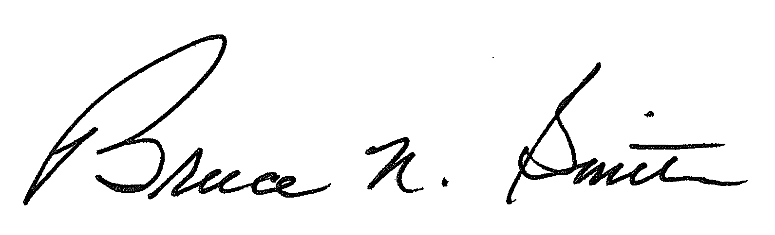
Bruce N. Smith
Director
/tmp/in/input.doc:srs

The Notice of Acceptance signed by Peak and DME was filed on November 4, 2003.

