Decision No. R03-1316-I
BEFORE THE PUBLIC UTILITIES COMMISSION OF THE STATE OF COLORADO
DOCKET NO. 03A-095T
in the matter of the application of ntch-colorado, inc., doing business as clear talk, for designation as an eligible telecommunications carrier.
interim order of
administrative law judge
MANA L. JENNINGS-FADER
vacating hearing, rescheduling
hearing, and requiring filing
Mailed Date: November 24, 2003

statement
- On March 12, 2003, NTCH-Colorado, Inc., doing business as Clear Talk (Applicant), filed its Application for Designation as an Eligible Telecommunications Carrier. Applicant has waived the requirements of § 40-6-109.5, C.R.S.
- On June 13, 2003, by Decision No. R03-0666-I, the undersigned Administrative Law Judge (ALJ) established a procedural schedule and hearing date in this proceeding. The hearing date and procedural schedule were vacated by Decision No. R03-0871-I.
- Applicant filed direct testimony and exhibits and rebuttal testimony and exhibits. Staff of the Commission filed answer testimony and exhibits and cross-answer testimony and exhibits. The Colorado Telecommunications Association, Inc., filed answer testimony and exhibits and filed cross-answer testimony and exhibits (which consisted of a reservation of right to file cross-answer testimony at a later time). The Colorado Office of Consumer Counsel filed answer testimony and exhibits and did not file cross-answer testimony.
- On November 24, 2003, pursuant to Decision No. R03-0997-I, the ALJ held a final prehearing conference in this proceeding. All parties were present, were represented, and participated in the prehearing conference.
- At the prehearing conference, Applicant stated that the parties were engaged in settlement discussions which looked to be promising and that, as a result, the parties desired to vacate the hearing scheduled for December 3 and 4, 2003; to file a stipulation and settlement agreement on or before December 5, 2003; and to schedule a hearing on the stipulation and settlement agreement. All parties concurred in Applicant’s statements.
- Based on the representations, the ALJ will vacate the hearing scheduled for December 3 and 4, 2003, and will schedule a December 16, 2003, hearing on the to-be-filed stipulation and settlement agreement.
- The ALJ will order the parties to file, on or before December 5, 2003, a stipulation and settlement agreement.
- Should it develop that the parties are unable to reach an agreement, Applicant shall file, on or before December 5, 2003, a statement to that effect. The filing shall include a list of three proposed hearing dates which are acceptable to all parties. If possible, the ALJ will select a date based on this filing.

order

It Is Ordered That:
- The hearing scheduled for December 3 and 4, 2003, is vacated.
- On or before December 5, 2003, the parties shall file a stipulation and settlement agreement.
- If the parties are unable to reach agreement, Applicant NTCH-Colorado, Inc., doing business as Clear Talk shall make, on or before December 5, 2003, a filing which complies with ¶ I.8, supra.
- This Order shall be effective immediately.

THE PUBLIC UTILITIES COMMISSION
OF THE STATE OF COLORADO
MANA L. JENNINGS-FADER
________________________________
Administrative Law Judge
(S E A L)

ATTEST: A TRUE COPY
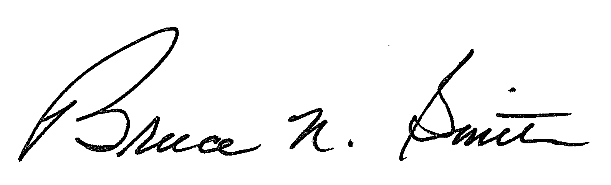
Bruce N. Smith
Director
/tmp/in/input.doc:srs

