Decision No. R03-1314-I
BEFORE THE PUBLIC UTILITIES COMMISSION OF THE STATE OF COLORADO
DOCKET NO. 03A-272G
in the matter of THE application of Aquila, Inc., doing business as aquila networks-Png, for an order authorizing the creation of a mechanism to allow sharing of capacity release credits and asset optimization margins.
interim order of
administrative law judge
dale e. isley
granting motion to continue
hearing and establishing
revised procedural schedule
Mailed Date: November 24, 2003

statement
- On November 19, 2003, Aquila, Inc., doing business as Aquila Networks-PNG (Aquila), filed an Unopposed Motion to Continue the Hearing Date and Procedural Schedule (Motion to Continue) and for Waiver of Response Time (Motion for Waiver) in the captioned proceeding.
- The Motion to Continue requests that the hearing dates and procedural schedule established by Decision No. R03-1181-I be vacated and that new hearing dates and a new procedural schedule be established. As grounds for that request, Aquila states that the parties have reached an agreement in principle settling all disputed issues in this docket but that they need additional time to finalize and memorialize the same. They indicate that a written settlement agreement may be filed by mid-December of this year.
- The Motion to Continue indicates that neither the Staff of the Commission nor the Colorado Office of Consumer Counsel object to the relief requested therein. It states that Aquila has previously waived the statutory deadlines established by § 40-6-109.5(1), C.R.S., for the issuance of a Commission decision in this matter. The Motion for Waiver requests that response time to the Motion to Continue be waived since no party objects to the same.
- Good grounds having been shown, the Motion to Continue will be granted consistent with the provisions of the Order that follows. The currently scheduled January 8, 2004, hearing date established by Decision No. R03-1181-I will be retained in the event a hearing is required in connection with any settlement agreement filed. The parties will be required to file any desired settlement agreement on or before December 29, 2003.
- Since all parties have agreed that the current procedural schedule should be vacated, no party will be prejudiced thereby. As a result, the Motion for Waiver will be granted.

order

It Is Ordered That:
- The Unopposed Motion to Continue the Hearing Date and Procedural Schedule filed by Aquila, Inc., doing business as Aquila Networks-PNG, is granted, consistent with the terms of this Order.
- The parties shall file any desired settlement agreement on or before December 29, 2003.
- The January 8, 2004, hearing date previously established in this matter by Decision No. R03-1181-I will be retained in the event a hearing is required in connection with any settlement agreement filed by the parties prior to that time.
- The January 9, 2004, hearing date and procedural schedule previously established in this matter by Decision No. R03-1181-I is vacated.
- The hearing of this matter is re-scheduled as follows:
DATES: February 18 and 20, 2004
TIME: 9:00 a.m.
PLACE: Commission Hearing Room
1580 Logan Street, OL2
Denver, Colorado
- The Staff of the Colorado Public Utilities Commission and the Colorado Office of Consumer Counsel shall file their answer testimony and exhibits, in question and answer form, on or before December 22, 2003.
- Any desired rebuttal or cross-answer testimony and exhibits shall be filed, in question and answer form, on or before January 12, 2003.
- To the extent possible, all answer testimony/exhibits, rebuttal testimony/exhibits, and cross-answer testimony/exhibits shall be served on all parties electronically on the same date they are filed with the Commission. If that is not possible, all such testimony/exhibits shall be served on all parties via overnight delivery for receipt on the next business day.
- To the extent possible, all discovery or audit requests and responses thereto (including attachments) shall be served electronically. If that is not possible, all such discovery/audit requests and responses thereto shall be served via overnight delivery for receipt on the next business day. Discovery requests served after noon on any Friday shall be deemed served as of the next business day. Responses to all written discovery or audit questions directed to rebuttal testimony/exhibits and cross-answer testimony/exhibits shall be served within seven calendar days of service of the discovery/audit requests to which they are directed. In all other respects, discovery shall be governed by Rules 77(a) and (b) of the Commission’s Rules of Practice and Procedure, 4 Code of Colorado Regulations 723-1-77(a) and (b).
- Any desired post-hearing Statements of Position shall be filed on or before March 12, 2004.
- This Order shall be effective immediately.

THE PUBLIC UTILITIES COMMISSION
OF THE STATE OF COLORADO
DALE E. ISLEY
________________________________
Administrative Law Judge
(S E A L)

ATTEST: A TRUE COPY
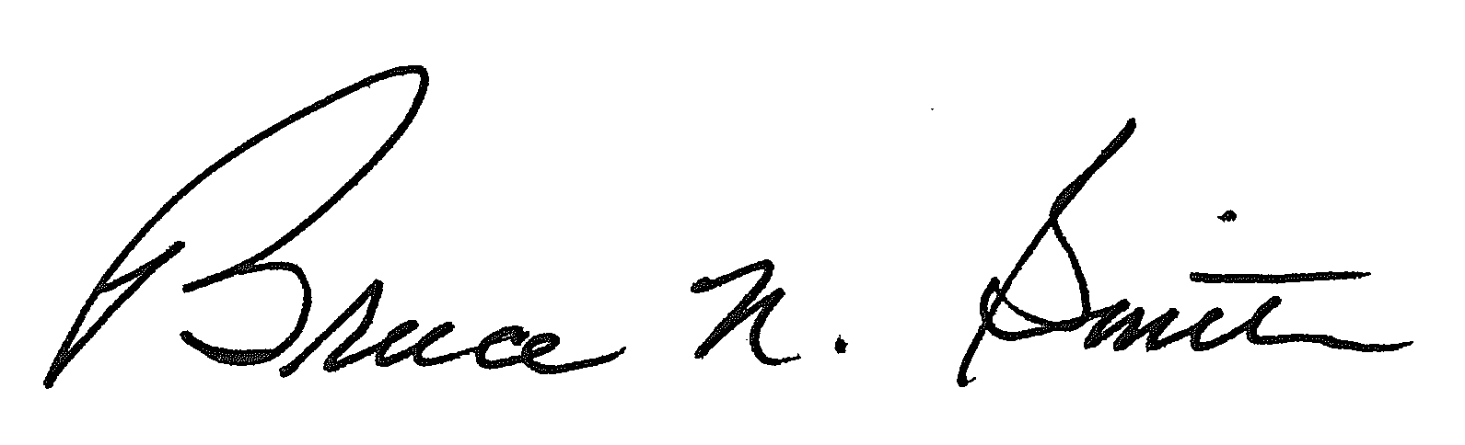
Bruce N. Smith
Director
/tmp/in/input.doc:srs

