Decision No. R03-1305-I
BEFORE THE PUBLIC UTILITIES COMMISSION OF THE STATE OF COLORADO
DOCKET NO. 03S-314T
in the matter of the investigation and suspension of tariff sheets filed by pine drive telephone company with advice letter no. 70.
interim order of
administrative Law Judge
william j. fritzel
granting motion to vacate
procedural schedule,
vacating hearing date, and
waiving response time
Mailed Date: November 20, 2003

statement
- On November 19, 2003, Pine Drive Telephone Company (Pine Drive) filed a Motion to Vacate the Procedural Schedule and Hearing Date of November 20, 2003. Pine Drive also requests a waiver of response time to the motion.
- Pine Drive states that it and Staff of the Commission (Staff) and the Colorado Office of Consumer Counsel (OCC) have reached a tentative settlement of all issues in the docket and the parties are now preparing and reviewing a draft Stipulation and Settlement Agreement.
- Both Staff and OCC support the motion.
- Good cause having been shown, the Motion to Vacate Procedural Schedule and to Vacate Hearing Date will be granted.

ORDER

It Is Ordered That:
- The Motion to Vacate Procedural Schedule filed by Pine Drive Telephone Company on November 19, 2003 is granted.
- The hearing of this matter scheduled for September 20, 2003 is vacated.
- Pine Drive Telephone Company, Staff of the Colorado Public Utilities Commission, and the Colorado Office of Consumer Counsel shall on or before December 5, 2003 file with the Commission a Stipulation and Settlement Agreement or a Status Report.
- Response time to the motion is waived.
- This Order is effective immediately.

THE PUBLIC UTILITIES COMMISSION
OF THE STATE OF COLORADO
WILLIAM J. FRITZEL
________________________________
Administrative Law Judge
(S E A L)

ATTEST: A TRUE COPY
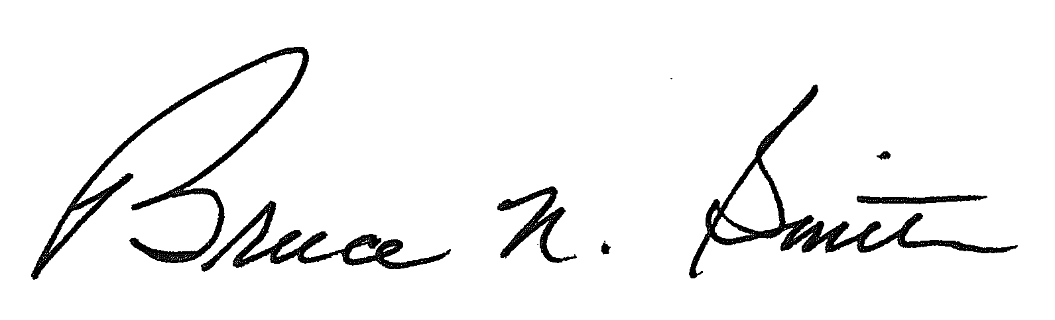
Bruce N. Smith
Director
/tmp/in/input.doc:srs

