Decision No. R03-1284
BEFORE THE PUBLIC UTILITIES COMMISSION OF THE STATE OF COLORADO
DOCKET NO. 03F-419E
JEAN A. SAIZ,

Complainant,

v.

PUBLIC SERVICE COMPANY OF COLORADO,

Respondent.
recommended decision of
administrative law judge
ken f. kirkpatrick
dismissing complaint
Mailed Date: November 14, 2003

statement
- On November 13, 2003, Complainant Jean A. Saiz filed a Withdrawal of Complaint. She states that the matter has been satisfactorily resolved and thereby seeks to have the complaint withdrawn.
- There being nothing further the matter should be dismissed.
- In accordance with § 40-6-109, C.R.S., it is recommended that the Commission enter the following order.

ORDER

The Commission Orders That:
- Docket No. 03F-419E being a complaint of Jean A. Saiz against Public Service Company of Colorado is dismissed. The hearing in this matter scheduled for November 17, 2003 is vacated.
- This Recommended Decision shall be effective on the day it becomes the Decision of the Commission, if that is the case, and is entered as of the date above.
- As provided by § 40-6-109, C.R.S., copies of this Recommended Decision shall be served upon the parties, who may file exceptions to it.
- If no exceptions are filed within 20 days after service or within any extended period of time authorized, or unless the decision is stayed by the Commission upon its own motion, the recommended decision shall become the decision of the Commission and subject to the provisions of § 40-6-114, C.R.S.
- If a party seeks to amend, modify, annul, or reverse basic findings of fact in its exceptions, that party must request and pay for a transcript to be filed, or the parties may stipulate to portions of the transcript according to the procedure stated in § 40-6-113, C.R.S. If no transcript or stipulation is filed, the Commission is bound by the facts set out by the administrative law judge and the parties cannot challenge these facts. This will limit what the Commission can review if exceptions are filed.
- If exceptions to this Decision are filed, they shall not exceed 30 pages in length, unless the Commission for good cause shown permits this limit to be exceeded.

THE PUBLIC UTILITIES COMMISSION
OF THE STATE OF COLORADO
KEN F. KIRKPATRICK
________________________________
Administrative Law Judge
(S E A L)

ATTEST: A TRUE COPY
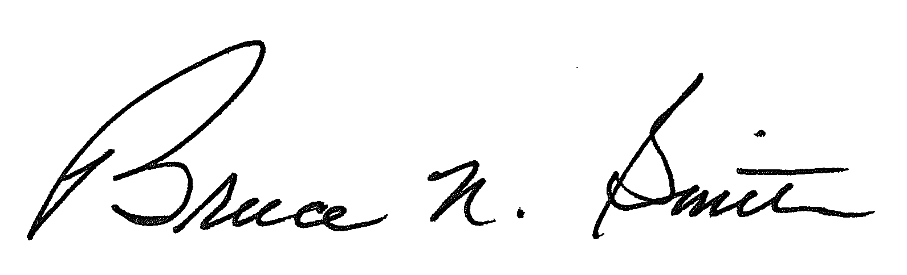
Bruce N. Smith
Director
/tmp/in/input.doc:srs

