Decision No. R03-1283-I
BEFORE THE PUBLIC UTILITIES COMMISSION OF THE STATE OF COLORADO
DOCKET NO. 03S-321T
RE: THE INVESTIGATION AND SUSPENSION OF TARIFF SHEETS FILED BY QWEST CORPORATION FILED WITH ADVICE LETTER NO. 2961.
interim order of
administrative law judge
ken f. kirkpatrick
modifying procedural schedule
Mailed Date: November 14, 2003

statement
- On November 10, 2003, Qwest Corporation, Home Builders Association of Metro Denver, Red Creek Ranches, Pueblo Association of Home Builders, Housing and Building Association of Colorado Springs, and the Colorado Association of Home Builders filed their Motion to Accept Stipulation and Modify Procedural Schedule. As part of this motion, the movants seek to have the procedural schedule modified to accommodate the Stipulation among the movants and to allow for answer testimony by the Staff of the Commission. Good cause having been shown the revised procedural schedule will be adopted and it is set forth in the order below.

ORDER

It Is Ordered That:
- The procedural schedule in this proceeding is modified as follows. Staff of the Commission will submit its answer testimony no later than November 10, 2003. The Stipulation submitted will be accepted in lieu of the developers’ answer testimony; Qwest Corporation and the developers will file rebuttal and cross-testimony in support of the Stipulation and rebutting Staff of the Commission’s answer testimony no later than November 24, 2003. Staff of the Commission will file its cross-answer testimony addressing the Stipulation on November 24, 2003. The hearing will proceed on December 11, 2003 as currently scheduled.
- This Order shall be effective immediately.

THE PUBLIC UTILITIES COMMISSION
OF THE STATE OF COLORADO
KEN F. KIRKPATRICK
________________________________
Administrative Law Judge
(S E A L)

ATTEST: A TRUE COPY
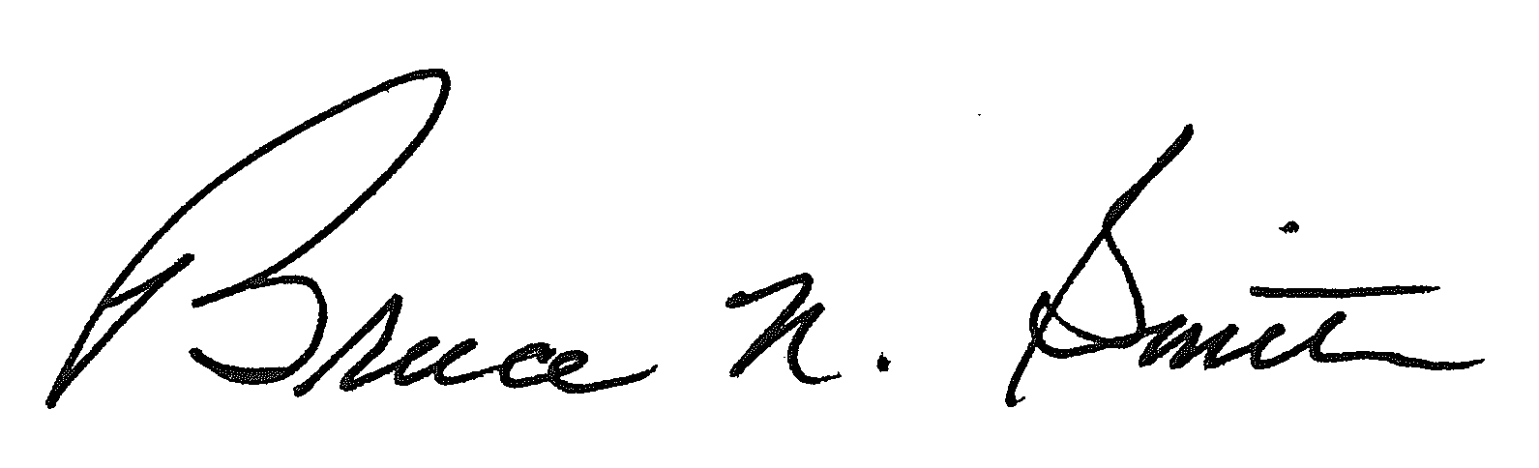
Bruce N. Smith
Director
/tmp/in/input.doc:srs

