Decision No. R03-1282
BEFORE THE PUBLIC UTILITIES COMMISSION OF THE STATE OF COLORADO
DOCKET NO. 03F-420E
rudolph and brinder bradberry,

complainants,

v.

aquila networks—wpc, f/k/a westplains energy,

respondent.
recommended decision of
administrative law judge
dale e. isley
dismissing Complaint
Mailed Date: November 13, 2003

statement, findings, and conclusions
- This proceeding was initiated on September 30, 2003, when Complainants, Rudolph and Brinder Bradberry (Bradberrys), filed a Complaint with the Colorado Public Utilities Commission (Commission) against the Respondent, Aquila Networks—WPC (Aquila).
- On October 2, 2003, the Commission issued its Order to Satisfy or Answer and served a copy of the same on Aquila. On that same day, it issued an Order setting this matter for hearing at the Commission’s office in Denver, Colorado, on November 18, 2003.
- On October 21, 2003, Aquila filed a Motion to Dismiss “Complaint” (Motion to Dismiss). On October 29, 2003, the Bradberrys filed a response to the Motion to Dismiss. On that same date they also requested that the location of the November 18, 2003, hearing be changed to Westcliffe, Colorado.
- On November 3, 2003, the Motion to Dismiss was granted, in part, and denied, in part, and the request to change the location of the hearing was granted. In addition, Aquila was ordered to file its Answer to the Complaint on or before November 10, 2003. See, Decision No. R03-1237-I.
- On November 12, 2003, the parties submitted a Stipulation for Dismissal (Stipulation) in this matter. The Stipulation indicates that the parties have reached a settlement that resolves all issues encompassed by this proceeding. They request that this matter be dismissed, with prejudice.
- Pursuant to § 40-6-109, C.R.S., it is recommended that the Commission enter the following order.

order

The Commission Orders That:
- The request of Complainants, Rudolph and Brinder Bradberry, and Respondent, Aquila Networks—WPC, to dismiss the captioned proceeding, with prejudice, is granted.
- The hearing of this matter, currently scheduled for November 18, 2003, is vacated.
- Docket No. 03F-420E is closed.
- This Recommended Decision shall be effective on the day it becomes the Decision of the Commission, if that is the case, and is entered as of the date above.
- As provided by § 40-6-109, C.R.S., copies of this Recommended Decision shall be served upon the parties, who may file exceptions to it.
- If no exceptions are filed within 20 days after service or within any extended period of time authorized, or unless the decision is stayed by the Commission upon its own motion, the recommended decision shall become the decision of the Commission and subject to the provisions of § 40-6-114, C.R.S.
- If a party seeks to amend, modify, annul, or reverse basic findings of fact in its exceptions, that party must request and pay for a transcript to be filed, or the parties may stipulate to portions of the transcript according to the procedure stated in § 40-6-113, C.R.S. If no transcript or stipulation is filed, the Commission is bound by the facts set out by the administrative law judge and the parties cannot challenge these facts. This will limit what the Commission can review if exceptions are filed.
- If exceptions to this Decision are filed, they shall not exceed 30 pages in length, unless the Commission for good cause shown permits this limit to be exceeded.

THE PUBLIC UTILITIES COMMISSION
OF THE STATE OF COLORADO
DALE E. ISLEY
________________________________
Administrative Law Judge
(S E A L)

ATTEST: A TRUE COPY
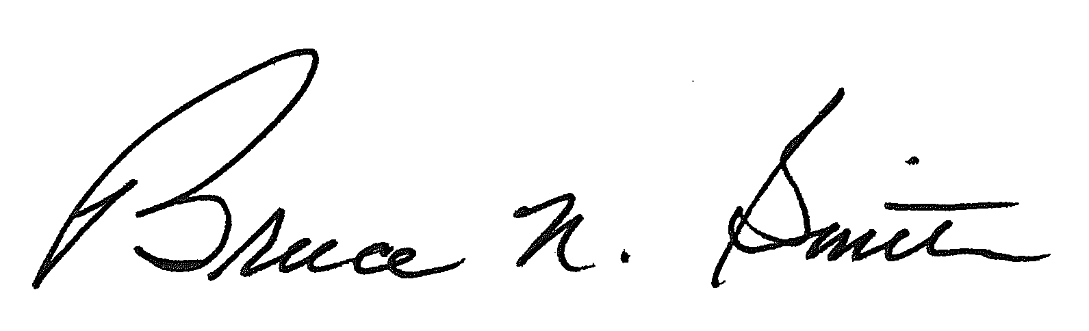
Bruce N. Smith
Director
/tmp/in/input.doc:srs

