Decision No. R03-1281-I
BEFORE THE PUBLIC UTILITIES COMMISSION OF THE STATE OF COLORADO
DOCKET NO. 03A-254R
in the matter of the application of the county of delta, colorado, for an order authorizing the installation of a railroad crossing protection device to be constructed on the right-of-way of the union pacific railroad company and 4th street (us dot-aaa grade crossing id no. 254050f at uprr milepost 0397.73), hotchkiss, colorado.
interim order of
administrative law judge
MANA L. JENNINGS-FADER
vacating hearing
Mailed Date: November 13, 2003

statement
- On June 11, 2003, the County of Delta, Colorado (Applicant), filed its Application for authorization to install a railroad crossing protection device (the Application).
- On June 17, 2003, the Commission issued a Notice of Application Filed in this proceeding. Staff of the Commission, the Colorado Department of Transportation, the Union Pacific Railroad Company (UPRR), and Daniel A. Stucker intervened. As discussed in Decision No. R03-1002-I at ¶ 6, only Mr. Stucker opposed the Application.
- The procedural schedule in this proceeding was set out in Decision No. R03-1002-I.
- On October 14, 2003, Applicant filed its Notice of Witnesses and Exhibits.
- On October 17, 2003, UPRR filed its List of Witnesses and Exhibits. On October 24, 2003, UPRR filed its Statement of Issues. UPRR is the only Intervenor to make the required filings. At the prehearing conference, counsel for UPRR stated that UPRR does not oppose the Application. Nothing in any subsequent filing indicates that UPRR has changed its position and that it now opposes the Application.
- On November 10, 2003, in Decision No. R03-1265-I at ¶ 8, the undersigned Administrative Law Judge (ALJ), inter alia, limited the issues for the hearing.
- On November 12, 2003, Applicant filed its Motion to Dismiss Hearing (Motion) and the supporting Affidavit of Ted H. Hayden (Hayden Affidavit.). In the Motion Applicant states that it seeks no funding from UPRR or from any Colorado state public fund. The Hayden Affidavit states that all costs for the proposed railroad crossing protective devices improvements are to be paid either from federal funds or by funds from Delta County.
- Section 40-6-106(2)(b), C.R.S., requires a hearing if the Commission is to allocate the costs of a railroad crossing or railroad crossing improvement among or between parties identified in that statutory provision. Based on the Motion and the Hayden Affidavit, it appears that there is no issue under § 40-6-106(2)(b), C.R.S., in this proceeding. As those allocation issues were the only issues to be litigated, there is no need to hold a hearing in this otherwise uncontested matter. The Motion states good cause. Granting the Motion will not prejudice any party. The hearing scheduled for November 14, 2003, will be vacated.
- In view of the hearing date of November 14, 2003, the ALJ contacted counsel for Applicant by telephone on November 13, 2004, and informed her that the Motion was granted. Counsel for Applicant was charged with notifying all parties that the hearing was vacated, and she agreed to do so.

order

It Is Ordered That:
- The Motion to Dismiss Hearing is granted.
- The hearing scheduled for November 14, 2003, is vacated.
- This Order shall be effective immediately.

THE PUBLIC UTILITIES COMMISSION
OF THE STATE OF COLORADO
MANA L. JENNINGS-FADER
________________________________
Administrative Law Judge
(S E A L)

ATTEST: A TRUE COPY
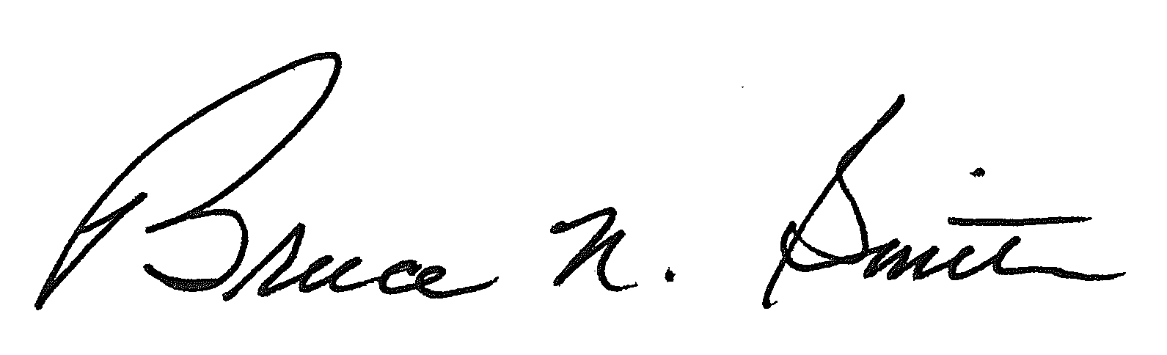
Bruce N. Smith
Director
/tmp/in/input.doc:srs

