Decision No. R03-1279
BEFORE THE PUBLIC UTILITIES COMMISSION OF THE STATE OF COLORADO
DOCKET NO. 03A-345CP-Transfer
in the matter of THE application of the mountain men, inc., dba best mountain tours, 3003 south macon circle, aurora, colorado 80014 for authority to transfer parts I through iv of certificate of public convenience and necessity puc no. 7010&I from the mountain men, inc., dba best mountain tours, to colorado tour lines, llc, dba gray line of denver.
RECOMMENDED DECISION OF
ADMINISTRATIVE LAW JUDGE
DALE E. ISLEY
granting APPLICATION
under modified procedure
Mailed Date: November 13, 2003

STATEMENT
- The captioned application was filed with the Colorado Public Utilities Commission (Commission) on August 7, 2003, and was published in the Commission’s “Notice of Applications Filed” on August 11, 2003. It seeks Commission approval for the permanent transfer of Parts I through IV of Certificate of Public Convenience and Necessity (CPCN) PUC No. 7010&I from The Mountain Men, Inc., and Jon Nicholls, its Trustee in Bankruptcy (Mountain Men), to Colorado Tour Lines, LLC, doing business as Gray Line of Denver (Gray Line).
- On September 11, 2003, the Commission issued an Order Setting Hearing and Notice of Hearing setting this matter for hearing in Denver, Colorado, on October 14, 2003. That hearing date was vacated pending issuance of a ruling on a motion submitted by Mountain Men for the dismissal of an intervention submitted by The Mountain Guides, Inc., doing business as Scenic Mountain Tours (TMG). See, Decision No. R03-1159-I
- On October 27, 2003, the TMG intervention was stricken and/or dismissed. See, Decision No. R03-1205-I.
- On November 5, 2003, Gray Line was ordered to submit a verified statement consistent with the provisions of 4 Code of Colorado Regulations (CCR) 723-1-24(a). See, Decision No. R03-1243-I. Gray Line submitted the required statement on November 12, 2003.
- In accordance with § 40-6-109, C.R.S., the undersigned now transmits to the Commission the record in this proceeding along with a written recommended decision.

FINDINGS AND CONCLUSIONS
- As indicated above, this application seeks Commission approval for the permanent transfer of Parts I through IV of CPCN PUC No. 7010&I from Mountain Men to Gray Line.
- Since this application is now uncontested, it is eligible for processing under modified procedure pursuant to § 40-6-109(5), C.R.S., and Rule 24 of the Commission’s Rules of Practice and Procedure, 4 CCR 723-1-24, and can be determined without a formal hearing.
- The application, now verified, establishes that Gray Line is familiar with the Commission’s Rules, Regulations and Civil Penalties Governing Common Carriers of Passengers by Motor Vehicle for Hire, 4 CCR 723-31, and agrees to be bound by the same. The application, along with other pertinent financial and related information already on file with the Commission, also establish that Gray Line will engage in bona fide common carrier operations under Parts I through IV of CPCN PUC No. 7010&I and that it is fit, financially and otherwise, to provide the service authorized by Parts I through IV of CPCN PUC No. 7010&I.
- The Commission has previously approved applications by Mountain Men to suspend operations under CPCN PUC No. 7010&I. See, Decision Nos. C03-0138 and R03-0721. In doing so, the Commission found no evidence to suggest that Mountain Men had abandoned service under CPCN PUC No. 7010&I or allowed the operating rights set forth therein to become dormant. Therefore, it is found and concluded that Mountain Men has previously engaged in bona fide common carrier operations under Parts I through IV of CPCN PUC No. 7010&I and Parts I through IV of CPCN PUC No. 7010&I have not been abandoned or allowed to become dormant.
- Under the application only Parts I through IV of CPCN PUC No. 7010&I will be transferred to Gray Line. The Commission has recently approved the transfer of Part V of CPCN PUC No. 7010&I from Mountain Men to Argo Enterprises, LLC. See, Decision No. C03-1177 in Docket No. 03A-382CP-Transfer. Such a “split” in the operating rights encompassed by CPCN PUC No. 7010&I is in the public interest since it will serve to reinstate service under all portions of the subject authority.
- Gray Line currently owns and operates CPCN PUC No. 55716, portions of which duplicate the operating rights contained in Parts I through IV of CPCN PUC No. 7010&I. Mountain Men and Gray Line indicate in their application that they have no objection to the elimination of such duplicative/overlapping operating rights. Attached hereto as Appendix I is a description of revised Gray Line CPCN PUC No. 55716. Appendix I incorporates Parts I through IV of CPCN PUC No. 7010&I into CPCN PUC No. 55716 and gives effect to the elimination of duplicative/overlapping operating rights.

ORDER

The Commission Orders That:
- The application filed by The Mountain Men, Inc., and Jon Nicholls, its Trustee in Bankruptcy, for approval to transfer Parts I through IV of Certificate of Public Convenience and Necessity PUC No. 7010&I to Colorado Tour Lines, LLC, doing business as Gray Line of Denver, is granted.
- Colorado Tour Lines, LLC, doing business as Gray Line of Denver, Certificate of Public Convenience and Necessity PUC No. 55716 is hereby amended as set forth in Appendix I attached hereto. Appendix I is incorporated into this Recommended Decision as if set forth herein.
- Colorado Tour Lines, LLC, doing business as Gray Line of Denver, shall operate in accordance with all applicable Commission rules and regulations.
- Approval of the transfer of Parts I through IV of Certificate of Public Convenience and Necessity PUC No. 7010&I is conditioned on the prior filing by The Mountain Men, Inc., and Jon Nicholls, its Trustee in Bankruptcy, of delinquent reports, if any, covering operations under the certificate up to the consummation of the transfer.
- Colorado Tour Lines, LLC, doing business as Gray Line of Denver, shall cause to be filed with the Commission certificates of insurance as required by Commission rules. Colorado Tour Lines, LLC, doing business as Gray Line of Denver, shall also adopt the tariff of The Mountain Men, Inc., and Jon Nicholls, its Trustee in Bankruptcy, which shall become that of Colorado Tour Lines, LLC, doing business as Gray Line of Denver, until changed in accordance with public utilities law. Colorado Tour Lines, LLC, doing business as Gray Line of Denver, shall pay applicable vehicle identification fees. The Mountain Men, Inc., and Jon Nicholls, its Trustee in Bankruptcy, shall file a terminating annual report from the first of January of this year to the effective date of this Order. An acceptance of transfer signed by both The Mountain Men, Inc., and Jon Nicholls, its Trustee in Bankruptcy, and Colorado Tour Lines, LLC, doing business as Gray Line of Denver, shall be filed with the Commission. Colorado Tour Lines, LLC, doing business as Gray Line of Denver, may not begin operations until these requirements have been met and notice in writing has been received from the Commission that it is in compliance and may begin service.
- If The Mountain Men, Inc., and Jon Nicholls, its Trustee in Bankruptcy, and Colorado Tour Lines, LLC, doing business as Gray Line of Denver, do not comply with the requirements of this Order within 60 days of its effective date, then the approval to transfer Parts I through IV of Certificate of Public Convenience and Necessity PUC No. 7010&I shall be void. For good cause shown, the Commission may grant additional time for compliance if the request for additional time is filed within the 60 days.
- This Recommended Decision shall be effective on the day it becomes the Decision of the Commission, if that is the case, and is entered as of the date above.
- As provided by § 40-6-109, C.R.S., copies of this Recommended Decision shall be served upon the parties, who may file exceptions to it.
- If no exceptions are filed within 20 days after service or within any extended period of time authorized, or unless the decision is stayed by the Commission upon its own motion, the recommended decision shall become the decision of the Commission and subject to the provisions of § 40-6-114, C.R.S.
- If a party seeks to amend, modify, annul, or reverse basic findings of fact in its exceptions, that party must request and pay for a transcript to be filed, or the parties may stipulate to portions of the transcript according to the procedure stated in § 40-6-113, C.R.S. If no transcript or stipulation is filed, the Commission is bound by the facts set out by the administrative law judge and the parties cannot challenge these facts. This will limit what the Commission can review if exceptions are filed.
- If exceptions to this Decision are filed, they shall not exceed 30 pages in length, unless the Commission for good cause shown permits this limit to be exceeded.

THE PUBLIC UTILITIES COMMISSION
OF THE STATE OF COLORADO
DALE E. ISLEY
________________________________
Administrative Law Judge
(S E A L)

ATTEST: A TRUE COPY
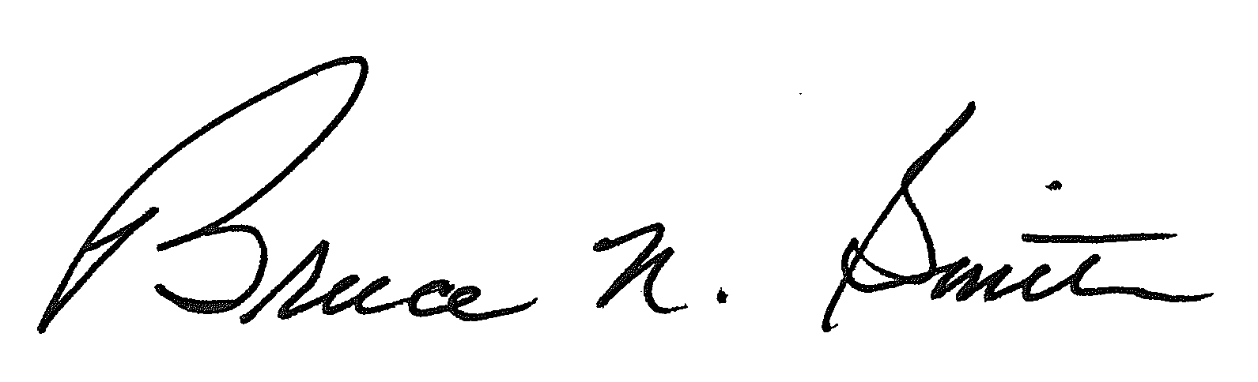
Bruce N. Smith
Director
/tmp/in/input.doc:srs

