Decision No. R03-1278
BEFORE THE PUBLIC UTILITIES COMMISSION OF THE STATE OF COLORADO
DOCKET NO. 03G-363CP
COLORADO PUBLIC UTILITIES COMMISSION,

Complainant,

v.

DENVER MOUNTAIN CARRIER, INC. D/B/A DENVER MOUNTAIN EXPRESS,

Respondent.
DOCKET NO. 03G-376CP
COLORADO PUBLIC UTILITIES COMMISSION,

Complainant,

v.

HOTEL OF DENVER MOUNTAIN CARRIER, INC. D/B/A DENVER MOUNTAIN EXPRESS,

Respondent.
recommended decision of
administrative law Judge
Ken f. kirkpatrick
accepting stipulation and
assessing civil penalty
Mailed Date: November 12, 2003

statement
- These two proceedings concern Civil Penalty Assessment Notice (CPAN) Nos. 28249 and 28302. On September 22, 2003, Commission Staff (Staff) and Respondent Denver Mountain Express filed their Stipulation of Settlement and Motion to Close Docket. By this motion the parties indicated that they had reached a settlement for the matters charged in the two CPANs.
- By Decision No. R03-1153-I, the Administrative Law Judge (ALJ) indicated that the parties needed to supplement the Stipulation in order for it to be adequately supported.
- On October 24, 2003, Staff filed its Supplemental Response (Supplement). No response to the interim order or to Staff’s response was filed by Respondent.
- Staff’s Supplement indicates additional information which supports the Stipulation. The Supplement notes that three alleged violations contained on lines 17, 18, and 20 of CPAN No. 28249 involve the same vehicle on separate days, showing a pattern of the Respondent of not complying with the requirement that the driver file his daily vehicle inspection report. The Supplement also clarifies that the violations alleged on lines 10, 11, and 12 of CPAN No. 28249 refer to separate days of July 9, 16, and 23, 2003.
- Next, the supplement clarified that it was a driver of the Respondent, and not management of Respondent, who had altered the driver DOT certificate. It does not appear that the management of the Respondent had any knowledge of this. Finally, Staff notes that CPAN No. 28302 was based on the results of random vehicle inspections and follow-up records checks at Denver International Airport. This random check, conducted 14 days after the issuance of the initial CPAN, detected similar violations in similar vehicles. Staff suggests, and the ALJ finds, that the Respondent did not take immediate action to remedy the defective vehicle problems based on the initial review and subsequent inspections from the first CPAN. The factors in aggravation support a proposed penalty that is approximately 70 percent of the amount originally charged. This is significantly higher than the somewhat standard 50 percent acceptable for when a respondent agrees to cooperate, admits allegations, agrees to pay the fine, and remedies the violation. Here the Respondent did not remedy the violations and indeed its degree of cooperation appears to be less than 100 percent. Therefore the proposed penalty of $4,700 is appropriate.
- In accordance with § 40-6-109, C.R.S., it is recommended that the Commission enter the following order.

ORDER

The Commission Orders That:
- The Stipulation filed September 22, 2003 by Commission Staff and Respondent Denver Mountain Express is accepted. It is attached to this Order as Appendix A. The terms of the Stipulation are incorporated into this Order as if fully set forth. Respondent Hotels of Denver Mountain Carrier, Inc., doing business as Denver Mountain Express shall pay a civil in the amount of $4,700 within ten days of the effective date of this Order.
- Dockets Nos. 03G-363CP and 03G-376CP are closed.
- This Recommended Decision shall be effective on the day it becomes the Decision of the Commission, if that is the case, and is entered as of the date above.
- As provided by § 40-6-109, C.R.S., copies of this Recommended Decision shall be served upon the parties, who may file exceptions to it.
- If no exceptions are filed within 20 days after service or within any extended period of time authorized, or unless the decision is stayed by the Commission upon its own motion, the recommended decision shall become the decision of the Commission and subject to the provisions of § 40-6-114, C.R.S.
- If a party seeks to amend, modify, annul, or reverse basic findings of fact in its exceptions, that party must request and pay for a transcript to be filed, or the parties may stipulate to portions of the transcript according to the procedure stated in § 40-6-113, C.R.S. If no transcript or stipulation is filed, the Commission is bound by the facts set out by the administrative law judge and the parties cannot challenge these facts. This will limit what the Commission can review if exceptions are filed.
- If exceptions to this Decision are filed, they shall not exceed 30 pages in length, unless the Commission for good cause shown permits this limit to be exceeded.

THE PUBLIC UTILITIES COMMISSION
OF THE STATE OF COLORADO
KEN F. KIRKPATRICK
________________________________
Administrative Law Judge
(S E A L)

ATTEST: A TRUE COPY
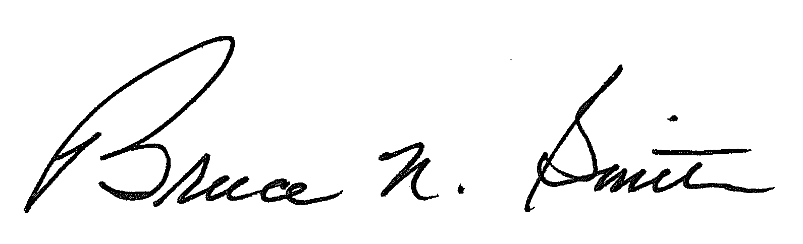
Bruce N. Smith
Director
/tmp/in/input.doc:srs

