Decision No. R03-1265-I
BEFORE THE PUBLIC UTILITIES COMMISSION OF THE STATE OF COLORADO
DOCKET NO. 03A-254R
in the matter of the application of the county of delta, colorado, for an order authorizing the installation of a railroad crossing protection device to be constructed on the right-of-way of the union pacific railroad company and 4th street (us dot-aaa grade crossing id no. 254050f at uprr milepost 0397.73), hotchkiss, colorado.
interim order of
administrative law judge
MANA L. JENNINGS-FADER
setting issues for hearing
and limiting witnesses
Mailed Date: November 10, 2003

statement
- On June 11, 2003, Applicant, the County of Delta, Colorado, filed its Application for authorization to install a railroad crossing (the Application).
- On June 17, 2003, the Commission issued a Notice of Application Filed in this proceeding. Staff of the Commission, the Colorado Department of Transportation, the Union Pacific Railroad Company (UPRR), and Daniel A. Stucker intervened. As discussed in Decision No. R03-1002-I at ¶ 6, only Mr. Stucker opposed the Application.
- The procedural schedule in this proceeding was set out in Decision No. R03-1002-I. A copy of that decision was served on all parties.
- On October 14, 2003, Applicant filed its Notice of Witnesses and Exhibits.
- On or before October 24, 2003, Intervenors were to file their lists of witnesses and copies of their exhibits. In addition, Intervenors were to file a statement of the issues which they intend to raise concerning the Application. See Decision No. R03-1002-I at ¶ 7. Intervenors were reminded of their filing obligation in Decision No. R03-1185-I at ¶ 23. A copy of that decision was served on all parties.
- On October 17, 2003, UPRR filed its List of Witnesses and Exhibits. On October 24, 2003, UPRR filed its Statement of Issues. UPRR is the only Intervenor to make the required filing. At the prehearing conference, counsel for UPRR stated that UPRR does not oppose the Application. Nothing in any subsequent filing indicates that UPRR has changed its position and that it now opposes the Application.
- On June 17, 2003, in the Notice of Application Filed, the Commission notified all recipients of the consequences of failing to make a required filing. The Commission stated that, if a party failed to meet the stated requirements, “the Commission may dismiss the … intervention … upon the Commission’s own motion, unless good cause is shown.” In addition, the Administrative Law Judge (ALJ) made it clear at the prehearing conference, in which all parties participated, that an Intervenor’s filing of its statement of issues was a necessary prerequisite to its participation at the hearing. Finally, parties were to file prehearing motions on or before November 7, 2003. A check of the Commission’s file for this matter reveals that no prehearing motion was filed. Thus, Intervenors (except UPRR) have not make the required filings on or before October 24, 2003; have not sought permission to make a late filing; and have not established good cause for the failure to make timely filings.
- Based on the foregoing, the ALJ will limit the hearing scheduled for November 14, 2003. First, Applicant and UPRR filed the required list of witnesses. They will be permitted to offer the identified witnesses. In addition, Applicant may offer witnesses in rebuttal who have not been identified. Intervenors which did not file the required list of witnesses will not be permitted to offer testimony. Second, it appears that, aside from the issue of funding, the Application is uncontested. Thus, the hearing will be limited to determining the issues presented in § 40-4-106(b), C.R.S. See also Application at prayer for relief on page 2.
- Absent further Order, the hearing will be ordered to proceed in accordance with the limits established in ¶ 8, above.

order

It Is Ordered That:
- Absent further order, the hearing scheduled in this matter for November 14, 2003, will proceed in accordance with the limits established in ¶ I.8, supra.
- This Order shall be effective immediately.

THE PUBLIC UTILITIES COMMISSION
OF THE STATE OF COLORADO
MANA L. JENNINGS-FADER
________________________________
Administrative Law Judge
(S E A L)

ATTEST: A TRUE COPY
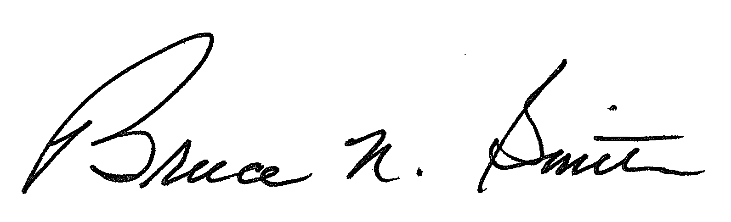
Bruce N. Smith
Director
/tmp/in/input.doc:srs

Parties are reminded that permission to cross-examination is limited to parties represented by counsel and to Mr. Stucker (provided he represents only himself). See Decisions No. R03-1002-I and No. R03-1185-I.

