Decision No. C03-1326
BEFORE THE PUBLIC UTILITIES COMMISSION OF THE STATE OF COLORADO
DOCKET NO. 00T-064
THE APPLICATION FOR APPROVAL OF INTERCONNECTION AGREEMENT BETWEEN US WEST COMMUNICATIONS, INC. AND ELECTRO-TEL, INC.
DECISION GRANTING JOINT MOTION
FOR APPROVAL OF AMENDMENT TO INTERCONNECTION AGREEMENT
Mailed Date: December 1, 2003
Adopted Date: November 26, 2003

BY THE COMMISSION

Statement
- This matter comes before the Commission on the joint motion of Qwest Corporation, formerly known as U S WEST Communications, Inc. (Qwest), and Eschelon Telecom of Colorado, Inc., formerly known as Electro-Tel, Inc. (Eschelon), to amend their original Interconnection Agreement (Agreement). The Agreement between Qwest and Eschelon was approved in Decision No. C00-245, issued by the Commission on March 9, 2000, and subsequently amended. The parties filed this amendment on October 14, 2003. The Amendment changes the rates for monthly recurring charges associated with the Unbundled Network Element-Platform (for Eschelon the term is UNE-E).
- The Telecommunications Act of 1996 (Act), 47 U.S.C. § 251 et seq. requires that the Commission review and approve or reject interconnection agreements involving incumbent local exchange carriers (ILECs) like Qwest. To comply with the Act, rates in negotiated agreements must be just and reasonable, nondiscriminatory, and based on the cost of providing the interconnection or network element. 47 U.S.C. § 252(e). In reviewing agreements (or portions thereof) the Commission, generally, is guided by 47 U.S.C. § 252(e)(2) requiring that interconnection agreements not discriminate against non-parties and be consistent with the public convenience and necessity.
- Pursuant to § 252(i) of the Act, 47 U.S.C. § 252(i), an ILEC shall make available any interconnection, service, or network element provided under an agreement or amendment previously approved by this Commission to which the ILEC is a party to any other requesting local exchange carrier upon the same terms and conditions as those provided in the agreement.
- We find it consistent with the directives of the Act and the spirit of our own interconnection agreement rules to approve the amendments subject to our own rules and general rate-making proceedings.

ORDER

The Commission Orders That:
- The joint motion of Qwest Corporation and Eschelon Telecom of Colorado, Inc., to amend their Interconnection Agreement is granted.
- This Order is effective on its Mailed Date.

ADOPTED IN COMMISSIONERS’ WEEKLY MEETING
November 26, 2003.

THE PUBLIC UTILITIES COMMISSION
OF THE STATE OF COLORADO
GREGORY E. SOPKIN
________________________________
POLLY PAGE
________________________________
JIM DYER
________________________________
Commissioners
(S E A L)

ATTEST: A TRUE COPY
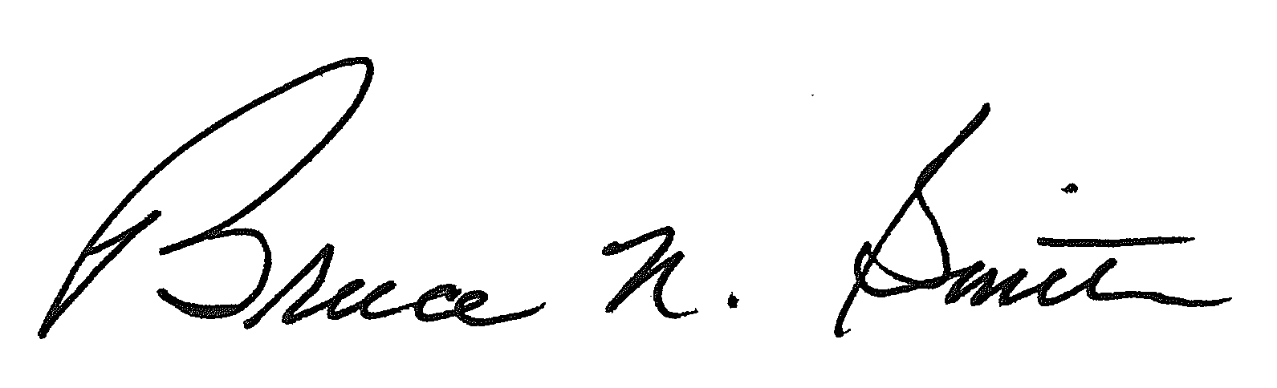
Bruce N. Smith
Director
/tmp/in/input.doc:srs

