Decision No. C03-1325
BEFORE THE PUBLIC UTILITIES COMMISSION OF THE STATE OF COLORADO
DOCKET NO. 03T-460
RE: THE APPLICATION FOR APPROVAL OF AN INTERCONNECTION AGREEMENT BETWEEN QWEST CORPORATION AND IDT AMERICA, CORP.
DECISION GRANTING APPLICATION FOR APPROVAL OF INTERCONNECTION AGREEMENT
Mailed Date: December 1, 2003
Adopted Date: November 26, 2003

BY THE COMMISSION

Statement
- This matter comes before the Colorado Public Utilities Commission (Commission) for consideration of the Joint Application (Application) for Approval of an Interconnection Agreement filed by Qwest Corporation (Qwest) and IDT America Corp. (IDT), filed on October 20, 2003. The Application seeks approval of the Parties’ Interconnection Agreement (Agreement) for the provision of Qwest’s local exchange services. The Agreement is based upon the terms and conditions contained in Qwest’s proposed Ninth Revised Statement of Generally Available Terms and Conditions for Interconnection, Unbundled Network Elements, Ancillary Services, and Resale of Telecommunication Services (SGAT). The Ninth Revised SGAT became effective on May 3, 2003, pursuant to Commission Decision No. C03-0464, mailed May 5, 2003. In addition, the Bill and Keep language in Section 7.3 and the language for Exchange Service (EAS/Local) Traffic in Section 7.2 were separately negotiated.
- The Application is filed pursuant to the Commission's Rules Establishing Procedures Relating to the Submission for Approval of Interconnection Agreements, and any Amendments to Interconnection Agreements within Colorado by Telecommunications Carriers, 4 Code of Colorado Regulations (CCR) 723-44 (Interconnection Agreement Rules) and 47 U.S.C. § 252(a)(1). As part of their Application, Qwest and IDT attached their Agreement.
- Pursuant to 4 CCR 723-44-5.6 of the Interconnection Agreement Rules, notice of the submitted Application was given to the public. Interested persons were given an opportunity to file comments within 30 days of the notice. No comments were filed with the Commission. Likewise, no person has sought to intervene in this matter.

Background
- The Application and Agreement were submitted following the successful completion of voluntary negotiations between Qwest and IDT. The requirements of Rule 44 have been included in the Application. Pursuant to 4 CCR 723-44-5.7.3, the Commission shall approve or reject this negotiated Agreement within 90 days after its submission by the parties; otherwise the Agreement shall be deemed approved. In deciding whether to approve or reject the Agreement, the Commission follows the Interconnection Agreement Rules. Those rules were promulgated to implement certain directives set forth in the Telecommunications Act of 1996 (Act), 47 U.S.C. § 251 et seq.
- The Act sets forth the procedures for negotiation, arbitration, and approval of interconnection agreements between telecommunications providers. Notably, 47 U.S.C. §§ 252(a) and (e) mandate that all interconnection agreements between providers shall be submitted to the State commission (e.g., the Colorado Public Utilities Commission) for review. The State commission may approve or reject any submitted agreement in accordance with the standards listed in 47 U.S.C. § 252(e)(2) (commission may reject an agreement adopted by negotiation if it discriminates against a telecommunications carrier not a party to the agreement or if the implementation of such agreement is not consistent with the public interest, convenience, and necessity).
- In pertinent part, 47 U.S.C. § 251 and the regulations promulgated by the Federal Communications Commission (FCC) require telecommunications carriers to interconnect their facilities and equipment. 47 U.S.C. § 251(a). The Act further imposes upon all local exchange carriers duties concerning resale, number portability, dialing parity, access to rights-of-way, and reciprocal compensation. 47 U.S.C. § 251(b). Additionally, the Act obligates incumbent local exchange carriers to negotiate in good faith the particular terms and conditions of interconnection agreements for the transmission and routing of telephone exchange service and exchange access. 47 U.S.C. § 251(c). The FCC's regulations implementing 47 U.S.C. § 251 are codified at 47 C.F.R. pt. 51.
- Section 47 U.S.C. § 252(d) addresses pricing standards. In order to comply with this section, rates for interconnection and network elements must be just and reasonable, nondiscriminatory, and based on the cost of providing the interconnection or network element. This section also deals with charges for the transportation and termination of traffic and with wholesale prices for telecommunications services.
- Since 47 U.S.C. § 252(e) compels State commissions to review interconnection agreements between telecommunications carriers, the Commission adopted the Interconnection Agreement Rules to establish the procedures for Commission review and approval of all interconnection agreements entered into between telecommunications carriers.
- Under the 47 U.S.C. § 252(i) “pick and choose” provision of the Act, IDT may at some future date opt into the rates, terms, and conditions of Commission approved and effective agreements, amendments, or SGATs.

Findings
- Rule 4 CCR 723-44-5.7.2.1 of the Interconnection Agreement Rules provides that the Commission may reject a submitted interconnection agreement entered into by negotiation only if:
(1) The agreement, or portion thereof, discriminates against a telecommunications carrier not a party to the agreement; or
(2) The implementation of such agreement, or portion thereof, is not consistent with the public interest, convenience, and necessity; or
(3) The agreement is not in compliance with intrastate telecommunications service quality standards or requirements.
- We find that given the requirements of Rule 4 CCR 723-44-5.7.2.1, the Application should be granted. The Agreement addresses all pertinent provisions of 47 U.S.C. § 251. With respect to 47 U.S.C. § 252(d), costing and pricing issues are governed by the Agreement which incorporates by reference interim and final orders of the Commission.

Conclusion
- Based upon the record in the present proceeding and the standards for review of interconnection agreements as set forth in the Interconnection Agreement Rules, we conclude that the Application should be granted.

ORDER

The Commission Orders That:
- The Joint Application for an interconnection agreement filed by Qwest Corporation and IDT America Corp. on October 20, 2003, is granted.
- This Order is effective on its Mailed Date.

ADOPTED IN COMMISSIONERS' WEEKLY MEETING
November 26, 2003.

THE PUBLIC UTILITIES COMMISSION
OF THE STATE OF COLORADO
GREGORY E. SOPKIN
________________________________
POLLY PAGE
________________________________
JIM DYER
________________________________
Commissioners
(S E A L)

ATTEST: A TRUE COPY
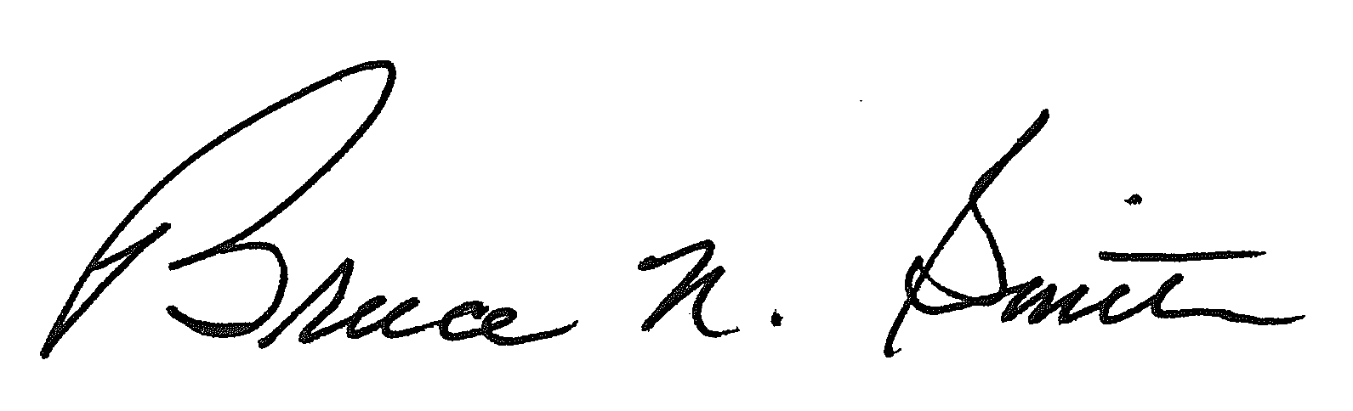
Bruce N. Smith
Director
/tmp/in/input.doc:srs

