Decision No. C03-1276
BEFORE THE PUBLIC UTILITIES COMMISSION OF THE STATE OF COLORADO
DOCKET NO. 03T-467
IN THE MATTER OF THE APPLICATION FOR APPROVAL OF INTERCONNECTION AGREEMENT BETWEEN QWEST CORPORATION AND WILTEL LOCAL NETWORK, LLC.
DECISION APPROVING REPORT OF
ADOPTION OF PREVIOUSLY APPROVED INTERCONNECTION AGREEMENT
Mailed Date: November 13, 2003
Adopted Date: November 12, 2003

BY THE COMMISSION

Statement
- This matter comes before the Colorado Public Utilities Commission (Commission) on the submittal of a Report of Adoption of Previously Approved Interconnection Agreement (Report of Adoption) filed by Qwest Corporation (Qwest) and WilTel Local Network, LLC (WilTel) pursuant to Commission Rule 4 Code of Colorado Regulations (CCR) 723-44 et seq.
- The Parties filed this Report of Adoption on October 23, 2003. WilTel has voluntarily adopted Qwest’s Ninth Revised Statement of Generally Available Terms and Conditions for Interconnection, Unbundled Network Elements, Ancillary Services, and Resale of Telecommunication Services (SGAT). The Ninth Revised SGAT originally became effective on May 3, 2003 pursuant to Commission Decision No. C03-0464, and has been subsequently amended. This would be WilTel’s first interconnection agreement with Qwest. Rates are taken from SGAT Exhibit A.
- The Parties have complied with the requirements of 4 CCR 723-44 et seq. for the submission for approval of interconnection agreements. Additionally, the Report of Adoption contains all information required in 4 CCR 723-44-6.
- Pursuant to § 252(i) of the Telecommunications Act of 1996 (Act), 47 U.S.C. § 252(i), an incumbent local exchange carrier (ILEC) shall make available any interconnection, service, or network element provided under an agreement or amendment previously approved by this Commission to which the ILEC is a party to any other requesting local exchange carrier upon the same terms and conditions as those provided in the agreement.
- Section 47 U.S.C. § 251 et seq. of the Act requires that the Commission review and approve or reject interconnection agreements involving ILECs like Qwest. To comply with the Act, rates in negotiated agreements must be just and reasonable, nondiscriminatory, and based on the cost of providing the interconnection or network element. 47 U.S.C. § 252(e). In reviewing agreements or portions thereof, the Commission, generally, is guided by 47 U.S.C. § 252(e)(2), requiring that interconnection agreements not discriminate against non-parties and be consistent with the public interest, convenience, and necessity.
- The Commission has previously approved the rates, terms, and conditions in the Amendments adopted by the parties. We find it consistent with the terms of the agreement, the directives of the Act, and the spirit of our own interconnection agreement rules to approve the Report of Adoption subject to our own rules and general rate-making proceedings.

ORDER

The Commission Orders That:
- The joint filing of a Report of Adoption by Qwest Corporation and WilTel Local Network, LLC to adopt Qwest Corporation’s Ninth Revised Statement of Generally Available Terms and Conditions for Interconnection, Unbundled Network Elements, Ancillary Services, and Resale of Telecommunication Services is granted.
- This Order is effective on its Mailed Date.

ADOPTED IN COMMISSIONERS’ WEEKLY MEETING
November 12, 2003.

THE PUBLIC UTILITIES COMMISSION
OF THE STATE OF COLORADO
GREGORY E. SOPKIN
________________________________
POLLY PAGE
________________________________
JIM DYER
________________________________
Commissioners
(S E A L)

ATTEST: A TRUE COPY
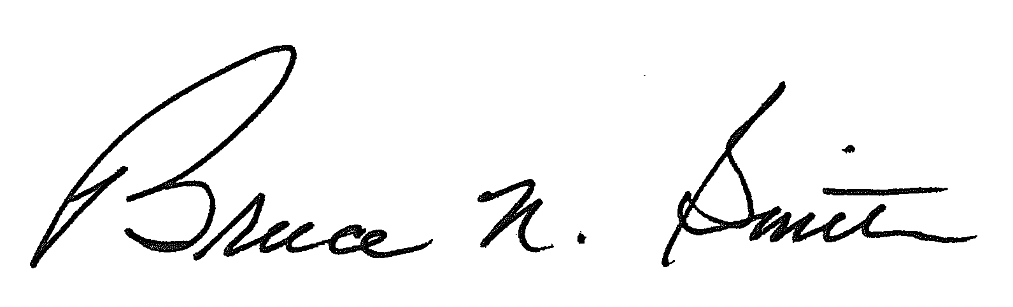
Bruce N. Smith
Director
/tmp/in/input.doc

