Decision No. C03-1251
BEFORE THE PUBLIC UTILITIES COMMISSION OF THE STATE OF COLORADO
DOCKET NO. 03I-478T
REGARDING THE UNBUNDLING OBLIGATIONS OF INCUMBENT LOCAL EXCHANGE CARRIERS PURSUANT TO THE TRIENNIAL REVIEW ORDER--INITIAL COMMISSION REVIEW.
Order Granting Joint Motion
For Adoption of Batch Cut Forum
Mailed Date: November 6, 2003
Adopted Date: November 5, 2003

BY THE COMMISSION

Statement
- This matter comes before the Commission for consideration of the Joint Motion for Adoption of Batch Cut Forum by Qwest Corporation; AT&T of the Mountain States, Inc.; and WorldCom, Inc., on behalf of its regulated subsidiaries. The Joint Motion requests that we establish a procedure by which the Commission, with participation of interested persons, will investigate and eventually adopt a batch hot cut process pursuant to 47 C.F.R. § 51.319(d)(2)(ii). The Joint Motion suggests that certain filings be made to the Commission by certain dates, certain meetings among interested parties to discuss a batch hot cut process, and other procedural devices be adopted by the Commission.
- In Decision No. C03-1225, ¶ 12 (Mailed Date of October 31, 2003), we directed Qwest Corporation (Qwest) to inform the Commission by November 6, 2003, of the procedure by which it suggests we consider adoption of a batch hot cut process in accordance with Rule 51.319(d)(2)(ii). The Joint Motion satisfies that directive.
- Now being duly advised in the premises, we generally grant the Joint Motion. By separate order, we open a new docket to consider adoption of a batch hot cut process and issue procedural directives for that docket. We clarify that the Joint Motion satisfies the requirement in C03-1225 that Qwest inform the Commission of its suggestion regarding consideration of a batch hot cut process.

ORDER

The Commission Orders That:
- Response time to the Joint Motion for Adoption of Batch Hot Cut Forum is waived and the Joint Motion is granted consistent with the above discussion. By separate order we open a new docket to consider adoption of a batch hot cut process and issue further procedural directives there.
- This Order is effective on its Mailed Date.

ADOPTED IN COMMISSIONERS’ WEEKLY MEETING
November 5, 2003.

THE PUBLIC UTILITIES COMMISSION
OF THE STATE OF COLORADO
GREGORY E. SOPKIN
________________________________
POLLY PAGE
________________________________
JIM DYER
________________________________
Commissioners
(S E A L)

ATTEST: A TRUE COPY
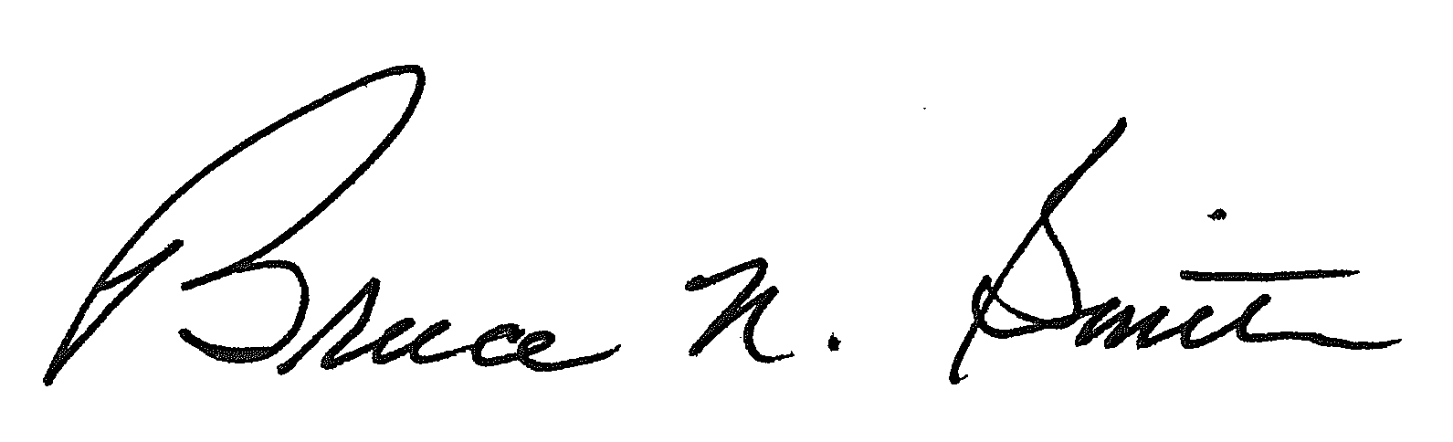
Bruce N. Smith
Director
/tmp/in/input.doc:srs

The rule defines a batch cut process as a process by which an incumbent local exchange carrier simultaneously migrates two or more loops from one carrier's local circuit switch to another carrier's local circuit switch.
As described in the separate order, we have slightly modified the dates and procedure suggested by the parties to address the batch hot cut process.

