Decision No. C02-0082
BEFORE THE PUBLIC UTILITIES COMMISSION OF THE STATE OF COLORADO
DOCKET NO. 01A-551CP-Transfer
the application of Odd Lyngholm, DOING BUSINESS AS Estes Park Shuttle & Mountain Tours, FOR APPROVAL TO transfer CERTIFICATE OF PUBLIC CONVENIENCE AND NECESSITY PUC NO. 54696 to Estes Park Express, Ltd.
COMMISSION ORDER APPROVING transfer of
certificate of public convenience
and necessity
Mailed Date: January 30, 2002
Adopted Date: January 24, 2002

BY THE COMMISSION:

Statement, Findings and Conclusions

    - On November 29, 2001, Odd Lyngholm, doing business as Estes Park Shuttle & Mountain Tours, filed an application for approval to transfer Certificate of Public Convenience and Necessity ("CPCN") PUC No. 54696 to Estes Park Express, Ltd.
    - The Commission noticed this application to all interested persons, firms, and corporations pursuant to § 40-6-108(2), C.R.S., on December 3, 2001. The Commission set this matter for hearing on February 12, 2002.
    - No petition to intervene or otherwise participate in this proceeding has been filed. This proceeding is noncontested. Under § 40-6-109(5), C.R.S., this matter may be determined without a hearing.
    - The submitted information warrants the grant of the requested transfer.
    - The financial standing of Estes Park Express, Ltd., has been satisfactorily established.
    - Estes Park Express, Ltd., is ready, willing, and able properly to perform the service as requested.
    - This application for permanent approval of the transfer of CPCN PUC No. 54696 is in the public interest.

ORDER

The Commission Orders That:

    - The hearing set for February 12, 2002, is vacated.
    - This application was deemed complete on January 14, 2002, within the meaning of § 40-6-109.5, C.R.S.
    - The application filed by Odd Lyngholm, doing business as Estes Park Shuttle & Mountain Tours, for approval to transfer Certificate of Public Convenience and Necessity PUC No. 54696, subject to encumbrances, if any, against the authority, to Estes Park Express, Ltd., is granted.
    - Estes Park Express, Ltd., shall operate in accordance with all applicable Commission rules and regulations.
    - Approval of the transfer of Certificate of Public Convenience and Necessity PUC No. 54696 is conditioned on the prior filing by Odd Lyngholm, doing business as Estes Park Shuttle & Mountain Tours, of delinquent reports, if any, covering operations under the certificate up to the consummation of the transfer.
    - Estes Park Express, Ltd., shall cause to be filed with the Commission certificates of insurance as required by Commission rules. Estes Park Express, Ltd., shall also adopt the tariff of Odd Lyngholm, doing business as Estes Park Shuttle & Mountain Tours, which shall become that of Estes Park Express, Ltd., until changed in accordance with the public utilities law. Estes Park Express, Ltd., shall pay the vehicle identification fee. Odd Lyngholm, doing business as Estes Park Shuttle & Mountain Tours, shall file a terminating annual report from the first of January to the date of this Order. An acceptance of transfer signed by both Odd Lyngholm, doing business as Estes Park Shuttle & Mountain Tours, and Estes Park Express, Ltd., shall be filed with the Commission. Estes Park Express, Ltd. may not begin operations until it has received notice in writing from the Commission that it is in compliance and may begin service.
    - If Odd Lyngholm, doing business as Estes Park Shuttle & Mountain Tours, and Estes Park Express, Ltd., do not comply with the requirements of this Order within 60 days of its effective date, then the approval to transfer Certificate of Public Convenience and Necessity PUC No. 54696 shall be void. For good cause shown, the Commission may grant additional time for compliance if the request for additional time is filed within the 60 days.
    - This Order is effective on its Mailed Date.

ADOPTED IN THE COMMISSIONERS’ WEEKLY MEETING January 24, 2002.

THE PUBLIC UTILITIES COMMISSION
OF THE STATE OF COLORADO
RAYMOND L. GIFFORD
________________________________
POLLY PAGE
________________________________
JIM DYER
________________________________
Commissioners

(S E A L)


ATTEST: A TRUE COPY

Bruce N. Smith
Director
i:\trans\orders\01A-551CP.doc

TRANSFEROR:

Odd Lyngholm
dba Estes Park Shuttle & Mountain Tours
481 West Elkhorn Avenue
Estes Park, CO 80517

TRANSFEROR'S ATTORNEY:
Charles M. Williams
Charles M. Williams, P.C.
1700 Broadway
Denver, CO 80203

TRANSFEREE:
Estes Park Express, Ltd.
875 Moraine Avenue
Estes Park, CO 80517

TRANSFEREE'S ATTORNEY:
Richard L. Fanyo
Dufford & Brown, P.C.
1700 Broadway
Suite No. 1700
Denver, CO 80517

ROUTE:
60; 6; all PUC staff, including staff that may be listed as parties, received this decision electronically.

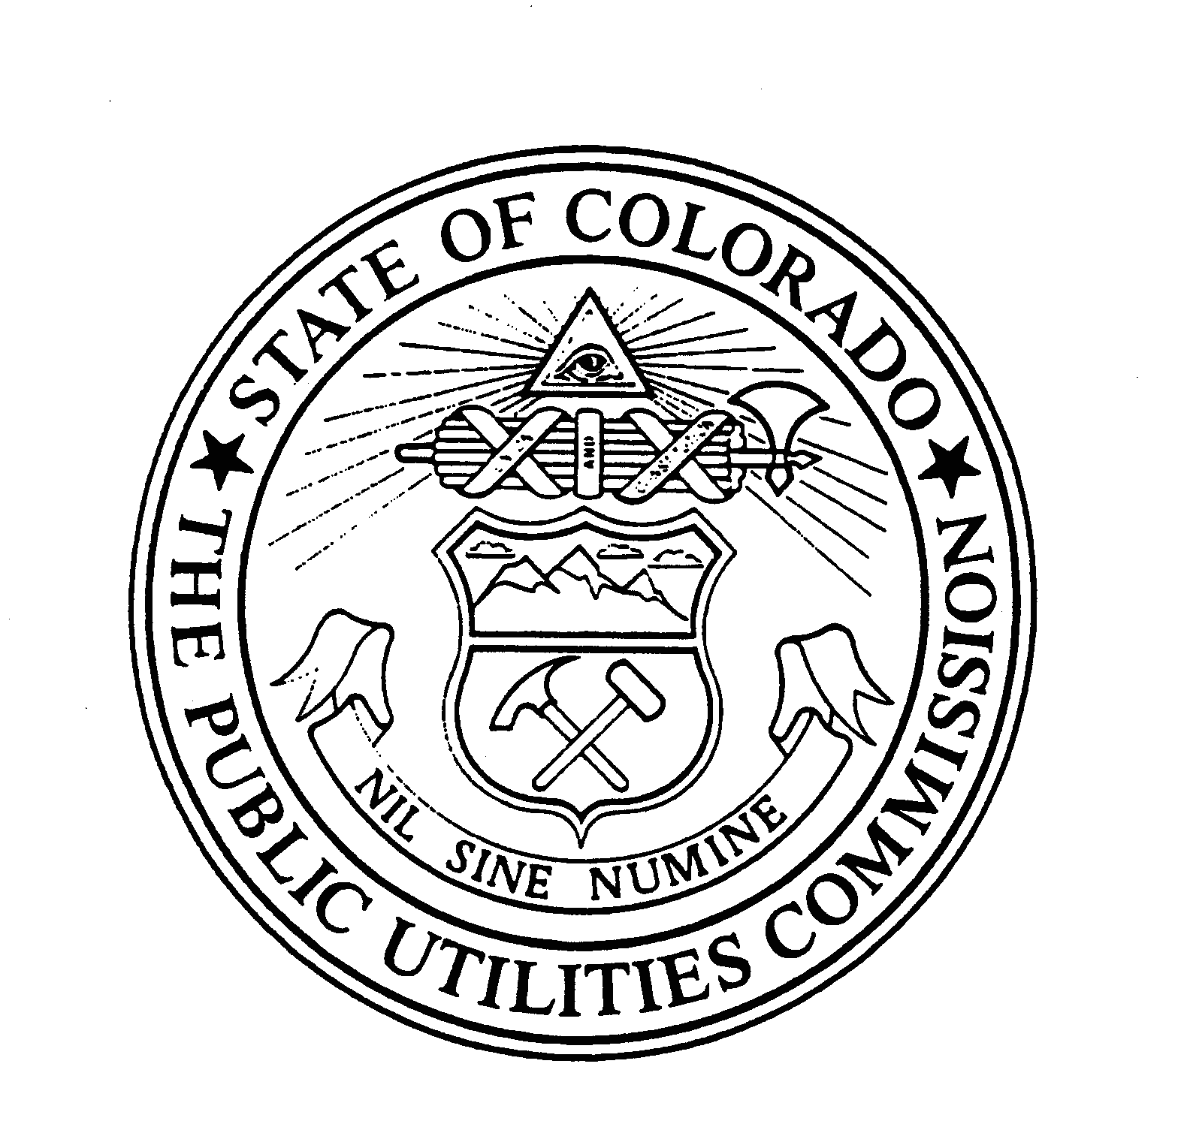 | WITNESS MY HAND AND THE SEAL OF THE PUBLIC UTILITIES COMMISSION OF THE STATE OF COLORADO

