Decision No. R24-159-I
BEFORE THE PUBLIC UTILITIES COMMISSION OF THE STATE OF COLORADO
PROCEEDING NO. 23A-0494E
IN THE MATTER OF PUBLIC SERVICE COMPANY'S APPLICATION FOR A CERTIFICATE OF PUBLIC CONVENIENCE AND NECESSITY FOR THE FORM ENERGY LONG DURATION BATTERY PROJECT AT COMANCHE GENERATING STATION.
interim decision OF
ADMINISTRATIVE LAW JUDGE
CONOR F. FARLEY GRANTING UNOPPOSED MOTION TO VACATE DEADLINE FOR REBUTTAL AND CROSS-ANSWER TESTIMONY AND WAIVING RESPONSE TIME
Mailed Date: March 11, 2024

STATEMENT

Background
- On October 4, 2023, Public Service Company of Colorado (Public Service) filed the Verified Application (Application) described above.
- On January 9, 2024, the undersigned Administrative Law Judge issued
Decision No. R24-0013-I that established the schedule in this proceeding, including the deadline of March 8, 2024 for the filing of rebuttal and cross-answer testimony.
- On March 7, 2024, Public Service filed a Notice of Unopposed Comprehensive Settlement in Principle and Unopposed Motion to Vacate Deadline for Rebuttal/Cross-Answer Testimony and Request for Waiver of Response Time (Unopposed Motion).

Unopposed Motion
- In the Unopposed Motion, Trial Staff of the Colorado Public Utilities Commission, the Office of the Utility Consumer Advocate, the Colorado Solar and Storage Association and the Solar Energy Industries Association, and Holy Cross Electric Association (collectively, the Settling Parties) provided notification that they reached an unopposed and comprehensive settlement in principle (Settlement). The Colorado Energy Consumers is not a party to the Settlement, “but has agreed not to oppose it.”
- Based on the Settlement, Public Service requests that the March 8, 2024 deadline for the filing of rebuttal and cross-answer testimony be vacated. Public Service also states that no party opposes the Unopposed Motion. For that reason, Public Service requests that response time to the Unopposed Motion be waived.

Analysis
- Public Service has stated good cause to grant the Unopposed Motion. Accordingly, the Unopposed Motion shall be granted.

ORDER

It Is Ordered That:
- The Unopposed Motion to Vacate Deadline for Rebuttal/Cross-Answer Testimony and Request for Waiver of Response Time filed by Public Service Company of Colorado on March 7, 2024 is granted.
- This Decision is effective immediately.

(S E A L)    ATTEST: A TRUE COPY  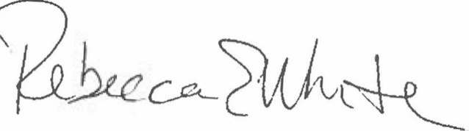  Rebecca E. White,  Director | THE PUBLIC UTILITIES COMMISSION  OF THE STATE OF COLORADO  CONOR F. FARLEY  ________________________________  Administrative Law Judge

Unopposed Motion at 1 n.1.

