Decision No. R24-0880-E
BEFORE THE PUBLIC UTILITIES COMMISSION OF THE STATE OF COLORADO
PROCEEDING NO. 24C-0427-INS
IN THE MATTER OF COMMISSION ACTION AGAINST THE CERTIFICATE(S) AND PERMIT(S) OF MOTOR CARRIERS CONCERNING FINANCIAL RESPONSIBILITY PURSUANT TO § 40-10.1-112, C.R.S., AND RULE 4 CCR 723-6-6008 OF THE RULES REGULATING TRANSPORTATION BY MOTOR VEHICLES.
ERRATA NOTICE FOR
RECOMMENDED DECISION
REVOKING AUTHORITIES AND PERMITS
Errata mailed December 19, 2024
Original Decision R24-0880 mailed December 4 , 2024

- Decision R24-0880 states an incorrect issue date of November 4, 2024.
- The issue date shall be corrected to December 4, 2024.
(S E A L)    ATTEST: A TRUE COPY  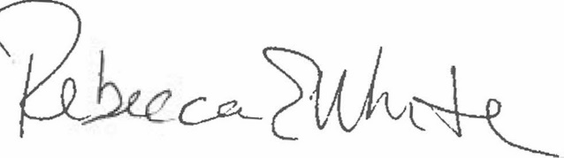  Rebecca E. White,  Director | THE PUBLIC UTILITIES COMMISSION  OF THE STATE OF COLORADO  ROBERT I. GARVEY  ________________________________  Administrative Law Judge

