Decision No. R24-0820-I
BEFORE THE PUBLIC UTILITIES COMMISSION OF THE STATE OF COLORADO
PROCEEDING NO. 23AL-0635G
IN THE MATTER OF ADVICE LETTER NO. 133 FILED BY COLORADO NATURAL GAS, INC. TO ELIMINATE THE CONSTRUCTION ALLOWANCES, TO BECOME EFFECTIVE APRIL 29, 2024.
INTERIM decision GRANTING MOTIONS FOR PRO HAC VICE ADMISSION
Issued Date: November 13, 2024
- On October 16, 2024, Sarah O. Jorgensen, Leaf Williams, and Brian C. Baran (“Movants”) filed separate Verified Motions for Admission Pro Hac Vice (“Verified Motions”). In their Verified Motions, Movants request admission to represent Colorado Natural Gas, Inc. (“CNG”) in this proceeding. On October 24, 2024, Movants filed in this proceeding a statement from the Clerk of the Colorado Supreme Court Office of Attorney Registration that they filed the Verified Motions with the Attorney Registration Office, paid the applicable fee, a disciplinary history revealed no adverse information with respect to any of them, and the Attorney Registration Office issued Pro Hac Vice registration numbers to each of them.
- Under Colorado law, legal counsel who are not licensed to practice law in Colorado can be granted permission to appear pro hac vice in this Proceeding. Counsel who seek to appear pro hac vice must comply with Colorado Rule of Civil Procedure (C.R.C.P.) 205.4, which incorporates by reference C.R.C.P. 205.3. C.R.C.P. 205.3(2) details the requirements that an out-of-state attorney must satisfy to be permitted to appear pro hac vice.
- Here, Movants have complied with the requirements of C.R.C.P. 205.3 and 205.4. For this reason, the Verified Motions shall be granted. Movants shall be permitted to represent CNG in this proceeding.

ORDER

It Is Ordered That:
- The Verified Motions for Admission Pro Hac Vice filed by Sarah O. Jorgensen, Leaf Williams, and Brian C. Baran are granted.
- This Decision is effective immediately.
(S E A L)    ATTEST: A TRUE COPY  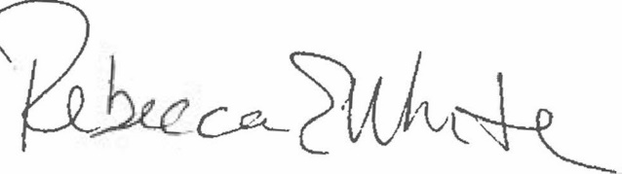  Rebecca E. White,  Director | THE PUBLIC UTILITIES COMMISSION  OF THE STATE OF COLORADO  CONOR F. FARLEY  ________________________________  Administrative Law Judge

