Decision No. R24-819-I
BEFORE THE PUBLIC UTILITIES COMMISSION OF THE STATE OF COLORADO
PROCEEDING NO. 24F-0365TO
ANTHONY SMITH,

COMPLAINANT,
V.
TOWING OPERATIONS, LLC DOING BUSINESS AS WYATT'S TOWING,

RESPONDENT.
INTERIM DECISION continuing hearing
Issued Date: November 12, 2024

statement
      - On August 28, 2024, Anthony Smith (“Complainant”) filed a formal complaint against Towing Operations, LLC, doing business as Wyatt’s Towing (“Respondent”).
      - This matter was referred by minute entry to an Administrative Law Judge (“ALJ”) for resolution during the Commission’s Weekly Meeting held September 11, 2024.
      - By Decision No. R24-0732-I, issued on October 11, 2024, the undersigned ALJ, among other things, scheduled an evidentiary hearing in this matter for November 14, 2024 and a prehearing conference for October 21, 2024.
      - On October 21, 2024, a prehearing conference was held. Complainant appeared pro se and Respondent appeared via counsel. At the prehearing conference, Respondent requested that evidentiary hearing in this matter be postponed due to Respondent’s counsel needing to prepare to represent his clients in two unrelated legal matters around the time of the scheduled evidentiary hearing in this Proceeding (November 14, 2024). Based on Respondent’s request, both parties ultimately agreed to participate in an evidentiary hearing in this matter on December 6, 2024, in lieu of the previously-scheduled evidentiary hearing on November 14, 2024. Based on the parties’ agreement as to the date of the evidentiary hearing in this matter, the evidentiary hearing will be continued to December 6, 2024, as ordered below.

ORDER

It Is Ordered That:
      - The evidentiary hearing in this matter is continued and will be conducted at the following date, time, and place:
DATE: December 6, 2024
TIME: 9:00 a.m.
WEBCAST: Hearing Room B
PLACE: In-person:
Commission Hearing Room A
Suite 250
1560 Broadway, Denver, Colorado 80202
By video conference using Zoom at the link to be provided in an email from the Administrative Law Judge or Staff of the Colorado Public Utilities Commission
Optionally, any party may participate remotely by joining a video conference using Zoom at the link to be provided to the established parties in an e-mail prior to the scheduled hearing.
      - The parties and witnesses may not distribute the Zoom link and access code to anyone not participating in the hearing.
      - The remaining requirements set forth in Decision No. R24-0732-I shall remain in effect.
      - This Decision shall be effective immediately.
(S E A L)    ATTEST: A TRUE COPY  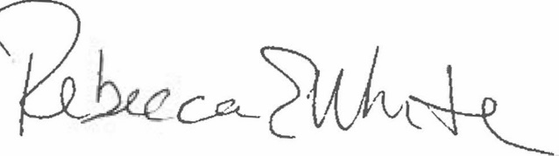  Rebecca E. White,  Director | THE PUBLIC UTILITIES COMMISSION  OF THE STATE OF COLORADO  AVIV SEGEV  ________________________________  Administrative Law Judge

Additional information about the Zoom platform and how to use the platform are available at: https://zoom.us/. All are strongly encouraged to participate in a test meeting prior to the scheduled hearing. See https://zoom.us/test.

