Decision No. R24-0797-I
BEFORE THE PUBLIC UTILITIES COMMISSION OF THE STATE OF COLORADO
PROCEEDING NO. 24M-0399TR
IN THE MATTER OF THE PETITION OF RICARDO GONZALES TO REVERSE AN INITIAL DRIVER DISQUALIFICATION DETERMINATION PURSUANT TO RULE 1007(A) AND RULE 1401, AND REQUEST FOR HEARING
interim DECISION
requiring parties to confer and
STAFF TO file a report REGARDING THE CONFERRAL
Issued Date: November 1, 2024

STATEMENT

Background
- On September 20, 2024, Ricardo Gonzales filed the Petition described in the caption above (“Petition”).
- On October 8, 2023, Trial Staff (“Staff”) of the Commission filed a Notice of Intervention by Right.
- On October 9, 2024, the Commission referred the proceeding to an Administrative Law Judge (“ALJ”). The proceeding was subsequently assigned to the undersigned ALJ.

Conferral and Conferral Report
- Staff shall confer with Mr. Gonzales regarding a schedule for this proceeding, including a date for the hearing, deadlines for the filing and serving of witness and exhibit lists and exhibits, and the method by which the hearing should be conducted. The Commission can conduct in-person, remote, or hybrid hearings. A remote hearing is one in which all of the participants appear and participate from remote locations over the Zoom web conferencing platform. A hybrid hearing involves the ALJ and at least one party and/or witness participating from one of the Commission’s hearing rooms in Denver, and the remaining party and witness(es) participating from one or more remote locations using the Zoom web conferencing platform. An in-person hearing is one in which the ALJ and all parties and witnesses participate in the hearing at the same location.
- Staff shall file a report of the results of the conferral. If there is agreement on the topics described above, the report shall state as much and detail the stipulated procedural schedule, discovery procedures, and/or method for conducting the hearing. If no agreement is achieved, the report shall state as much and identify the differences on the topics described above. The parties are on notice that the ALJ will retain the discretion to change the method by which the hearing will be conducted.
- The parties are urged to review the Commission’s public calendar to identify suitable days for the hearing in this proceeding and propose more than one date or consecutive dates for the hearing. The deadline for Staff to file the report is November 13, 2024.
- The Parties are advised and are on notice that this proceeding is governed by the Rules of Practice and Procedure found at 4 CCR 723-1. The ALJ expects the Parties to be familiar with and to comply with these rules. The rules are available on the Commission’s website http://www.dora.colorado.gov/puc and in hard copy from the Commission.

ORDER

It Is Ordered That:
- Trial Staff of the Commission shall file the report of the conferral identified above on or before November 13, 2024.
- This Decision is effective immediately.

(S E A L)    ATTEST: A TRUE COPY  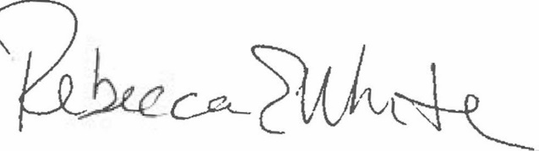  Rebecca E. White,  Director | THE PUBLIC UTILITIES COMMISSION  OF THE STATE OF COLORADO  CONOR F. FARLEY  ________________________________  Administrative Law Judge

