Decision No. R24-0792-IE
BEFORE THE PUBLIC UTILITIES COMMISSION OF THE STATE OF COLORADO
PROCEEDING NO. 24A-0369G
IN THE MATTER OF THE APPLICATION OF PUBLIC SERVICE COMPANY OF COLORADO FOR APPROVAL OF THE SELECTION OF PILOT PROJECTS TO PROVIDE THERMAL ENERGY SERVICE AND APPROVAL TO RECOVER THROUGH THE DEMAND SIDE MANAGEMENT COST ADJUSTMENT THE COMPANY'S COMMUNITY OUTREACH AND PROJECT DESIGN EFFORTS TO DEVELOP SELECTED PILOTS.

ERRATA NOTICE FOR

INTERIM DECISION
aDDRESING INTERVENTIONS; Extending STATUTORY DEADLINE FOR A COMMISSION DECISION; ESTABLISHING PROCEDURES, SCHEDULING EVIDENTIARY HEARING, PROVIDING INSTRUCTIONS CONCERNING EXHIBITS AND PARTICIPATING IN Remote EVIDENTIARY HEARING; Scheduling a Remote Public Comment Hearing; and Granting Motion for Extraordinary Protection

Errata mailed: November 1, 2024
Original Decision R24-0792-I issued October 31, 2024

- Decision No. 43 states,
The ALJ finds and concludes that the Company stated good cause for its requested relief and complied with the requirements set forth in Rule 1101, 4 CCR 723-1. Therefore, the Motion for Extraordinary Protection will be conditionally granted, as ordered below.
That paragraph is incorrect:
Decision No. 43 shall be corrected to read:
The ALJ finds and concludes that the Company stated good cause for its requested relief and complied with the requirements set forth in Rule 1101, 4 CCR 723-1. Therefore, the Motion for Extraordinary Protection will be conditionally granted, as ordered below.

(S E A L)    ATTEST: A TRUE COPY  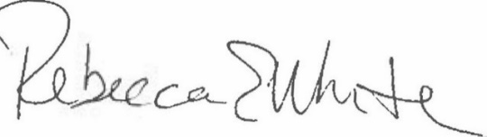  Rebecca E. White,  Director | THE PUBLIC UTILITIES COMMISSION  OF THE STATE OF COLORADO  AVIV SEGEV  ________________________________  Administrative Law Judge

