Decision No. R24-0765-E
BEFORE THE PUBLIC UTILITIES COMMISSION OF THE STATE OF COLORADO
PROCEEDING NO. 24A-0159R
IN THE MATTER OF THE APPLICATION OF THE COLORADO DEPARTMENT OF TRANSPORTATION FOR AUTHORITY TO REPLACE A TRAFFIC SIGNAL CABINET AND ADD BLANK OUT SIGNS AT US 85 AND DUCKWOOD RD, MILE POST 86.18, BNSF AND UPRR RAILWAYS, US DOT NO. 440805J IN THE CITY OF FOUNTAIN,
EL PASO COUNTY, STATE OF COLORADO.
ERRATA NOTICE FOR
Recommended decision
approving APPLICATION
Errata issued November 7, 2024
Original Decision R24-0765 issued: October 23, 2024

- Decision Order paragraph no. #7 states:

CDOT shall inform the Commission in writing when the crossing construction is complete and operational within ten days of completion. The Commission will expect this letter on or before February 14, 2024.
That paragraph is incorrect.
Decision Order paragraph no. #7 shall be corrected to read:
CDOT shall inform the Commission in writing when the crossing construction is complete and operational within ten days of completion. The Commission will expect this letter on or before February 14, 2025.
(S E A L)    ATTEST: A TRUE COPY  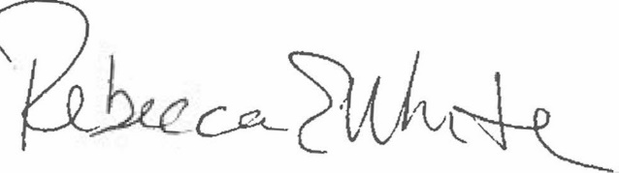  Rebecca E. White,  Director | THE PUBLIC UTILITIES COMMISSION  OF THE STATE OF COLORADO  G. HARRIS ADAMS  ________________________________  Administrative Law Judge

