Decision No. R16-____
BEFORE THE PUBLIC UTILITIES COMMISSION OF THE STATE OF COLORADO
PROCEEDING NO. Ctrl-A to select, F9 to update
[GET captioN FROM ifms]
INTERIM / RECOMMENDED DECISION …
Issued Date: <Alt-d>

STATEMENT, FINDINGS, AND CONCLUSIONS

ORDER

It is Ordered That: / The Commission Orders That:

- This Recommended Decision shall be effective on the day it becomes the Decision of the Commission, if that is the case, and is entered as of the date above.
- As provided by § 40-6-109, C.R.S., copies of this Recommended Decision shall be served upon the parties, who may file exceptions to it.
  - If no exceptions are filed within 20 days after service or within any extended period of time authorized, or unless the decision is stayed by the Commission upon its own motion, the recommended decision shall become the decision of the Commission and subject to the provisions of § 40-6-114, C.R.S.
  - If a party seeks to amend, modify, annul, or reverse basic findings of fact in its exceptions, that party must request and pay for a transcript to be filed, or the parties may stipulate to portions of the transcript according to the procedure stated in § 40-6-113, C.R.S. If no transcript or stipulation is filed, the Commission is bound by the facts set out by the administrative law judge and the parties cannot challenge these facts. This will limit what the Commission can review if exceptions are filed.
- If exceptions to this Decision are filed, they shall not exceed 30 pages in length, unless the Commission for good cause shown permits this limit to be exceeded.

This Order is effective immediately on its Issued Date.

(S E A L)    ATTEST: A TRUE COPY  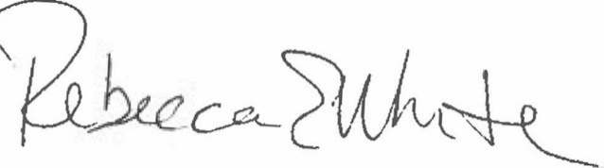  Rebecca E. White,  Director | THE PUBLIC UTILITIES COMMISSION  OF THE STATE OF COLORADO  G. HARRIS ADAMS  ________________________________  Administrative Law Judge

