Decision No. R24-0503-I
BEFORE THE PUBLIC UTILITIES COMMISSION OF THE STATE OF COLORADO
PROCEEDING NO. 24A-0159R
in the matter of the application of the colorado department of transportation for authority to replace traffic signal cabinet and add blank out signs at us 85 and duckwood rd, mile post 86.18, bnsf railway, us dot no. 440805j in the city of fountain, el paso county, state of colorado.
INTERIM DECISION
rescheduling prehearing conference
Mailed Date: July 11, 2024

STATEMENT
- On April 2, 2024, the Colorado Department of Transportation (“CDOT”) filed the above-captioned application (“Application”) requesting authority to add a blank out sign, advance flashing warning beacons, and a modification to the preemption timing at the Duckwood Road crossing of BNSF Railway Company (“BNSF”) and Union Pacific Railroad Company (“UPRR”) on the BNSF Pikes Peak Subdivision, railroad milepost 86.18, National Inventory
No. 440805J, in the City of Fountain, County of El Paso, in the State of Colorado.
- By Decision No. R24-0474-I, a prehearing conference in this proceeding is scheduled for July 12, 2024.
- On July 11, 2024, the Unopposed Motion to Vacate and Reschedule the Prehearing Conference was filed by BNSF. Due to a family emergency of counsel, BNSF requests that the scheduled prehearing conference be rescheduled.
- Counsel for BNSF conferred with counsel for both CDOT and UPRR and has been informed that both counsels have no objections to the change. Further, all parties will be available after July 18th to convene for the rescheduled Prehearing Conference.
- The request being unopposed, it is appropriate that response time be waived.
- Based upon good cause shown for the unopposed request, the motion will be granted.

It Is Ordered That:
- Response time to the Unopposed Motion to Vacate and Reschedule the Prehearing Conference filed by BNSF Railway Company (“BNSF”) on July 11, 2024, is waived and the motion is granted.
- The prehearing conference scheduled in this proceeding to be held on July 12, 2024, is vacated.
- A prehearing conference in this proceeding is scheduled as follows:
DATE: July 23, 2024
TIME: 10:00 a.m.
PLACE: Commission Hearing Room
1560 Broadway, 2nd Floor
Denver, Colorado
- This Decision is effective immediately.

(S E A L)    ATTEST: A TRUE COPY  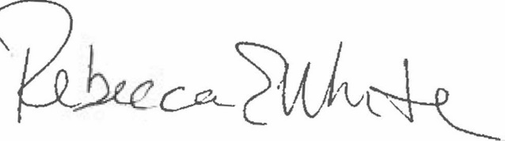  Rebecca E. White,  Director | THE PUBLIC UTILITIES COMMISSION  OF THE STATE OF COLORADO  G. HARRIS ADAMS  ________________________________  Administrative Law Judge

