Decision No. R24-0466-I
BEFORE THE PUBLIC UTILITIES COMMISSION OF THE STATE OF COLORADO
PROCEEDING NO. 24F-0236CP
MOUNTAIN STAR TRANSPORTATION, LLC DOING BUSINESS AS RED ROCKS SHUTTLE,

COMPLAINANT,

V.

ON LOCATION EVENTS, LLC DOING BUSINESS AS SHUTTLES TO RED ROCKS, AND ACE EXPRESS COACHES, LLC AND RAMBLIN’ EXPRESS, INC.,

RESPONDENTS.
INTERIM DECISION
PROVIDING OPPORTUNITY FOR PARTIES TO FILE a STATEMENT addressing the PREFERENCE FOR A REMOTE, HYBRID, Or IN-PERSON HEARING
Issued Date: June 28, 2024

STATEMENT

Procedural History
- This proceeding concerns the formal complaint filed by Mountain Star Transportation, LLC (“Mountain Star”) doing business as Red Rocks Shuttle on May 24, 2024, against On Location Events, LLC, doing business as Shuttles to Red Rocks and Ace Express Coaches, LLC, (“On Location”) and Ramblin’ Express, Inc. (“Ramblin Express”).
- On June 5, 2024, the Commission issued its Order Setting Hearing and Notice of Hearing (“Notice”), which was then amended on June 6, 2024, setting this matter for hearing on August 12, 2024, before an Administrative Law Judge (“ALJ”). The Notice also stated that the ALJ would establish the place and manner in which the hearing would be held.
- On June 12, 2024, the Commission referred this proceeding to an ALJ by minute entry.

Hearing
- The Commission can conduct in-person, remote, or hybrid hearings. A remote hearing is one in which all of the participants appear and participate from remote locations over the Zoom web conferencing platform. A hybrid hearing involves the ALJ and at least one party and/or witness participating from one of the Commission’s hearing rooms in Denver, and the remaining party(ies) and witness(es) participating from one or more remote locations using the Zoom web conferencing platform. An in-person hearing is one in which the ALJ and all parties and witnesses participate in the hearing at the same location.
- The parties will be given the opportunity to file a Statement Regarding Hearing identifying the filer’s preference for an in-person, remote, or hybrid hearing. If a filer prefers an in-person hearing, the filer must identify its preferred location and provide an explanation of why the hearing should be conducted at the filer’s preferred location. Any additional information supporting a request for a particular method of conducting the hearing (e.g., remote, hybrid, or in-person) can be included in a Statement Regarding Hearing.
- The deadline for the filing of the Statements Regarding Hearing will be
July 3, 2024. The parties are on notice that the ALJ will retain discretion to change the method by which the hearing will be conducted (e.g., remote, hybrid, or in-person) and/or the location of the hearing.

Additional Advisements
- The parties are advised and are on notice that this proceeding is governed by the Rules of Practice and Procedure found at 4 Code of Colorado Regulations 723-1. The ALJ expects the parties to be familiar with and to comply with these rules. The rules are available on the Commission’s website http://www.dora.colorado.gov/puc and in hard copy from the Commission.

ORDER

It Is Ordered That:
- The deadline to file any Statement Regarding Hearing containing the information described above is 5:00 p.m. on July 3, 2024.
- This Decision is effective immediately.

(S E A L)    ATTEST: A TRUE COPY  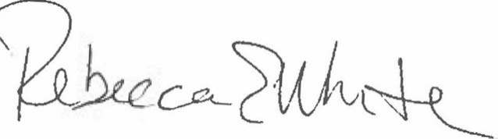  Rebecca E. White,  Director | THE PUBLIC UTILITIES COMMISSION  OF THE STATE OF COLORADO  G. HARRIS ADAMS  ________________________________  Administrative Law Judge

