Decision No. R24-0286-IE
BEFORE THE PUBLIC UTILITIES COMMISSION OF THE STATE OF COLORADO
PROCEEDING NO. 23AL-0635G
IN THE MATTER OF ADVICE LETTER NO. 133 FILED BY COLORADO NATURAL GAS, INC. TO ELIMINATE THE CONSTRUCTION ALLOWANCES, TO BECOME EFFECTIVE APRIL 29, 2024.
errata notice for
interim decision OF
ADMINISTRATIVE LAW JUDGE
CONOR F. FARLEY
VACATING REMOTE
PREHEARING CONFERENCE, EXTENDING STATUTORY DEADLINE, ESTABLISHING PROCEDURAL SCHEDULE, ASSIGNING EXHIBIT NUMBER BLOCKS, AND SCHEDULING REMOTE HEARING
Errata issued November 8, 2024
Original Decision R24-0286-I issued April 29, 2024
- Decision Paragraph Nos. #17 and #19 state that Attachments A and B are attached to Decision R24-0286-I.
However, Attachments A and B were inadvertently omitted from Decision No. R24-0286-I.
Attachments A and B to Decision No. R24-0286-I are attached to this Notice.
(S E A L)    ATTEST: A TRUE COPY  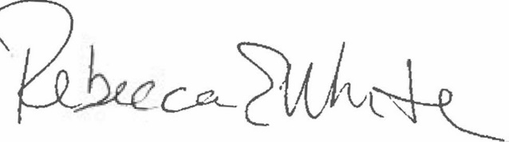  Rebecca E. White,  Director | THE PUBLIC UTILITIES COMMISSION  OF THE STATE OF COLORADO  CONOR F. FARLEY  ________________________________  Administrative Law Judge

