Decision No. R24-0247-I
BEFORE THE PUBLIC UTILITIES COMMISSION OF THE STATE OF COLORADO
PROCEEDING NO. 24M-0110TO
IN THE MATTER OF THE PETITION OF GOLDEN EAGLES TOWING LLC TO REVERSE AN INITIAL TOWING PERMIT DENIAL PURSUANT TO 40-10.1-401(2)(a), C.R.S., AND RULE 6504(d)
interim DECISION of
administrative law judge
Aviv Segev
requiring parties to confer and STAFF TO file a report REGARDING THE CONFERRAL
Mailed Date: April 18, 2024

STATEMENT

Background
      - On March 6, 2024, Golden Eagle Towing LLC (Golden Eagle) filed the Petition described in the caption above (Petition).
      - On March 27, 2024, the Commission referred the proceeding to an Administrative Law Judge (ALJ) by minute entry. The proceeding was subsequently assigned to the undersigned ALJ.
      - On April 10, 2023, Trial Staff of the Commission (Staff) noticed its intervention by right in this Proceeding.

Conferral and Conferral Report
      - Staff shall confer with Golden Eagle regarding a procedural schedule for this Proceeding, including a date for the hearing, deadlines for the filing and serving of witness and exhibit lists and exhibits, and the method by which the hearing should be conducted.
The Commission can conduct in-person, remote, or hybrid hearings. A remote hearing is one in which all of the participants appear and participate from remote locations over the Zoom
web-conferencing platform. A hybrid hearing involves the ALJ and at least one party and/or witness participating from one of the Commission’s hearing rooms in Denver, and the remaining party and witness(es) participating from one or more remote locations using the Zoom
web-conferencing platform. An in-person hearing is one in which the ALJ and all parties and witnesses participate in the hearing at the same location.
      - Staff shall file a report of the results of the conferral. If there is agreement on the topics described above, the report shall state as much and detail the stipulated procedural schedule, discovery procedures, and/or method for conducting the hearing. If no agreement is achieved, the report shall state as much and identify the differences on the topics described above. The parties are on notice that the ALJ will retain the discretion to ultimately determine the method by which the hearing will be conducted.
      - The parties are urged to review the Commission’s public calendar to identify suitable days for the hearing in this proceeding and propose more than one date or consecutive dates for the hearing. The deadline for Staff to file the report is April 25, 2023.
      - The Parties are advised and are on notice that this proceeding is governed by the Rules of Practice and Procedure found at 4 CCR 723-1. The ALJ expects the Parties to be familiar with and to comply with these rules. The rules are available on the Commission’s website (https://puc.colorado.gov/pucrules) and in hard copy from the Commission.

ORDER

It Is Ordered That:
- Trial Staff of the Commission shall file the report of the conferral identified above on or before April 25, 2024.
- This Decision is effective immediately.

(S E A L)    ATTEST: A TRUE COPY  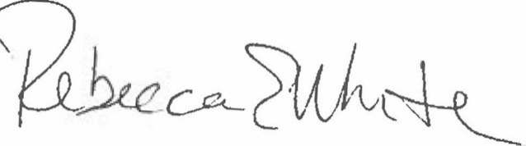  Rebecca E. White,  Director | THE PUBLIC UTILITIES COMMISSION  OF THE STATE OF COLORADO  AVIV SEGEV  ________________________________  Administrative Law Judge

