Decision No. C24-0805-I
BEFORE THE PUBLIC UTILITIES COMMISSION OF THE STATE OF COLORADO
PROCEEDING NO. 21A-0141E
IN THE MATTER OF THE APPLICATION OF PUBLIC SERVICE COMPANY OF COLORADO FOR APPROVAL OF ITS 2021 ELECTRIC RESOURCE PLAN AND CLEAN ENERGY PLAN.
Interim Decision Granting
Unopposed Motion To Access Limited Confidential And Highly Confidential Information
Mailed Date: November 6, 2024
Adopted Date: November 6, 2024

BY THE COMMISSION

Statement
- By this Decision, the Public Utilities Commission (“Commission”) grants the unopposed motion, filed by Mainspring Energy, Inc. (“Mainspring”) on November 1, 2024 (“Motion”). Through the Motion, Mainspring requests the Commission amend Decision No. C21-0343-I, issued on June 11, 2021, and for a partial waiver of Rule 1101(h), 4 Code of Colorado Regulations (“CCR”) 723-1, to permit Mainspring to access limited confidential and highly confidential information, upon the filing of appropriate non-disclosure agreements.
- Through Decision C21-0343-I, the Commission, among other things, granted Public Service Company of Colorado’s request to restrict access to eight categories of information, including bid information. Mainspring requests the Commission exercise its discretion and grant Mainspring access to the confidential and highly confidential information pertaining only to Mainspring’s Bid No. 0011 and its associated project being developed in Alamosa, Colorado (“Alamosa Project”).
- Mainspring submits good cause exists to grant the Motion and that doing so would support an efficient evidentiary record and would not create any competitive advantages. Mainspring states that the upcoming hearing scheduled for November 7 and 8, 2024, may include cross-examination or discussion involving the confidential and highly confidential testimony or responses relating to Bid No. 0011 or the Alamosa Project. Mainspring contends it would be appropriate for its witnesses and counsel to watch or participate in any such cross-examination or discussion at the hearing since its pecuniary interest could be directly impacted.
- Mainspring states it recognizes its role as a project developer and bidder and does not seek access to any confidential or highly confidential information regarding any of the bids, contracts, or other matters in this proceeding other than Bid No. 0011 and the Alamosa Project. Additionally, Mainspring states it has conferred with the parties in this proceeding and the Motion is unopposed.
- The Commission finds that good cause exists to grant Mainspring’s Motion, such that Mainspring, upon the filing of the appropriate non-disclosure agreements, can access the requested confidential and highly confidential information relating to Bid No. 0011 and the associated Alamosa Project.

ORDER

The Commission Orders That:
- The unopposed motion filed by Mainspring Energy, Inc., on November 1, 2024, requesting access to limited confidential and highly confidential information, upon the filing of appropriate non-disclosure agreements, is granted consistent with the discussion above.
- This Decision is effective upon its Issued Date.

ADOPTED IN COMMISSIONERS’ WEEKLY MEETING
November 6, 2024.
(S E A L)    ATTEST: A TRUE COPY  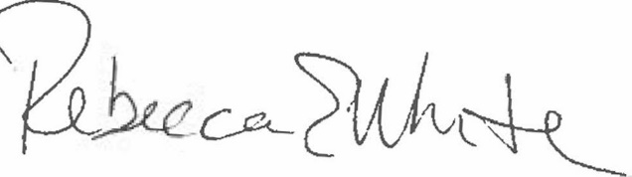  Rebecca E. White,  Director | THE PUBLIC UTILITIES COMMISSION  OF THE STATE OF COLORADO  ERIC BLANK  ________________________________  MEGAN M. GILMAN  ________________________________  TOM PLANT  ________________________________  Commissioners

