Decision No. C24-0691-I
BEFORE THE PUBLIC UTILITIES COMMISSION OF THE STATE OF COLORADO
PROCEEDING NO. 24A-0288R
IN THE MATTER OF THE APPLICATION OF THE CITY OF WHEAT RIDGE FOR AUTHORITY TO CONSTRUCT AND MAINTAIN A PEDESTRIAN BRIDGE CROSSING OF THE BNSF GOLDEN SUBDIVISION RAILROAD (ALSO UTILIZED BY REGIONAL TRANSPORTATION DISTRICT FOR COMMUTER RAIL) IN THE CITY OF WHEAT RIDGE, JEFFERSON COUNTY, STATE OF COLORADO.
INTERIM COMMISSION DECISION
GRANTING MOTION FOR EXTENSION OF TIME
TO PROVIDE FINAL PLANS
Issued Date: September 26, 2024
Adopted Date: September 25, 2024

by the commission

Statement
- This matter comes before the Commission for consideration of a Motion for Extension of Time (“Motion”) filed by the City of Wheat Ridge (“Wheat Ridge”) on
September 6, 2024, requesting an extension of time to December 30, 2024, to file the final plans for Commission review and action.
- As grounds for the Motion, Wheat Ridge states that there have been delays in resolving issues related to finalizing the design and a delay in finalizing a contract amendment with the consulting firm that is designing the project. Because of these unforeseen delays, Wheat Ridge requests an extension to December 30, 2024, to submit final plans.
- No responses were filed to the Motion.
- Now being fully advised in the matter, we grant the Motion

ORDER

It Is Ordered That:
- The Motion for Extension of Time (Motion) filed by the City of Wheat Ridge (“Wheat Ridge”) on September 6, 2024, requesting an extension of time to December 30, 2024, to file the final plans for Commission review and action.
- Wheat Ridge is required to file final plans for this project by December 30, 2024.
- The Commission retains jurisdiction to enter further decisions as necessary.
- This Decision is effective upon its Issued Date.

ADOPTED IN COMMISSIONERS’ WEEKLY MEETING
September 25, 2024.
(S E A L)    ATTEST: A TRUE COPY  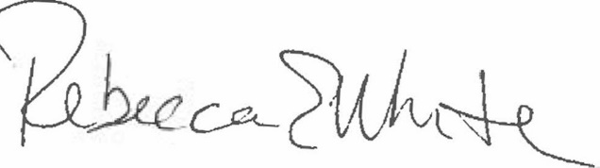  Rebecca E. White,  Director | THE PUBLIC UTILITIES COMMISSION  OF THE STATE OF COLORADO  ERIC BLANK  ________________________________  MEGAN M. GILMAN  ________________________________  TOM PLANT  ________________________________  Commissioners

