Decision No. C24-0557-E
BEFORE THE PUBLIC UTILITIES COMMISSION OF THE STATE OF COLORADO
PROCEEDING NO. 24M-0329T
IN THE MATTER OF ESTABLISHING THE 2025 EMERGENCY TELEPHONE CHARGE THRESHOLD, STATEWIDE 9 1 1 SURCHARGE, PREPAID WIRELESS 9 1 1 CHARGE, AND SURCHARGE DISTRIBUTION FORMULAS PURSUANT TO §§ 29-11-102 THROUGH 102.5, C.R.S.
ERRATA NOTICE FOR
COMMISSION DECISION OPENING PROCEEDING; SETTING NOTICE AND INTERVENTION PERIOD; AND PROPOSING THRESHOLD, SURCHARGE, AND CHARGE AMOUNTS AND DISTRIBUTION FORMULA
Errata issued August 6, 2024
Original Decision No. C24-0557 issued August 2, 2024

- Footnote No. 15 currently reads as follows:
¹⁵ Attachment A.
Footnote No. 15 is corrected to read as follows:
¹⁵ Attachment B to this Decision.
- Footnote Nos. 8, 19, and 20 are corrected to include the language “to this Decision.”
- The Original Decision did not include Attachments A, B, and C. Those attachments are attached to this Errata.
(S E A L)    ATTEST: A TRUE COPY  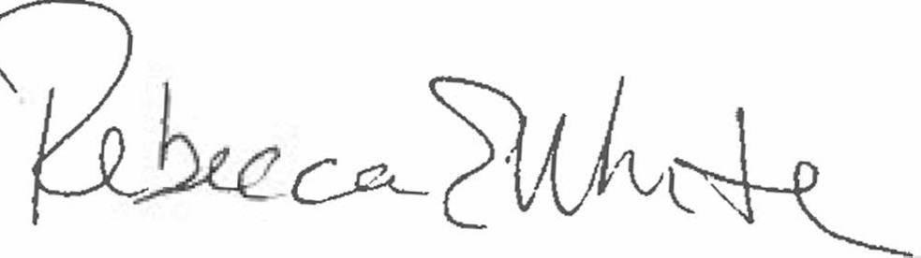  Rebecca E. White,  Director | THE PUBLIC UTILITIES COMMISSION  OF THE STATE OF COLORADO  REBECCA E. WHITE  ________________________________  Director

