Decision No. C24-0436
BEFORE THE PUBLIC UTILITIES COMMISSION OF THE STATE OF COLORADO
PROCEEDING NO. 23A-0458R
IN THE MATTER OF THE APPLICATION OF CITY AND COUNTY OF DENVER FOR AUTHORITY TO ALTER THE EXISTING AT-GRADE CROSSING AND MODIFY WARNING DEVICES OF THE BURLINGTON NORTHERN SANTA FE RAILWAYS TRACKS NEAR THE INTERSECTION OF SOUTH KALAMATH STREET AND WEST BAYAUD AVENUE (US DOT #245394V) IN THE CITY AND COUNTY OF DENVER, STATE OF COLORADO.
commission decision granting
motion for extension of time
Issued Date: June 26, 2024
Adopted Date: June 17, 2024

BY THE COMMISSION

Statement
- This matter comes before the Commission for consideration of an Unopposed Motion for Extension of Time (Motion) filed by the City and County of Denver (“Denver”) on June 10, 2024, requesting an extension of time to September 30, 2024, to file a copy of the signed Construction and Maintenance (“C&M”) Agreement for this project with the Commission.
- As grounds, Denver states that parties have made progress in finalizing a C&M Agreement for the approved improvements for this project, gut need additional time to finalize the C&M Agreement. Denver requests an additional extension of time to September 30, 2024, to file a signed copy of the agreement.
- Denver conferred with counsel for the BNSF Railway and BNSF does not object to the relief sought in this Motion.
- The Commission retains jurisdiction to enter further decisions as necessary,
- Now being fully advised in the matter, we grant the Motion.
- ORDER
  - The Commission Orders That:
- The Unopposed Motion for Extension of Time (“Motion”) filed by the City and County of Denver (“Denver”) on June 10, 2024, requesting an extension of time to
September 30, 2024. to file a copy of the signed Construction and Maintenance (“C&M”) Agreement for this project with the Commission is granted.
- Denver shall file the signed C&M Agreement for this project by
September 30, 2024.
- This Decision is effective on its Issued Date.
  - ADOPTED IN COMMISSIONERS’ WEEKLY MEETING
June 17, 2024.
(S E A L)    ATTEST: A TRUE COPY  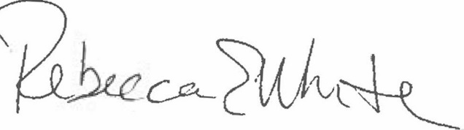  Rebecca E. White,  Director | THE PUBLIC UTILITIES COMMISSION  OF THE STATE OF COLORADO  ERIC BLANK  ________________________________  MEGAN M. GILMAN  ________________________________  TOM PLANT  ________________________________  Commissioners

