Decision No. C24-0259-E
BEFORE THE PUBLIC UTILITIES COMMISSION OF THE STATE OF COLORADO
PROCEEDING NO. 24M-0061G
IN THE MATTER OF THE GAS INFRASTRUCTURE PLAN OF ATMOS ENERGY CORPORATION FILED PURSUANT TO 4 CODE OF COLORADO REGULATIONS
723-4-4552 OF THE COMMISSION'S RULES REGULATING GAS UTILITIES.
ERRATA NOTICE FOR
COMMISSION DECISION OPENING PROCEEDING, ESTABLISHING NOTICE AND INTERVENTION PERIOD, SETTING COMMENT DEADLINES, REQUIRING CONFERRAL ON DISCOVERY PROCEDURES, SCHEDULING WORKSHOP, REFERRING PUBLIC COMMENT HEARING TO AN ADMINISTRATIVE LAW JUDGE, AND DIRECTING FILING OF STAFF REPORT
Errata Mailed: April 29, 2024
Original Decision No. C24-0259 mailed: April 22, 2024

- Ordering Paragraph 7 of this Decision reads as follows:
7. Initial written comments on Atmos’s Gas Infrastructure Plan shall be filed no later than July 23, 2024. Reply Comments shall be filed no later than August 20, 2024.
Ordering Paragraph 7 is amended to read as follows:
7. Initial written comments on Atmos’s Gas Infrastructure Plan shall be filed no later than August 13, 2024. Reply Comments shall be filed no later than September 10, 2024.

(S E A L)    ATTEST: A TRUE COPY  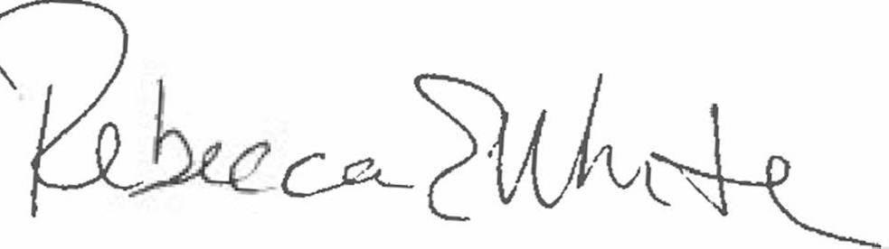  Rebecca E. White,  Director | THE PUBLIC UTILITIES COMMISSION  OF THE STATE OF COLORADO  REBECCA E. WHITE  ________________________________  Director

