Decision No. C24-0165
BEFORE THE PUBLIC UTILITIES COMMISSION OF THE STATE OF COLORADO
PROCEEDING NO. 06A-153R
IN THE MATTER OF THE JOINT APPLICATION OF THE PARK CREEK METROPOLITAN DISTRICT AND THE CITY AND COUNTY OF DENVER FOR AUTHORITY TO CONSTRUCT A NEW PUBLIC HIGHWAY-RAILROAD AT-GRADE CROSSING ACROSS AN INDUSTRIAL RAILROAD SPUR TRACK WITHIN THE CITY AND COUNTY OF DENVER WHICH IS OPERATED BY THE UNION PACIFIC RAILROAD COMPANY AND TO INSTALL APPROPRIATE GRADE CROSSING WARNING DEVICES.
commission decision granting motion
for extension of time to provide final plans
Mailed Date: March 15, 2024
Adopted Date: March 13, 2024

by the commission

Statement
- This matter comes before the Commission for consideration of a Status Report and Request for Extension of Time (Motion) filed by Park Creek Metropolitan District (Park Creek) on December 29, 2023, requesting an extension of time to July 31, 2024, to file the signed Construction and Maintenance Agreement, and requesting until December 31, 2024, to file the completion letter and to update the crossing inventory form.
- As grounds for the Motion, Park Creek states they have filed the required Union Pacific (UPRR) signal preemption request form and detailed plans for review. Park Creek filed its Amended Application with the Commission on May 23, 2023, after receiving no review information from UPRR’s consultants by the agreed-on date of May 22, 2023. Two weeks later, UPRR’s consultants cited technical concerns related to the future operation of the queue cutter signal by the City and County of Denver (Denver) and possible interconnection software upgrades that may be installed at the existing traffic signal to enhance the queue-cutter signal. Since that time, Park Creek has tried to work in good faith with Denver and UPRR’s consultant to resolve the remaining technical operating concerns, but to date has not been successful.
- Park Creek states that their understanding is that UPRR will not amend the existing Construction and Maintenance Agreement or updated C&M agreement until its technical concerns have been resolved. As such, Park Creek is unable to meet the requirements of the Commission decision.
- There were no responses filed to the Motion.
- Now being fully advised in the matter, we grant the Motion.

ORDER

The Commission Orders That:
- The Status Report and Request for Extension of Time (Motion) filed by Park Creek Metropolitan District on December 29, 2023, requesting an extension of time to
July 31, 2024, to file the signed Construction and Maintenance Agreement, and requesting until December 31, 2024, to file the completion letter and to update the crossing inventory form is granted.
- Park Creek shall file the signed Construction and Maintenance Agreement in this matter by July 31, 2024.
- Park Creek shall inform the Commission of project completion and Union Pacific shall provide an updated National Inventory Form for this project by December 31, 2024.
- The Commission retains jurisdiction to enter further decisions as necessary.
- This Decision is effective on its Mailed Date.

ADOPTED IN COMMISSIONERS’ WEEKLY MEETING
March 13, 2024.
(S E A L)    ATTEST: A TRUE COPY  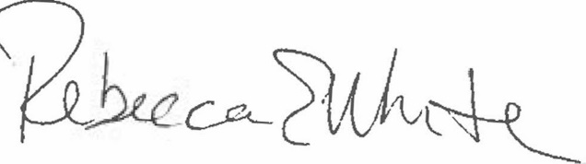  Rebecca E. White,  Director | THE PUBLIC UTILITIES COMMISSION  OF THE STATE OF COLORADO  ERIC BLANK  ________________________________  MEGAN M. GILMAN  ________________________________  TOM PLANT  ________________________________  Commissioners

