Decision No. C24-0164
BEFORE THE PUBLIC UTILITIES COMMISSION OF THE STATE OF COLORADO
PROCEEDING NO. 21A-0023T
IN THE MATTER OF THE APPLICATION OF STARLINK SERVICES, LLC FOR DESIGNATION AS AN ELIGIBLE TELECOMMUNICATIONS CARRIER FOR PURPOSES OF RECEIVING RURAL DIGITAL OPPORTUNITIES FUND SUPPORT.
COMMISSION DECISION APPROVING DISCONTINUANCE OF ELIGIBLE TELECOMMUNICATIONS CARRIER
DESIGNATION IN COLORADO
Mailed Date: March 18, 2024
Adopted Date: March 13, 2024

By the Commission

Statement
- This Decision addresses a request for Relinquishment of Eligible Telecommunication Carrier (ETC) designation filed on February 23, 2024, by Starlink Services, LLC (Starlink). We approve the relinquishment of the ETC designation with further details below.

Background
- The procedural history of Starlink’s ETC designation is set forth in this docket by Decision No. C21-0262.
- Starlink Applied for ETC designation as a requirement of winning bids in the Federal Communications Commission (FCC) Rural Digital Opportunity Fund (RDOF). Starlink noted in its initial application that it applied for this designation exclusively in connection with RDOF funding.
- Starlink notes that the Wireline Competition Bureau (Bureau) denied Starlink Services’ RDOF “Long Form” application. Starlink subsequently appealed the Bureau decision to the FCC, and the FCC later affirmed the Bureau’s decision.
- As indicated in Starlink’s filing, Starlink will not receive any RDOF support to provide services in Colorado. Starlink has no existing subscribers and has never received universal services support, nor has it provided telecom services in the state of Colorado.
For these reasons, we find granting Starlink’s request to relinquish ETC designation in Colorado is in public interest and will have no adverse effects as it never provided ETC services in Colorado. We also find good cause to waive the requirement in Commission Rule 2188 that an application be filed to relinquish ETC designation; given that Starlink’s ETC designation was granted in connection with RDOF funding and Starlink has not provided service under that designation we consider the February 23, 2024 Notice to be sufficient for the purposes of notice and our review.

order

The Commission Orders That:
- The request for relinquishment of its Eligible Telecommunications Carrier designation granted by Decision No. C21-0262 as presented in the February 23, 2024 Notice filed by Starlink Services, LLC is granted.
- Commission Rule 2188 is waived as discussed above.
- This proceeding is closed.
- This Decision is effective on its mailed date.

ADOPTED IN COMMISSIONERS' WEEKLY MEETING
March 13, 2024.
(S E A L)    ATTEST: A TRUE COPY  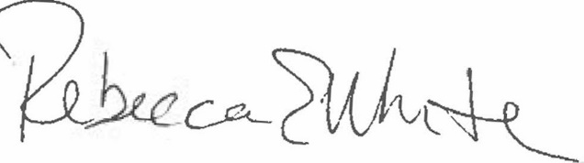  Rebecca E. White,  Director | THE PUBLIC UTILITIES COMMISSION  OF THE STATE OF COLORADO  ERIC BLANK  ________________________________  MEGAN M. GILMAN  ________________________________  TOM PLANT  ________________________________  Commissioners

See Rural Digital Opportunity Fund Auction Support for 80 Winning Bids Ready to Be Authorized, Bid Defaults Announced, AU Docket No. 20-34 et al., Public Notice, DA 22-848, at 8-11 (WCB/OEA Aug. 10, 2022).
See Application for Review of Starlink Services, LLC, WC Docket No. 10-90 (filed Sept. 9, 2022).
See Order on Review, WC Docket No. 10-90, et al. (rel. Dec. 12, 2023).

