Decision No. C24-0057-I
BEFORE THE PUBLIC UTILITIES COMMISSION OF THE STATE OF COLORADO
PROCEEDING NO. 23A-0216G
IN THE MATTER OF ATMOS ENERGY CORPORATION'S APPLICATION TO OPEN DEMAND-SIDE MANAGEMENT STRATEGIC ISSUES PROCEEDING.
INTERIM Commission decision
STAYING RECOMMENDED DECISION No. r24-0016
Mailed Date: January 24, 2024
Adopted Date: January 24, 2024

BY THE COMMISSION

Statement, Findings, and Conclusions
- By this Decision, the Commission stays Decision No. R24-0016, mailed
January 9, 2024, by Administrative Law Judge (ALJ) Alenka Han (Recommended Decision). The Recommended Decision approves the unanimous, partial Settlement Agreement (Settlement) proposed by all parties to this Proceeding and determines that Atmos Energy will not be required to design and implement a Beneficial Electrification program.
- Pursuant to § 40-6-109(2), C.R.S., Decision No. R24-0016 will become the decision of the Commission if no exceptions are filed within 20 days after service of the order, or within such extended period of time as the Commission may order. However, § 40-6-109(2), C.R.S., permits the Commission to stay a recommended decision upon its own motion.
- The Commission will stay Decision No. R24-0016 on its own motion to allow for a Commission review of the recommendation of the ALJ. We do not disturb any other deadlines in this Proceeding. At a future Commissioners’ Weekly Meeting, we will review the ALJ’s recommendations along with any exceptions filed within 20 days after Decision No. R24-0016 was mailed.

ORDER

It Is Ordered That:
- In accordance with § 40-6-109(2), C.R.S., Decision No. R24-0016, mailed
January 9, 2024, is stayed.
- The deadline for the filing of exceptions, on or before January 29, 2024, and for responses to any exceptions, on or before February 5, 2024, remains unchanged.
- This Decision is effective upon its Mailed Date.

ADOPTED IN COMMISSIONERS’ WEEKLY MEETING
January 24, 2024.
(S E A L)    ATTEST: A TRUE COPY  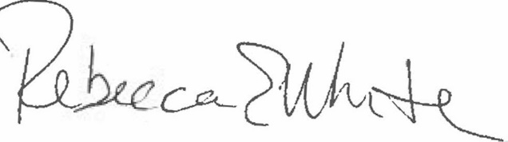  Rebecca E. White,  Director | THE PUBLIC UTILITIES COMMISSION  OF THE STATE OF COLORADO  ERIC BLANK  ________________________________  MEGAN M. GILMAN  ________________________________  TOM PLANT  ________________________________  Commissioners

